Living a healthier lifestyle in Surrey
Have your say.

Surrey County Council is looking at the help people get to live a healthier lifestyle.
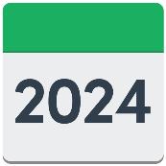
The contract for Surrey Healthy Lifestyles Service runs out on 31 March 2024.
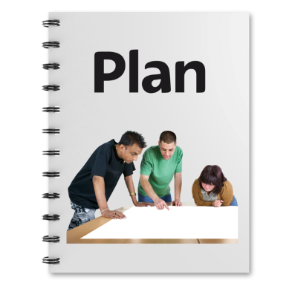
Lots of things have changed since we agreed our contract.

We want to make sure our plans for the new contract are what people in Surrey need.
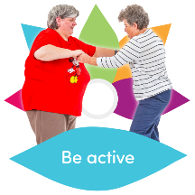
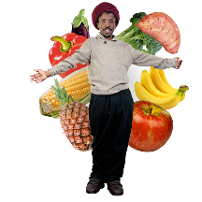
What the Healthy Lifestyles Service does now.
Help to stop smoking.
Help to be a healthier weight.
Help to do more exercise.
Help to understand heart health.
Help people get health checks.
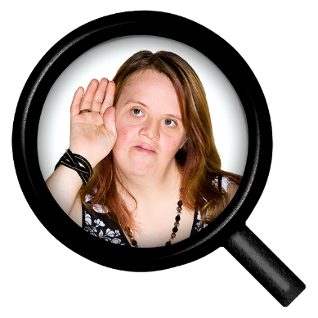

We have already listened to lots of different people about what is important to them.

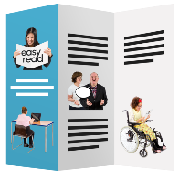
What we think the new healthy lifestyles service could offer.
One place for people to get help to change their lifestyle.
Special help for people who want to stop smoking.
Help to be a healthy weight for people who find it hardest to have a healthy lifestyle.
Information and other things about healthier lifestyles.
Advice and help to find other ways of getting support.

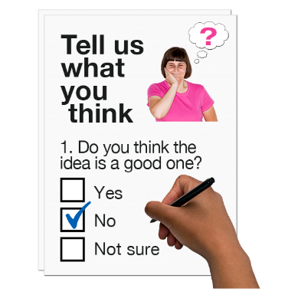

We want to hear what you think about our plans.

What you tell us will help us agree what the new Healthy Lifestyles Service will be for Surrey.

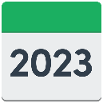
Please send your answers back by
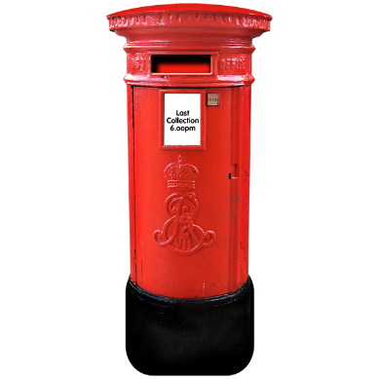
Friday 28th April 2023
Healthy Lifestyles Consultation
Public Health
Surrey County Council
Cockshot Hill
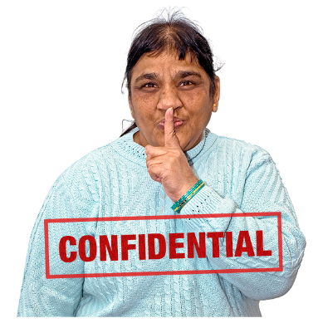
Reigate
RH2 8EF

We will keep the information you give us confidential.
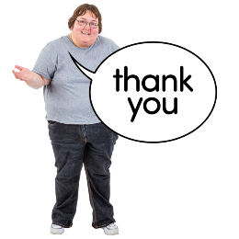
Please do not share any personal information in your answers.

Thank You for helping us with our survey.

1 | 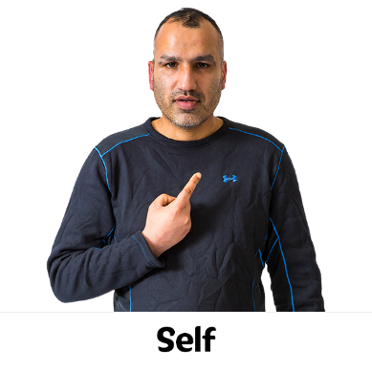 | Are you answering for yourself or for a local organisation or group?  For myself  For an organisation or group  What is the name of your organisation or group?

2 | 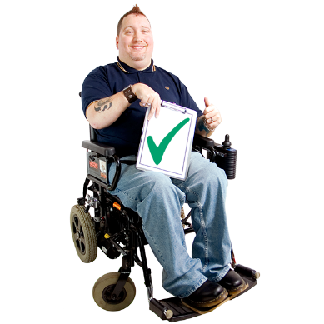 | Please tick next to the answer that best says why you are answering the survey.  I have used Healthy Lifestyles before  or might use the new service.  My friend or relative might use  healthy lifestyles.  Not saying.  Something else.  Please say more if you ticked something else.

3 | 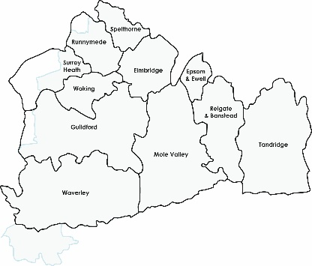 | Please tick where you live.  Elmbridge  Epsom and Ewell  Guildford  Mole valley  Reigate and Banstead  Surrey Heath  Tandridge  Waverley  Woking

4 | 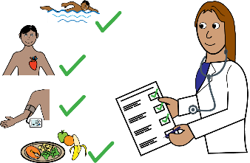 | If you or the person you are supporting has used the Healthy Lifestyles Service, please tick the ones used.  Support to stop smoking.  Support to lose weight for adults.  Support to lose weight for children and families  NHS Health Checks  None of the above  Something else

 | 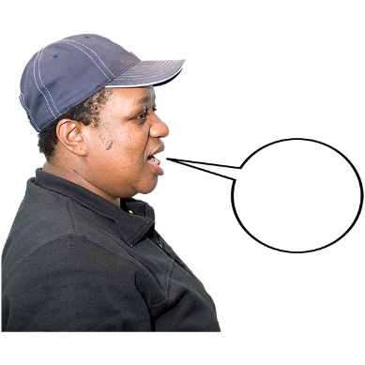 | If you have used any of the services in the last question, can you say how it was?

5 | 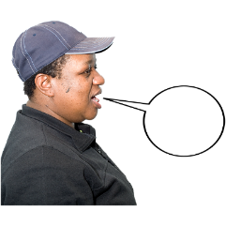  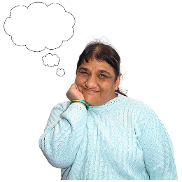  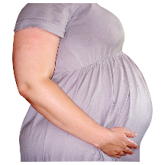 | What services might you or the person you support use in the future?  One to one support to stop smoking.  One to one support to lose weight.  One to one support to do more exercise.  One to one support to cut down alcohol.  Group support to stop smoking.  Group support to lose weight.  Group support to do more exercise.  Group support to cut down alcohol.  Support online.  Information and advice.  Asking someone like a GP about support.  I wouldn’t contact healthy lifestyles.  Something else.  If you said something else, can you say what here?

6 | 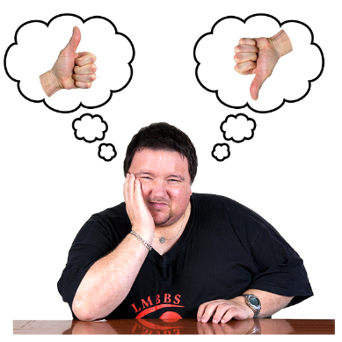 | Do you agree this service should support people who find it hardest to have a healthy lifestyle?  Don’t agree a lot  Agree a lot  Agree a bit  In the middle  Don’t agree
 |  | Can you say why you think this?
7 | 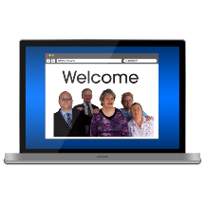  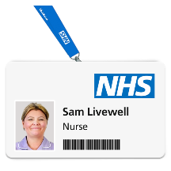  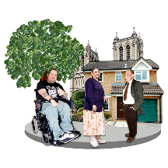 | If you or the person you are supporting needed help about being healthier, how would you find out more?  Tick the answers you think you might try.  The internet or google.  NHS or Council website.  GP  Another health person.  Pharmacy.  A friend or family member.  A group in the community.  Something else  If you said something else, can you say where?

8 | 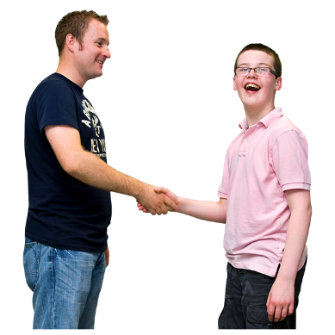 | How would you or the person you are supporting want to get healthy lifestyle support?  Drop in advice and support.  Arranged one to one support face to face.  Arranged support in a group.  Arranged support online.  Support by phone.  Support by text.  Support by e-mail.  Information to support yourself.  Support from other people like you.  Something else.  If you said something else, can you say what?

9 | 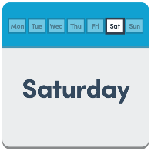 | Do you think it is important for support to be available at times like evenings and weekends as well as during weekdays?  Yes  No  Not Sure  Yes very
 | 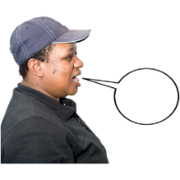 | Can you say what times or days would be good.

10 |  | If you or the person you are supporting wanted to change their lifestyle, is there anything that would get in the way?

11 | 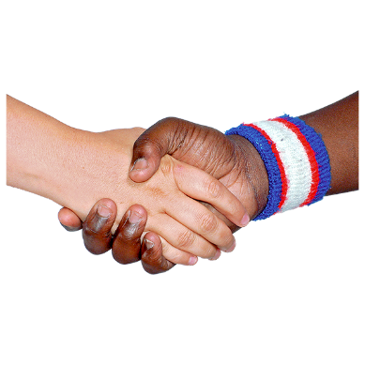 | If you or the person you are supporting wanted to change their lifestyle, is there anything that would help?

12 |  | Is there anything else you want to say to help us with our plans?

About You.
The next questions are about you.
You don’t have to answer them but if you can it will help us make sure we have information from lots of people with different experiences.
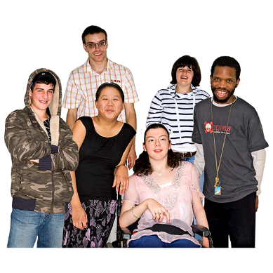
- Please tick or colour the box that best describes your gender.
Male
Female
Not saying
Something else
If you said something else can you say how you describe yourself here?

- Is this the same gender as when you were born?
Yes
No
Not saying

- How old are you?
Under 16
16-17
18-24 44-54
25-34 55-64
35-44 65-74
Not saying Over 75

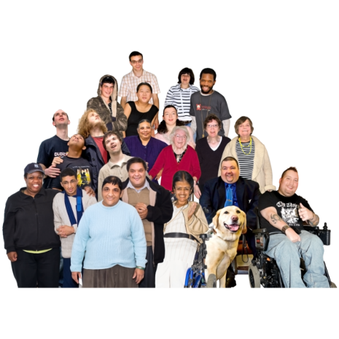
- Please tell us which in this list best describes you.
Not saying
Arab
Arab British
Asian or Asian British - Indian
Asian or Asian British - Pakistani
Asian or Asian British - Bangladeshi
Asian or Asian British - Chinese
Asian or Asian British - Any other Asian background
Black or Black British - Caribbean
Black or Black British - African
Black or Black British -Any other Black background
Mixed - White and Black Caribbean
Mixed - White and Black African
Mixed - White and Asian
Any other Mixed background
White British
White Irish
Any other White background
Something else
If you chose something else, can you tell us how you describe yourself here?

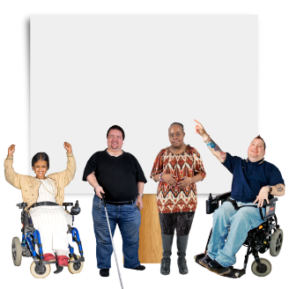
- Do you have a disability or have a long term illness or health condition?
Yes
No
Not saying

Thank You for your help with our survey

