Surrey Integrated All Age Autism Strategy
DRAFT
Contents
Introduction 2
Our Vision 2
What is Autism? 2
The Local Picture 3
Outcomes of Our Consultation 5
Our Principles 8
Our Plan 8
Making our plan happen 9
My Voice 9
Awareness and understanding of autism in services and the wider community 9
Information and Navigation to live an active life 10
Education and Preparation for Adulthood 11
Health and Social Care support 12
Housing and Independent living 18
Employment 20
Glossary 21
References 22

Introduction
This strategy has been brought together by autistic children, young people, adults and family carers together with professionals from across Surrey’s service system, to make our joint ambitions clear. We want to achieve an autism friendly approach across the County in education, health, social care, work and communities. We want services to have a more joined-up, proactive and autism-accessible offer so that autistic people have equality of access. The Strategy will promote a cultural shift so that community and service settings are understanding and welcoming for autistic children and adults.
We have agreed to use the term autistic people to refer to children, young people and adults.

Our Vision
Our vision is for Surrey to be a place that offers opportunities for people to live healthy and fulfilling lives, where people’s contributions to their local communities are welcomed, supported and valued, and no-one is left behind. These opportunities should extend to all autistic people in Surrey. All organisations involved in developing and implementing this strategy are committed to ensuring that the vision and aims will be delivered in full for autistic people.
The development of the strategy has been centred around involvement of autistic people and family carers. The implementation of the strategy will continue this, with a commitment to ongoing involvement and engagement with Surrey’s community of autistic people and family carers.

What is Autism?
There are several names used to describe the autism spectrum, including Autistic Spectrum Disorder, Autism Spectrum Condition, and others which have been used to describe a part of the spectrum, such as Asperger Syndrome or Classic Autism. In this strategy we use the term ‘autism’ to refer to the whole autism spectrum and the strategy recognises that autism is one of a wider range of neurodiverse conditions.

“Autism is a lifelong developmental disability which affects how people communicate and interact with the world. One in 100 people are on the autism spectrum and there are around 700,000 autistic adults and children in the UK. Autism is a spectrum condition and affects people in different ways. Like all people, autistic people have their own strengths and weaknesses.” (https://www.autism.org.uk/advice-and-guidance/what-is-autism)

The way that autistic people experience their environment can lead to areas of strength or difficulty, that vary between individuals and may not be immediately obvious. For example, autistic people can have:
- Strong attention to detail
- Above average technical or creative skills
- Character strengths, such as honesty and loyalty
- Differences in sensory processing, including over- and under-sensitivity
- Difficulty predicting what is going to happen next
- Difficulty knowing or understanding what other people think or feel

Autism varies widely and is often referred to as a spectrum. However, this spectrum is not linear - it is not possible to line autistic people up in order of being more or less autistic. Different features of autism vary from individual to individual, as well as over the lifespan. How an autistic person appears in a particular environment may not be representative of how they appear in other environments.
We know that not everyone autistic has had or would like a diagnostic assessment. Our aim is that changes promoted by this strategy will benefit autistic and other neurodivergent people whether or not they have a diagnosis.
Co-occurring conditions
The National Institute for Health and Care Excellence (NICE) estimates that around 70% of autistic people have an additional condition, which is “often unrecognised”. The main conditions that co-occur more frequently in autistic people compared with the general population include:
- Mental health conditions. Research suggests that 70% of autistic people have a mental health condition, and that 40% have two or more. Autistic people are up to four times more likely to have anxiety, and twice as likely to have depression. Research has shown that autistic people are more vulnerable to negative life experiences, which may also impact mental health. Compared to the general population, autistic people report having a lower quality of life.9
- Neurodevelopmental conditions. These are caused by differences in early brain development, and affect the way that a person processes information, thinks, or learns. Autism is one such condition, and it is common for autistic people to have other neurodevelopmental conditions. These include general learning disabilities (affecting between 15% and 30% of autistic people), specific learning difficulties (such as dyslexia and attention-deficit hyper-activity disorder), and other conditions such as epilepsy. Delays in language development are common in autism, and up to 30% of autistic people are non-speaking (completely, temporarily, or in certain contexts).

The Local Picture
Surrey’s population in 2021 is projected to be 1.23 million so, our best approximation of its autistic population is 12,300 people, made up of:
  - 2,900 children aged 0-17
  - 900 young people aged 18-24
  - 8,200 people aged 25 and over

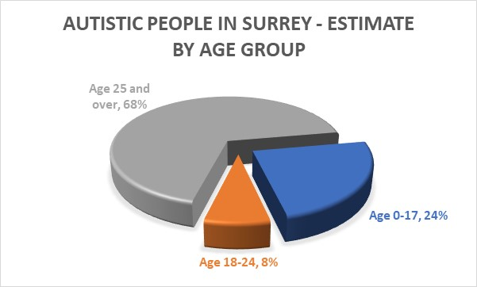

Children and Young People with Autism in Surrey -
The total number of Education, Health and Care Plans (EHCPs) for young people up to the age of 25 in 2020 was 10,762 of which 3,653 or 34% with primary need of autism as follows:
- Male – 2,958 or 81% of all plans with primary need of autism
- Female – 695 or 19% of the total number of plans with primary need of autism
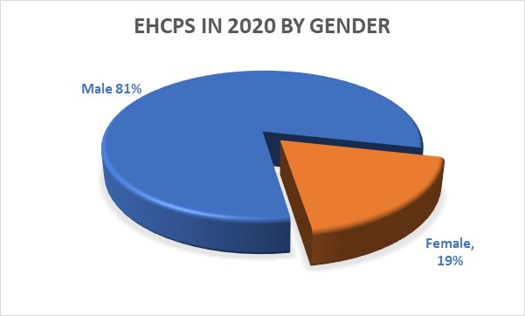
Adult Population / People 18 and Over in Surrey
National data shows the number of people aged 18 and over with autistic spectrum disorders in Surrey in 2021 is about 9,100. A summary of recent research shows that autism is about three times more common in men than women.
20% of Surrey’s predicted adult autistic population (1,834 people) are in receipt of a service from Adult Social Care (ASC), and a third of these are women.

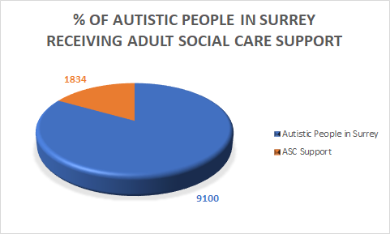

Why do we need a Strategy?
Autistic people and family carers have told us that there are significant barriers to achieving our vision across the service system and the wider community. Addressing these barriers will require better understanding of autism, and culture change across Surrey’s services and community.

These are not quick things to deliver, but we know that with focussed leadership across the system over time, autistic children, young people and adults in Surrey can be supported to achieve better outcomes. The work of the strategy will need to be embedded in organisations and the wider community so that it is sustained and can be built on. We are committed to bringing the right people together to break down barriers to community access and use our resources effectively to deliver the support that people need. Our strategy is here to focus the action of all the partners across Surrey who will work together to make the changes we need to see.

Outcomes of Our Consultation
We carried out a public consultation in 2020. Professionals, autistic people, and carers developed a set of questions to ask people about their experiences and how things could be improved in Surrey. We received 1,165 detailed responses.
- 109 autistic people,
- 756 family members, carers or partners of autistic people,
- 237 professionals; and
- 63 ‘others’.
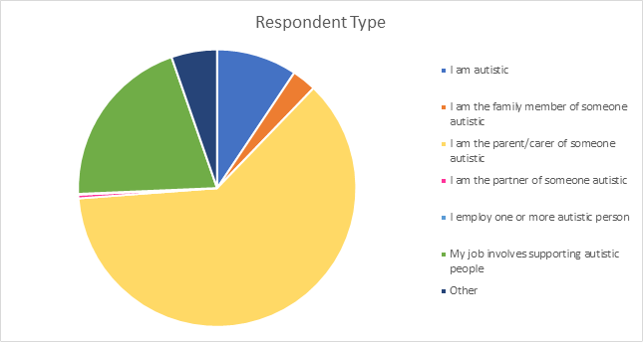

We have worked with London South Bank University to analyse the responses and draw together the key themes. We have checked the themes with autistic young people and adults, families, carers and professionals through a series of online workshops.

Priorities identified by autistic people:
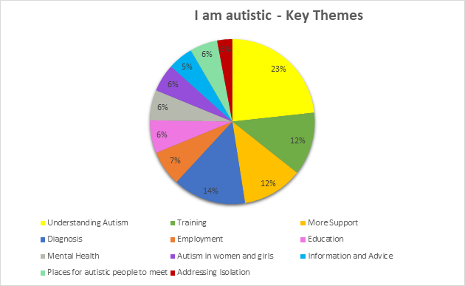

Priorities identified by family members and parent/carers of someone autistic:
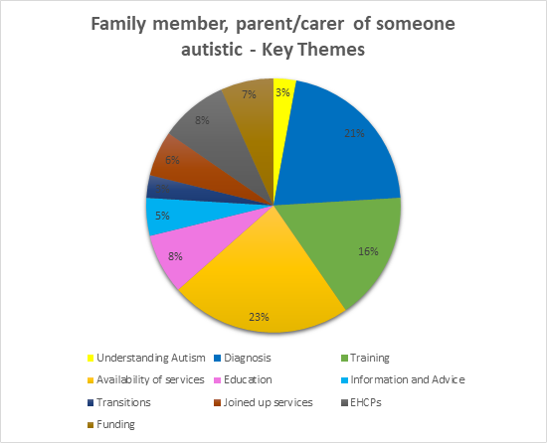

Priorities identified by people whose job involves supporting autistic people:
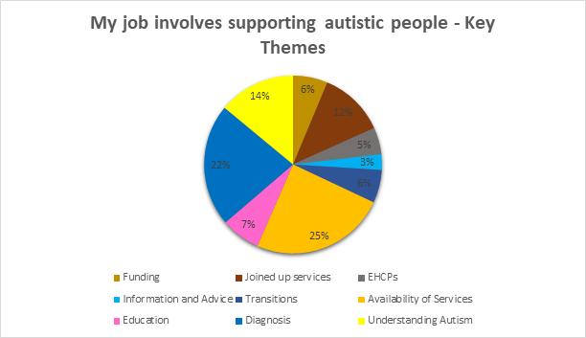

Our Principles
- My Voice - Work on developing and implementing the strategy will involve autistic people and family carers. – Nothing About Us Without Us. We make fair and strong decisions together.
- Partnership Working – Many different agencies and organisations will be involved in delivering this strategy. We will work together towards the common goals outlined here.
- Strengths-Based Approach – We intend to build on strengths of individuals, organisations and communities
- Closer to Home – We will aim for autistic people to be included and supported in their local communities as far as possible. When people require specialist support that cannot be delivered in every locality, we will aim for support to be in-County wherever possible.
- Efficient use of Resources – We know that services have limited resources, and this strategy is ambitious in aiming for widespread change. Making the system more joined-up, inclusive and accessible will prevent crises for autistic people and their families, and improve efficiency across the service system. To ensure the change can be as wide as possible we will use the resources available in the most effective way.

Our Plan
Over the next 5 years, bringing people together to develop and implement work plans focusing on the following priority areas:
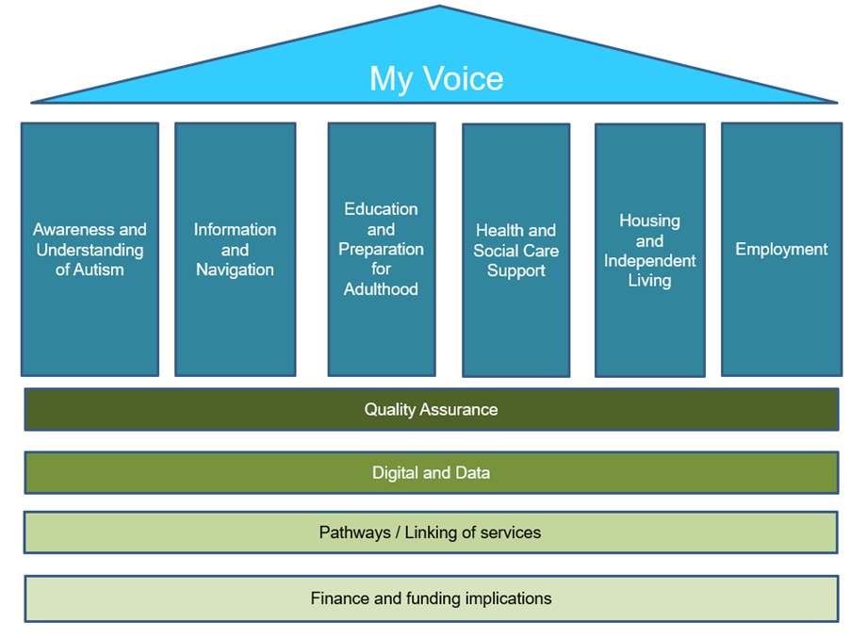
The work carried out to implement the plan will report back through the Children’s and Adults’ Autism Partnership Boards and the decision-making bodies for Surrey County Council and the NHS in Surrey.

Making our plan happen
We have divided up our plan into the priority areas shown above. Each section will be backed up by an action plan developed and monitored by people from services working with autistic people and family carers.

My Voice
What do we want to achieve? | What could work better? | What do we need to do?
Autistic people and their family carers are involved in developing and implementing the strategy, and in designing and making changes to services | Autistic people and their family carers could be more involved in developing and implementing  improvements to services and community support | Establish a Children’s Autism Partnership Board to support involvement of autistic children and young people.  Develop a Reference Group of autistic young people / family carers to support development and implementation of the strategy  Maintain and build on current involvement in the Adults’ Autism Partnership Board.  Develop a Reference Group of autistic people to support development and implementation of the strategy.  Ensure involvement of experts by experience in the strategy workstreams

Awareness and understanding of autism in services and the wider community
What do we want to achieve? | What could work better? | What do we need to do?
Community
Autistic people are understood, welcomed and can access community services, for example leisure facilities, shops, youth clubs and community events | Wider awareness and understanding of autism community | Develop options and approaches for an autism training offer for community services, and priorities for rollout of training across the 5-year lifespan of the strategy
Services
Services are inclusive, accessible and helpful for autistic people and family carers | Better awareness and understanding of autism across services, front line staff and managers  Service design accounts for the needs of autistic people and their family carers | Develop options and approaches for an autism training offer for community services, and priorities for rollout of training across the 5-year lifespan of the strategy  Develop processes to audit autism accessibility of services to ensure continuous improvement
Family carers
Family carers understand the strengths and needs of their autistic family member(s) and how to support them | Autism training for family carers which is relevant and proportionate to need | Develop options and approaches for an autism training offer for family carers
Autistic people
Autistic people are supported to understand what their autism means for them, their strengths and skills and so that they can live fulfilling lives | An autism training offer which is relevant and proportionate to individual need | Develop options and approaches for an autism training offer for autistic people

Information and Navigation to live an active life
What do we want to achieve? | What could work better? | What do we need to do?
Information about where to find advice, signposting and support across education, health, care and the community can be found in one place and is accessible to all.  Autistic people and family carers are able to find information and support which helps them to live an active life | Easy access to information and advice for service users and providers  A single place which allows for a seamless flow of information  Support to navigate the system  - Peer support  - Autism champions  - Advocacy | Review and revise current information and advice content held on various websites across agencies.  Work to agree a single place which brings together all information, advice and signposting currently held in a number of different places.  Ensure content is available to those who do not access digital media.  Develop options for peer support and autism champions

Education and Preparation for Adulthood
What do we want to achieve? | What could work better? | What do we need to do?
Inclusive educational provision which enables children and young people to be taught within their local community, whether or not they have an EHCP | All Surrey education settings, mainstream and special, understand autism and can meet the holistic needs of their community of children  School-to-school support  Learning from placement breakdowns, complaints and making changes | Develop options and approaches for a multi-layered training programme for education settings, including school to school support.  To include a focus on the need for reasonable adjustments to environments and practice for pupils with sensory difficulties.  Commit to a multi-agency continuous improvement cycle – involving children and parents in lessons learnt.  Explain what children, parents and carers should expect from their schools.
Autistic people have their needs identified and met at the earliest time | Early intervention | For children in education settings front-line services operate in a team around the school model, providing early and additional support when needed.  Review service provision within and across agencies to ensure that autistic people have their needs identified and met at the earliest time, through a graduated response.
On leaving education young people are prepared to live as full and independent an adult life as possible | An increased focus on the 4 key preparation for adulthood areas fully informed by the pupil’s aspirations and the family carer’s views, irrespective of the type of school the pupil attends  Improved transition planning  Increased access to work experience  Parents fully understand the range of possibilities available after education | We need to ensure preparation for adulthood is included in all pathway planning.  We need to have the right curricula, which includes a clear focus on the development of the skills needed to live as independent and fulfilling life as possible.  Improve joined up working across agencies and services to ensure that transition planning is timely and seamless.  We need to improve understanding and community involvement.  Information about the range of options available after education.
Children and young people who need an education, health and care need assessment receive one. | Everyone understands the support available for a child or young person without a statutory assessment and when a statutory assessment is needed.  Improved understanding that a diagnosis of Autism does not necessarily mean an EHCP is required and that children can progress without EHCP  Improved experience of statutory processes including timeliness and co-production with family and carers  EHCPs are of better quality with pupil voice centred in the plan | Further embed the graduated approach in schools and settings ensuring that staff have support, training and advice to meet the needs of children and young people with Autism.  Provide information about support and training for parents of children with autism on the Local Offer both pre and post a diagnosis.  Further embed co-production of the EHCP with families and ensure feedback from them improves our working practices and processes.  Ensure the voice of the child/young person and the family is at the centre.

Health and Social Care support
What do we want to achieve? | What could work better? | What do we need to do?
Assessment Diagnosis and Support
To engage everyone involved to improve health and wellbeing for autistic children and adults.  To have a robust neurodevelopmental assessment pathway for children and adults.  Diagnosis will happen at the time appropriate for the individual.  Families and autistic people will know how to access support, have an assessment of their needs, and be able to live a fulfilling life. | All health and care professionals have a better awareness of autism in particular in women and girls, leading to appropriate support and referral for assessment of need  People need to know where and how to access support in their local area  Shorter waiting times for diagnostic assessment  Coordinated support for people pre- and post-diagnosis  Developing support options to ensure greater inclusion | Develop strength-based options for pre-and post-diagnostic support for people’s resilience in the community, such as circles of support, and links to the voluntary sector  Develop options for increasing diagnostic capacity to enable timely assessments  Plan for management of neurodevelopmental conditions  Understand and address the gaps in the commissioning of services
Mental Health and Wellbeing
Autistic people have good mental health and wellbeing, and access to Mental Health services as required as part of a graduated response | Improve ability of Mental Health services staff to recognise and respond appropriately to autistic people’s needs and understand how to treat their Mental health and wellbeing better.  Training and work on culture change to avoid diagnostic overshadowing and ensure reasonable adjustments are made so that a diagnosis of autism does not act as a barrier to accessing mental health support. | Deliver a dynamic programme of training to upskill the workforce (see Awareness and understanding of autism in services and the wider community work stream).  Develop stronger links with voluntary and private sector partners to meet people’s needs in a holistic, person centred way.  To enable autistic people to actively influence decisions about the way the support they need is delivered.
 | Early identification and co-ordinated response to support autistic people who have low-level mental health needs within the community to prevent crisis and hospital admissions | Develop community resilience by ensuring reasonable adjustments in universal services/community settings  Review mental health pathways and skills within services from an autism lens in order to support autistic people in the community.  Promote good mental health and wellbeing in all settings  Better at defining what the graduated response will look like
 | Mental health hospitals recognise and respond better to autistic people | Review autism accessibility of Mental Health hospital provision.
 | Avoiding unnecessary mental health hospital admissions, and timely and safe facilitation of discharge | We need to ensure that Mental Health services are fully engaged with Surrey’s Transforming Care approach.
 | Suicide prevention work in Surrey needs to recognise and respond better to autism | To ensure that suicide prevention work in Surrey takes account of autism.
Community Support
Autistic people and family carers can live a fulfilling life in the community. Facilities available to the community make reasonable adjustments to be autism accessible. This means that there are services and supports available to autistic people who are not eligible for statutory services. | Accessibility, inclusion and awareness in wider services and the community | Work to promote “Autism Friendly Communities”  Identify and prioritise community facilities, universal services and voluntary sector offer for focussed work on autism friendliness in the community.  Promote joint work to make adjustments to make the community more accessible.
 | Public sector bodies in Surrey building in requirements for contractors to support community access for autistic people. This may be through Social Value in contracts, Section 106 or other arrangements. | Make links with contracts departments in these organisations to develop these possibilities.
Health Inequalities
Mainstream health services make reasonable adjustments Ensure autistic people get access to the health support they need, in line with the national NHS Long-Term Plan and NICE guidance. | Improve understanding of autism in primary and acute health settings to enable reasonable adjustments to deliver better health care | Workforce education and skills development (see Awareness and understanding of autism in services and the wider community work stream).  Work with GP practices around implementing autism registers  Scope options for flagging autism on medical records, where people want this.  Proactive reasonable adjustments to support access to screening.  Deliver proactive health checks and screening to enable the early identification of health needs.
Mental Health and Wellbeing
Autistic people have good mental health and wellbeing, and access to Mental Health services as required as part of a graduated response | Improve ability of Mental Health services staff to recognise and respond appropriately to autistic needs and the impact on mental health and wellbeing better  Training and work on culture change to avoid diagnostic overshadowing and ensure reasonable adjustments are made so that a diagnosis of autism does not act as a barrier to accessing mental health support. | Deliver a dynamic programme of training to upskill the workforce (see Awareness and understanding of autism in services and the wider community work stream).
 | Early identification and co-ordinated response to support autistic people who have low-level mental health needs within the community to prevent crisis and hospital admissions | Develop community resilience by ensuring reasonable adjustments in universal services/community settings  Review mental health pathways and skills within services from an autism lens in order to support autistic people in the community.  Promote good mental health and wellbeing on a wider basis  Better at defining what the graduated response will look like  Review mental health pathways and skills within services from an autism lens in order to support autistic people in the community.
 | Mental health hospitals recognise and respond better to autistic people | Review autism accessibility of Mental Health hospital provision.
 | Avoiding unnecessary mental health hospital admissions, and timely and safe facilitation of discharge | We need to ensure that Mental Health services are fully engaged with Surrey’s Transforming Care approach.
 | Suicide prevention work in Surrey needs to recognise and respond better to autism | To ensure that suicide prevention work in Surrey takes account of autism.
Health and Social Care Teams
When an autistic person or family carer is assessed by a health or social care team or the Contact Centre, the assessor will understand autism, and the impact it may have.  The Health and Social Care Teams most likely to be supporting autistic people and family carers will be sources of autism expertise for the County.  The teams will use a strengths-based approach,  planning proactively around skills development for independence. | Better understanding of autism in health and social care teams and SCC Contact Centre.  Assessment is timely and takes into consideration the individual needs of the autistic person. | Develop and deliver improved autism training to health and social care teams and the Contact Centre. This will include understanding of how autism impacts on strengths-based work.  Build links between teams with good understanding of autism
Market Management
There is a suitable range of autism accessible support in Surrey that people can purchase with a personal budget or personal health budget.  This includes support when people struggle with their mental health, and support for older autistic people.  It includes low-level support for people to live in the community, and avoid escalating levels of needs. It will also include more specialist support when things go wrong, to avoid unnecessary hospital admissions and facilitate timely discharge. | A wider range of autism-accessible support delivered by providers including private, voluntary and independent sector.  Requirements for autism accessibility, training and understanding written into specifications and contracts, and monitored.  Providers work proactively to support people to develop skills for independence, and take on positive roles in society. | Ensure autism needs and strengths-based approaches are included in commissioning of:  - Outreach support  - Day and evening activities  - Education  - Health services and therapies  - Short Breaks and other family carer support  - Community Mental Health Support  - Home Based Care  - Employment support  - Supported living  - Residential and Nursing Care  Scope the services currently offered for autistic people and their family carers in Surrey, and identify gaps and inconsistencies in the offer.  Work with the provider market to address the gaps.
Forensic support, including police, prisons and criminal justice –
Surrey Police recognise the needs of autistic people, and make reasonable adjustments.  The criminal justice system, including the courts and court liaison, and prisons recognise the needs of autistic people and make reasonable adjustments.  When autistic people are at risk of undertaking criminal activity, they can get support from services that understand their autism (e.g Youth Offenders Service, Forensic Services). | Understanding of autism and reasonable adjustments throughout Surrey Police. | Build on the current Pegasus scheme to ensure autism accessibility, and extend current good practice.  Build on current Police autism training offer.
 | Understanding of autism and reasonable adjustments in Youth Offending Services, Courts, Court Liaison, Probation and the criminal justice system. | Develop options for autism training and awareness-raising in these services.
 | Coordination across community and criminal justice system | Develop a clear integrated forensic pathway to support autistic people at risk of offending, homeless and substance misuse and in the criminal justice system.
 | Understand from youth offending teams what support is required for autistic people | Work with all partner agencies to identify anyone that has been excluded from society, education and social care.  Supporting schools and education provisions with reasonable adjustments  Workforce development for criminal justice – training for police etc..

Housing and Independent living
What do we want to achieve? | What could work better? | What do we need to do?
Preparation for Independence
Young people are better prepared for work and independent living when they leave education | Link between preparation for adulthood work and adult support | Support autistic young people to raise expectations and learn the skills they will need for independence. To include independence skills in EHCPs where appropriate, including for academically able young people.
ASC Independent Living
Housing and support is available and accessible for autistic people eligible for Adult Social Care Support | The Independent Living Framework to specify autism accessibility.  Accommodation and Support commissioned for people with mental health needs and older people to include provision with suitable environments and staff skills for autistic people. | Independent Living framework delivers  - Schemes where staff have skills in supporting autistic people  - Schemes where the built environment is accessible for autistic people  - A variety of accommodation options including options for sharing with an appropriate peer group, and for people who do not wish to share  Commissioning of accommodation and support for people with mental health needs and older people addresses autism needs.
District and Borough Housing
For District and Borough Housing staff to understand autism, and make reasonable adjustments so that housing processes are autism accessible.  For borough housing stock to be autism accessible. | Accessibility of District and Borough housing processes, and housing stock for autistic people | - Autism training for District and Borough housing staff  - Review housing processes (e.g. housing lists, bidding for properties, adaptations etc.) in terms of autism accessibility
Building Standards
Autism accessibility is considered in all new buildings | Standards for disability access are set nationally. | Lobbying for national disability access standards in housing to include the needs of autistic people.

Employment
What do we want to achieve? | What could work better? | What do we need to do?
Preparation for Adulthood
Autistic children and young people leave education with the skills and understanding they need to get employment. | Access to employment for young people leaving education. | Increased work experience opportunities, better links to employers. Include people with significant support needs in this work.  Learning skills for independence including travel training and expectation of employment / taking on positive roles.
Work opportunities
More job opportunities for autistic people in Surrey | Access to supported employment, supported internships, apprenticeships and other employment schemes | Build links between organisations to improve understanding of autism, and accessibility of schemes.  Identify funding streams to support this work.  Supporting autistic people to retain work.
 | Employment-related voluntary sector offer for autistic people | Build links between organisations supporting autistic people in employment.
 | Accessibility of the DWP universal offer- Employers making reasonable adjustments | Build links with DWP in Surrey, and employers
Leading by example
Councils and the NHS in Surrey, and the organisations we commission leading by example in employing autistic people | Better understanding of autism in organisations  Reasonable adjustments to recruitments processes and job roles  Building autism accessibility into “Social Value” requirements when tendering and letting contracts  Organisations supporting autistic people placing more emphasis on employment. | Ensure the importance of understanding autism is built into organisations’ equalities training  HR departments to report on the autism reasonable adjustments they have made.  Monitor the number of autistic employees self-identifying in equalities data  Contracts departments reporting on autism-related social value requirements they have put in place  Develop the strengths-based work of existing supported living, outreach and day activity providers, supporting autistic people to find jobs and voluntary roles.

Glossary

All Age Autism Strategic Framework Glossary
ASC – Adult Social Care
ASD – Autism Spectrum Disorder
Co-morbid - existing simultaneously with and usually independently of another medical condition
Co-occurring conditions – Other conditions that people may have alongside autism. People may need support with other conditions that is delivered with reasonable adjustments for their autism
Diagnostic overshadowing - the attribution of a person's difficulties to autism, when they actually reflect a comorbid condition, such as a co-occurring mental health condition.
DWP – Department of Work and Pensions
EHCPs – Education, Health and Care Plans
GP – General Practitioner
HR – Human Resources
LSBU – London South Bank University
NHS – National Health Service
NICE - National Institute for Health and Care Excellence
POPPI – Projecting Older people Population Information
PANSI – Projecting Adult Needs and Service Information
SCC – Surrey County Council
School Model - A local network consisting of schools and other education and family support services that meet on a regular basis to have a shared conversation about children and young people that they may be worried about and that early help and intervention may stop concerns escalating.

Social Value - the quantification of the relative importance that people place on the changes they experience in their lives.

References
What Is Autism?
- https://www.autism.org.uk/advice-and-guidance/what-is-autism
- Parliamentary Post Note (2020) https://post.parliament.uk/research-briefings/post-pn-0612/ - Relevant references included in the post note:
- Fletcher-Watson, S. et al. (2019). Autism: A New Introduction to Psychological Theory and Current Debates. Taylor and Francis.
- Autistica (2019). Action Briefing: Strengths-based approaches. Autistica.
- Kapp, S. K. et al. (2013). Deficit, difference, or both? Autism and neurodiversity. Dev. Psychol., Vol 49, 59–71.
- Courchesne, V. et al. (2015). Autistic children at risk of being underestimated: school-based pilot study of a strength-informed assessment. Mol. Autism,
- Baron-Cohen, S. et al. (2009). Talent in autism: hyper-systemizing, hyper-attention to detail and sensory hypersensitivity. Philos. Trans. R. Soc. B Biol. Sci., Vol 364, 1377–1383.
- Meilleur, A.-A. S. et al. (2015). Prevalence of Clinically and Empirically Defined Talents and Strengths in Autism. J. Autism Dev. Disord., Vol 45, 1354–1367.
- Happé, F. et al. (2006). The Weak Coherence Account: Detail-focused Cognitive Style in Autism Spectrum Disorders. J. Autism Dev. Disord., Vol 36, 5–25.
- Murray, D. (2018). Monotropism – An Interest Based Account of Autism. in Encyclopedia of Autism Spectrum Disorders. (ed. Volkmar, F. R.) 1–3. Springer.
- Greenberg, D. M. et al. (2018). Testing the Empathizing-Systemizing theory of sex differences and the Extreme Male Brain theory of autism in half a million people. Proc. Natl. Acad. Sci. U. S. A., Vol 115, 12152.
- Pring, L. et al. (2012). Creativity in savant artists with autism. Autism, Vol 16, 45–57.
- Liu, M.-J. et al. (2011). Are children with Asperger syndrome creative in divergent thinking and feeling? A brief report. Res. Autism Spectr. Disord., Vol 5, 294–298.
- Schipper, E. de et al. (2016). Functioning and disability in autism spectrum disorder: A worldwide survey of experts. Autism Res., Vol 9, 959–969.
- Hendricks, D. (2010). Employment and adults with autism spectrum disorders: Challenges and strategies for success. J. Vocat. Rehabil., 125–134.
- Robertson, C. E. et al. (2017). Sensory perception in autism. Nat. Rev. Neurosci., Vol 18, 671–684.
- Crane, L. et al. (2009). Sensory processing in adults with autism spectrum disorders. Autism, Vol 13, 215–228.
- Tavassoli, T. et al. (2014). Sensory over-responsivity in adults with autism spectrum conditions. Autism Int. J. Res. Pract., Vol 18, 428–432.
- Robertson, A. E. et al. (2015). The sensory experiences of adults with autism spectrum disorder: A qualitative analysis. Perception, Vol 44, 569–586.
- Pellicano, E. et al. (2012). When the world becomes ‘too real’: a Bayesian explanation of autistic perception. Trends Cogn. Sci., Vol 16, 504–510.
- Sinha, P. et al. (2014). Autism as a disorder of prediction. Proc. Natl. Acad. Sci., Vol 111, 15220–15225.
- Van de Cruys, S. et al. (2014). Precise minds in uncertain worlds: Predictive coding in autism. Psychol. Rev., Vol 121, 649–675.
- Baron-Cohen, S. (2000). Theory of mind and autism: A review. in International Review of Research in Mental Retardation. Vol 23, 169–184. Academic Press.
- Senju, A. et al. (2009). Mindblind eyes: an absence of spontaneous theory of mind in Asperger syndrome. Science, Vol 325, 883–885.
- Senju, A. (2012). Spontaneous theory of mind and its absence in autism spectrum disorders. Neurosci. Rev. J. Bringing Neurobiol. Neurol. Psychiatry, Vol 18, 108–113.
- Wing, L. (1997). The autistic spectrum. The Lancet, Vol 350, 1761–1766.
- Lord, C. et al. (2018). Autism spectrum disorder. The Lancet, Vol 392, 508–520.
- de Schipper, E. et al. (2015). Ability and Disability in Autism Spectrum Disorder: A Systematic Literature Review Employing the International Classification of Functioning, Disability and Health-Children and Youth Version. Autism Res. Off. J. Int. Soc. Autism Res., Vol 8, 782–794.
- Krieger, B. et al. (2018). Supporting and hindering environments for participation of adolescents diagnosed with autism spectrum disorder: A scoping review. PLoS ONE, Vol 13,
- Turcotte, P. et al. (2016). Service Needs Across the Lifespan for Individuals with Autism. J. Autism Dev. Disord., Vol 46, 2480–2489.
- Matson, J. L. et al. (2016). Autism spectrum disorders: management over the lifespan. Expert Rev. Neurother., Vol 16, 1301–1310.
- Lever, A. G. et al. (2016). Psychiatric Co-occurring Symptoms and Disorders in Young, Middle-Aged, and Older Adults with Autism Spectrum Disorder. J. Autism Dev. Disord., Vol 46, 1916–1930.

- POPPI and PANSI data for Surrey February 2021
- Loomes, R. et al. (2017). What Is the Male-to-Female Ratio in Autism Spectrum Disorder? A Systematic Review and Meta-Analysis. J. Am. Acad. Child Adolesc. Psychiatry, Vol 56, 466–474

