

Our Autism Plan

For all ages
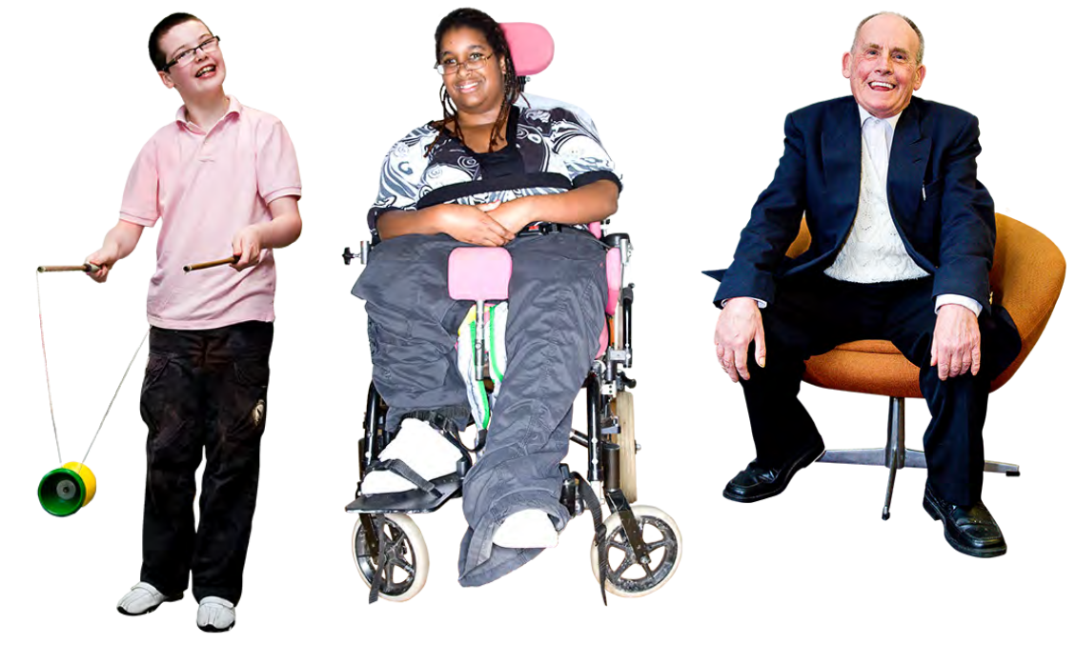
Introduction

Our plan is to improve life for autistic people in Surrey.

1,165 local people helped with the plan. They told us about what is important to them. They were:

- autistic people
- families of autistic people

- professionals

Many organisations are working together to make the plan happen:

- Surrey County Council
- The NHS

- Schools

- Community groups

2

Autism

12,300 people in Surrey have autism. Autism affects everyone in different ways.

Other names for autism are:

- Autistic spectrum disorder
- ASD

- Asperger syndrome

Autism affects communication and how people understand the world.

Many people with autism also have mental health conditions, dyslexia or epilepsy.

3

Our Plan

There are 7 topics that we are focusing on. There is a plan for each one:

- My Voice
We listen to peoples views

- Autism awareness Inclusion and understanding

- An active life

Information and support

- Education and transition Learning and moving on

- Health and social care Diagnosis and support

- Somewhere to live Housing and independence

- Employment

A range of job opportunities

4

My Voice

We want autistic people and their families to help us design services.

We will start a Children’s Autism Partnership Board. We will involve more people in the Adults Autism Partnership Board.

We will start 2 Reference Groups for autistic people and families. They will make sure that this plan happens.

We will make sure that experts by experience are involved in all of our work.

5

Autism awareness

We want everyone to understand autism. This will help autistic people to feel welcome and included.

We will give training to:

- Community services staff

- Health and social care staff

•

•

Family carers

Autistic people

6

An active life

People need information and advice about being active.

This will help autistic people and their families to get the support they need.

We will look at all the information which is available now.

There will be a single place where people can find all the information they need.

We will make information accessible for people who do not use computers or smart phones.

7

Education and
transition

We want all children and young people to go to school in their local community.

We want autistic children to get help as soon as possible. Schools and other services will work together to do this.

We want young people to be as independent as possible when they are adults.

Young people will get help to plan for when they leave school.

8

Some children and young people need an education, health and care (EHC) assessment.

We want all children who need an EHC assessment to have one.

School staff will get the training and support they need.

The training will help schools to support autistic children and young people.

9

Health & social care

Diagnosis

We want people to find out whether they have autism, at the right time for them.

We will find out when this is not happening, and improve the way people get diagnosed.

We want everyone to get the support they need to live a good life.

We will help people to get the support they need, close to home.

10

Mental Health

We want autistic people to have good mental health.

If people do not have good mental health, we want them to be able to get help.

The training on page 6 of this plan will help to support people’s mental health.

We will support autistic people to be involved in decisions about their care and support.

We will make sure that mental health services are accessible for autistic people.

11

Communities

We want all autistic people to live a fulfilling life in their local community.

We will promote Autism Friendly Communities.

Health

Autistic people must get the health care they need.

Hospitals, GPs and dentists need to make reasonable adjustments.

For example:

- quiet waiting rooms
- easy read information

- longer appointments

12

Health and social care

Health and social care staff give people assessments.

Assessments help them to decide how much support the person needs.

Staff who do assessments must understand autism.

Health and social care staff will get better autism training.

Health and social care teams will notice people’s strengths, as well as their needs.

13

Developing services

Sometimes people need more support than their family or community can give them.

They may need:

- day services
- residential care

- short breaks

- employment support

We will look at all the services in Surrey, to find out if there are people who cannot get good services.

We will work with people who run services to improve what is on offer.

14

Police, courts and prisons

We want the police, courts and prisons to:

- understand autism
- make reasonable adjustments

For example:

If an autistic person is in police custody and needs support, the police must call an Appropriate Adult.

We will improve the training that police already get.

Organisations will work together. They will support autistic people who are at risk of breaking the law.

15

Somewhere to live

Housing and support must be accessible for autistic people.

For example, new buildings could have:

- a simple layout
- calm lighting

- strong doors and walls, and be easy to maintain

We will make sure that all staff have the knowledge and skills to support autistic people. For example:

- Support staff
- Council staff

16

Employment

Young people need to learn the right skills to get a job.

We want more jobs for autistic people in Surrey.

We will do this by:

- encouraging the Council and NHS to employ autistic people

- talking to employers

- talking to organisations who support people at work

- finding out how many autistic people have jobs

- talking to the Department of Work and Pensions

17

Useful Links

Adult Autism Partnership Board Website

www.surreypb.org.uk/ surrey-autism-partnership-board.hml

This is an easy read version of a bigger plan. You can see the big plan on this website.

www.surreysays.co.uk

Tell us what you think of this plan

Email: ldcommunications@ surreycc.gov.uk

18

