A consultation on changes to Community Youth Work in Guildford
From 29th June until 4th September 2015

We are making changes to the Community Youth Work Service in Guildford. We want to find out what you think about our plans and your ideas of how we can do things better.

What is the Community Youth Work Service?
- The Community Youth Work Service (CYWS) helps young people to be more employable by building their resilience, developing their skills and improving their wellbeing through youth work.
- Youth work is often delivered from youth centres, but youth workers also work in the places where young people meet, for example in local parks. In Guildford, the youth centres are The Discovery Centre and Ash Youth Centre. Youth work is also delivered in Stoughton and Bellfields.
- Youth work is a way of working with young people that is voluntary (young people choose to get involved) and helps them to develop their skills, knowledge and confidence so that they can reach their goals.
- Young people are encouraged to plan and run activities and their youth centres with the youth workers.
- It is available to all young people, especially young people who need support the most.
- The Service will run a range of activities for young people including group projects, one to one support and open access (drop ins). Young people who need extra support will be able to receive Early Help.
- The service will work in partnership with other organisations to provide more activities for young people.

What do young people get out of being involved?
- Young people gain the skills and attitudes they need to join the workforce e.g. communication, working with other people, leadership and other practical skills
- Young people are more resilient (they have physical, emotional and social wellbeing which means they can bounce back when things are hard)
- Young people are safer in their communities
- Young people can make informed decisions about their health, education, careers and the things they do in their free time and know where to get help if they need it.
- Young people are more active members of their communities, will have positive role models and be involved in making decisions about the things that are important to them.

Why do changes need to be made?
- We want to use the money we have for youth work to make the biggest difference to young people. In particular this means helping them to prepare for work and their adult life
- To do this we need to divide the money we have fairly between different parts of Surrey to make sure that the young people who need support the most get it
- There is less money available for Services for Young People overall. This means we need to find ways of delivering youth work that make the most of the money we have.

How have we decided how to make the changes?
- We have worked out what the issues are that affect young people and stop them from achieving their goals and where the young people live who need support the most. We have done this by looking at statistics and a range of information. We have also asked young people, youth workers, local councillors and other people who work in local communities. This has helped us to work out how to share the money out across Surrey. From April 2015 the amount of money given to each borough/ district depends on how many young people need the support. This is called the Resource Allocation System (RAS).

What changes are being made to the CYWS?
- We are not planning to close any youth centres
- Moving some of the youth work to new places:
For many years youth work has been run in the places where youth centres happen to have been built. Many of the youth centres are in the right places. Some of them are not. The plan is to move some of the youth work to the places where the young people who need it the most live. This would mean that some youth centres would run fewer activities for young people than they do now, whilst other communities would get more.
- Involving other people in our work:
We would like to get other people involved in running projects and activities for young people so that more of them can benefit. We think that there should be 4 different ways of running our services in each borough or district. The SCC (Surrey County Council) Hub would be where most of the youth workers paid for by the CYWS would work and it would be in the place where most young people who need youth work live. The SCC Spoke would be where some CYWS staff are based. The Partnership Spoke would be run with a community group or organisation from the Voluntary, Community and Faith Sector (VCFS) so staff from the CYWS and the other organisation would work there. In areas of lower need where we have a youth centre, we hope to work with VCFS to continue to deliver from the centre.

As a result of the needs assessment and consultation we have done with young people, the local Youth Task Group and other people who work in Guildford, we think the Community Youth Work Service should work most in:
- Park Barn
- North Guildford (Westborough, Worplesdon, Stoke and Stoughton)
- Ash
We think that the most important issues for young people in Guildford are:
- Some young people are living in poverty. Parts of Westborough, Stoke, Ash Wharf and Worplesdon are amongst the most deprived areas for children in Surrey.
- Young people are at risk of not going into education, employment or training when they leave school at the end of year 11 (especially if they live in Stoke, Westborough, Ash Wharf and Worplesdon)
- Health issues, particularly smoking, sexual health, alcohol and weight management
- Offending and anti-social behaviour is an issue in some places (especially in Stoke, Holy Trinity, Ash South and Tongham, Friary and St Nicolas, Worplesdon, Stoke and Wesborough)
- There is a link between deprivation, school attendance and achievement and fixed term exclusions from school in Guildford
- Young people across the borough are currently supported by Children’s Services through Child Protection Plans, as Child in Need or are Looked After Children. Westborough, Stoke, Worplesdon and Stoughton have the highest number of young people supported in this way.
- Feedback from young people, partners and staff have demonstrated a clear need to provide support for young people with protected characteristics including young people who have special educational needs and disabilities, young carers and young people who are LGBTQ.

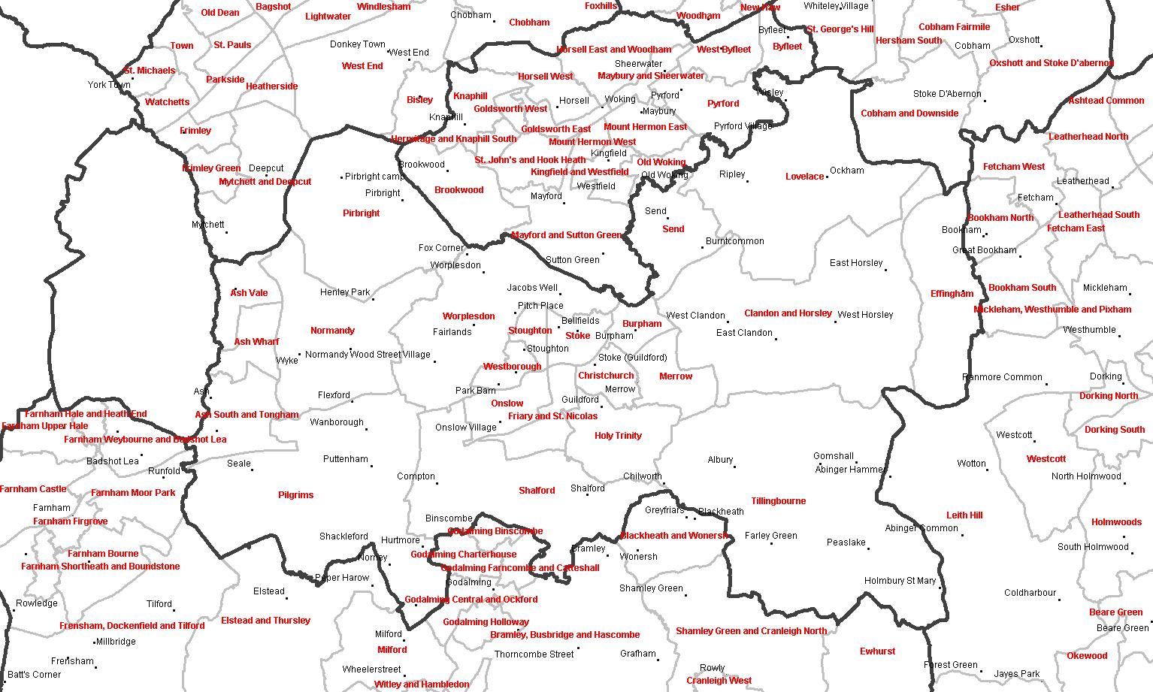
Ash
This is a SCC Spoke because...
- High level of young people who require support around employability, healthy lifestyle and offending behaviour
- 3rd highest most deprived area in Guildford
- In 2014/15, there were 34 children’s services referrals
Park Barn (in Westborough, part of North Guildford)
This is because...
- Westborough has the highest level of deprivation in Guildford, 3rd in Surrey
- High levels of young people requiring support around employability, healthy lifestyles and offending behaviour
- In 2014/15, there were 54 children's services referrals
North Guildford (Westborough, Worplesdon, Stoke and Stoughton)- SCC HUB. This is because...
- Stoke is the 2nd highest most deprived ward in Guildford
- Stoke has high levels of young people requiring support around employability and offending behaviour
- In Stoke there were 35 children’s services referrals in 2014/15
- Worplesdon has a high level of young people who require support around employability and offending behaviour
- In Worplesdon during 2014/15, there were 34 children’s services referrals
The table below shows what we ran for young people in Guildford during 2014-15:
 | 1.4.14 – 31.3.15
Area | What we did | Hours of delivery (per week)
Discovery Centre | Enterprise – LDD group | 3
 | Mercury – Arts group | 3
 | Nexus – LDD group | 3
 | Halo – LDD group (every 2 weeks) | 3
 | St Pauls Confidence group – year 7 | 2
 | St Pauls Confidence group – year 8 | 2
 | Babysitting course | n/a
Bellfields | Open access session (drop in) | 3
Stoughton | Open access session (drop-in) | 3
Ash | Open access session - GRT (drop in) | 3
 | Open access session - year 10 (drop in) | 3
 | Open access session - year 7-8 (drop in) | 3
Borough wide | Provision for young people who are LGBTQ | 3

For 2015-16, we think that the hours of youth work we have should be divided up like this:

 | 1.4.15 – 31.3.16
Area | Hours of SCC Delivery (per week) | Type of activity and what it will do
North Guildford: Stoke, Stoughton, Worplesdon | 6 | Open access: Young people need a safe space to engage with youth work. Offer young people new and exciting opportunities through generic activities. Offer young people social and personal development and support their learning in relation to this, Raise young people’s aspirations and increase their employability.
 | 6 | Targeted provision: Young women and young men nee targeted provision in single sex groups to support responses to health and emotional well-being needs including sexual health, personal hygiene, emotional health, smoking and behaviour.  Targeted provision12 week employability programme looking at the specific needs of young people and what is needed to become employable
Park Barn | 6 | Open Access: Young people need a safe space to engage with youth work. Offer young people new and exciting opportunities through generic activities. Offer young people social and personal development and support their learning in relation to this, Raise young people’s aspirations and increase their employability.
 | 6 | Targeted provision: Young women and young men nee targeted provision in single sex groups to support responses to health and emotional well-being needs including sexual health, personal hygiene, emotional health, smoking and behaviour.
 | 6 | Detached work to meet the needs in North Guildford and target specific places when needed
Ash Vale, Ash Wharf and Ash South and Tongham | 6 | Open access: Offer young people new and exciting opportunities through generic activities. Offer young people social and personal development and support their learning in relation to this, Raise young people’s aspirations and increase their employability
 | 3 | Targeted provision12 week employability programme looking at the specific needs of young people and what is needed to become employable
 | 3 | Targeted work to enable young people to understand a range of cultures to improve relationships within the community
Borough wide | 3 | Targeted provision for young people who are LGBTQ,
 | 3 | Targeted provision for young people who are young carers or a targeted provision for young people who have a special educational need
 | 6 | Targeted provision focussing on health
 | 6 | Detached work to meet the needs in more rural areas or target specific places when needed
 | 9 | One to one support: individual young people will e supported to look at things that area affecting them. This will be part of the Early Help offer.
What do you think of our plans?
Please let us know by answering these questions by 4th September 2015:
- Do you think we should put youth workers in the areas where they are needed the most?
Yes No
- Do you think we have chosen the right places where youth work would make the most difference to young people?
Yes No
Please tell us why you agree or not.

- Have we missed any communities that you think we should be looking at?

- The table below shows how many hours we plan to deliver in each community by youth workers paid by Surrey County Council. If you think we should do this differently, please tell us how. Remember that if more hours are put in one area, there will need to be less somewhere else.
 | We think  (hours per week) | You think  (hours per week)
North Guildford:  Westborough, Stoke, Stoughton, Worplesdon | 12
Park Barn | 18
Ash Vale, Ash Wharf and Ash South and Tongham | 12
Borough-wide | 27
Total | 69

- If you think we should do different things to meet the needs of young people in Guildford, please tell us.
 | 1.4.15 – 31.3.16
Area | Type of activity and what it will do
North Guildford:
Stoke, Stoughton, Worplesdon
Park Barn
Ash Vale, Ash Wharf and Ash South and Tongham
Borough wide

- Please tell us why you think this will be better for young people in Guildford

- Do you think we have worked out the biggest issues that are affecting young people in Guildford?
Yes No
If no, please tell us what you think the biggest issues are:

- Is there anything else you would like to say about our plans?

If you would like to get involved in the CYWS? If so, please give us your contact details here:
Name:
Email:

What are the next steps?
- There will be public meetings when there will be a presentation about the plans described in this here. You are welcome to come and share your thoughts with the team. They will be on:
- 22nd July in Park Barn
- 29th July at the Discovery Centre
- 12th August in Ash
- The CYWS will work with young people during the consultation period to make sure their voices are heard and in particular, centre steering groups will be involved.
- The consultation in Guildford finishes on 4th September 2015. All of the feedback will be looked at and put into a report with ideas of how our plans may need to change.
- The Local Committee will look at the report in September 2015 to help it make a decision about how we will use the money and staffing we have in the borough/ district
- We will put the report and the final decisions onto www.surreysays.co.uk by 31st October 2015.
If you would like to talk to someone about the plans for the CYWS, please contact:
Katie Gardner, Senior Practitioner for Guildford: katie.gardner@surreycc.gov.uk

