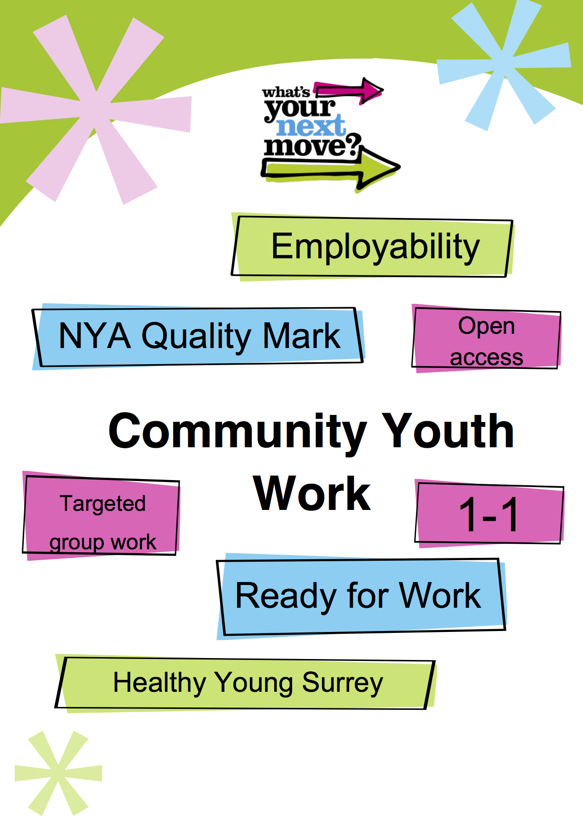
Spelthorne
Youth Work Needs Assessment
Area Overview
Spelthorne is in the North East of Surrey with a population of 97,456. Children and Young People make up 28.1% of the population with 10.7% of those aged 10-19yr (please refer to appendix B).
Spelthorne is close to the M25, M3, M4 and Heathrow Airport. With multiple routes into London and surrounding areas and the expansion of Heathrow it is a prime location for commuters and businesses. Staines upon Thames is ever increasing its capacity for business with multiple new offices builds. Spelthorne has the highest proportion in Surrey of Lower Super Output Areas (LSOAs) in the most deprived half of England at 10.3% of its population. Spelthorne also has the largest percentage of its children living in low income housing than any other borough in Surrey at 17.1%.
Within Spelthorne there are specific wards and LSOAs that are of the highest need and are subsequently the areas that the Community Youth Work Service will targeted, these are Specifically Ashford North and Stanwell South, Sunbury Common and Staines South. However, it is clear throughout the data analysis that there are other LSOA’s with specific needs although the ward as a whole is not in the top three.

Community Youth Work Aims and Objectives.
In September 2014, Surrey County Council’s Cabinet approved Services for Young People’s youth work commissioning model for 2015-2020 to deliver the strategic goal of employability for all young people in Surrey. A person’s health is influenced by the conditions in which they live. Social and economic conditions including low income, social exclusion, unemployment and poor housing have repeatedly shown to influence health and length of life. By targeting support for young people towards employability we are working towards helping the health and wellbeing of the people living within the community. To deliver this goal, the Community Youth Work Service (CYWS) will target areas where there is the greatest risk of young people not making a successful transition into employability.

For the last 3 years, the Centre-Based Youth Work contract has operated a “one size fits all” policy with regards to the division of resources in each area. This meant that all Surrey County Council owned youth centres received the same amount of provision both in staffing and in running costs irrespective of the need in that area.
The service has now adopted a needs based model that directs resources according to need. This need has been identified through the analysis of data relating to youth crime, NEET figures, Risk of NEET Indicators (RONI), health indicators, deprivation, Population and ethnicity and children and young people known to children’s services. This may mean that youth work is not always delivered from centres but may be a LA wide offer dependent on need. This will be achieved primarily through open access youth work with a further commitment to address early intervention, Healthy Young Surrey, Ready for Work and NEET prevention.
The new service will work through a ‘Hub and spoke’ approach. The purpose of this model is that there will be a hub of need where the SCC offer will be greater than other areas and the focus of resources will be delivered in this/these areas. There will also be areas where partnership work with other youth providers will be possible, working towards a joined up, holistic approach to address the needs of young people, potentially reducing the level of CYWS resource, yet still providing services to young people. The third spoke is a community offer where support will be offered to the community to take ownership of the needs, again supported through SCC in the form of equipment, training or premises.

The CYWS model offers a more flexible approach to delivery and by moving away from the centre-based model, gives greater freedom to work where the need is.
Current contextual Information

There are 5 SCC Youth Centres in Spelthorne, these are: Stanwell Youth Centre based in Ashford North Stanwell South ward, Sunbury Youth Centre based in Sunbury Cross ward, Ashford Youth Centre based in Ashford Town ward, Leacroft Youth Centre based in Staines South ward and Shepperton Youth Centre based in Shepperton Town ward. (Refer to appendix B for map). These centres offer a variety of targeted and open access sessions throughout the week.
In 2014/2015 each of these centres had a weekly allocation of a 37hr FT Centre Based Youth Worker (CBYW) post and 37 FTE hours for Leaders in Charge (LiC) and Assistant youth workers (AYW). This equated to 185 CBYW hrs and 185 Part time hrs.
The New models staffing allocation for 2015/2016 is 37hrs Senior Practitioner, 111hrs Community Youth Worker (CYW), 60hrs LiC and 99 hrs AYW. This totals to 148 FT hrs and 159 PT hrs. This is a slight reduction in hours and a table identifying the financial implications for this can be found in the appendix (C).

Summary of Key findings for Spelthorne Borough
- Spelthorne has a higher percentage of young people in the population that are NEET than any other borough or district in Surrey.
  - The wards of Staines South, Sunbury Common and Ashford North and Stanwell South have the highest numbers of NEET.
- Spelthorne has the highest proportion of children and Young People living in low-income houses in Surrey.
- Spelthorne is one of the highest numbers of young people who are open to Children’s Services in Surrey.
  - The wards of Ashford North and Stanwell South and Staines South have the highest numbers of Children in Need (CiN).
  - The wards of Sunbury Common, Ashford North and Stanwell South and Stanwell North have the highest number of Looked After Children (LAC).
  - 25% of all children and Young People on a Child Protection (CP) Plan in Spelthorne live in Sunbury Common.
- Spelthorne has the highest proportion of young people who are undertaking a Youth Restorative Intervention (YRI) in Surrey.
  - The highest levels of Crime associated with young people are recorded in the areas of Stanwell, Staines Town and Sunbury.
- Spelthorne has the highest number of teenage conception rates in Surrey and the lowest proportion of these leading to termination.
- Spelthorne has the highest number of adult hospital admissions for alcohol related illnesses than any other LA in Surrey.
- Spelthorne has the highest proportion of the population that are Indian, Chinese and ‘other’ Asian.

Needs assessment for the Borough
EMPLOYABILITY
Over the last 5 years, at any one time in Surrey, there have been between 800-1000 NEET young people aged 16-19 and the same amount in Jobs Without Training (JWT) where young people do not have the opportunity to develop their skills for the future. Employability is the key goal of the new Community Youth Work model. Supporting young people to gain the skills, confidence, aspiration and opportunities to enter into the workforce will be at the heart of what we do. There are a number of factors that impact on young people’s employability from both a personal and socio-economic perspective, and there are groups that are over represented within the NEET cohort such as Learners with Learning Difficulties and Disabilities (LLDD), Young Offenders and Young People who are Looked After or Care Leavers. As well as seeking to support those that are NEET to secure employment the new service will be focusing on early intervention with young people who are at risk of becoming NEET or RONI.
Below is a table that identifies the levels of NEET and RONI young people by ward across Spelthorne.

Spelthorne has a significantly higher percentage of young people who are NEET than any other borough or district in Surrey with 4.3% of the 16-19 age group, the next highest LA is 3.2%.

From the data we can see that Staines South has the most NEET young people whilst Staines seems to have a far greater number of young people who are NEET than there is RONI, identifying that the high levels of NEET do not correlate with the risk indicators in this area and this will need some further investigation and specific targeted work.

It is also worthy to note that although Laleham and Shepperton ward is in the middle it does contain the second highest number of NEET within a LSOA. Similarly Ashford North and Stanwell South contains the LSOA with the highest number of RONI at 40% of the wards total figure.

Spelthorne has one of the highest proportions of young people with Special Educational Needs and Disabilities (SEND) at 2.5%. Of this the most significant diagnoses are Behavioral Emotional and Social Difficulties (BESD) and Moderate Learning Difficulties (MLD). This is particularly high within the Ashford/Stanwell area

DEPRIVATION

Levels of deprivation can have a significant impact on the proportions of young people who are NEET. Spelthorne has the highest number of LSOAs in the most deprived areas with 10.3% of the population living in the most deprived quintiles. Spelthorne also has the highest number of young people living in low income housing in Surrey at 17.1%. In addition to this around 11% of all children and young people aged 0-18 live in households with out of work benefit claimants. This has a further impact on RONI figures as it can suggest a risk of a generational unemployment trend.

CHILD PROTECTION /SAFEGUARDING

Young people who are open to children’s services are not only some of the most vulnerable in Surrey but this increases their risk of becoming NEET. This is due to an increased risk of poor attachments and subsequently mental health and wellbeing concerns, specifically low self esteem, confidence and low aspirations. Spelthorne has significantly high numbers of young people open to children’s services and is around second highest in Surrey in terms of percentage of the population.

There are 80 Children in Need (CIN) in Spelthorne. Ashford North and Stanwell South and Staines South have the highest proportion of CIN with 15% of the total figure, next is Sunbury Common at 14%.

There are 36 children and Young people in Spelthorne who are Looked After Children (LAC). The highest proportion of these is in Sunbury Common with 19% of the total figure. Next is Ashford North and Stanwell South with 17% then Stanwell North at 11%.

There are 36 children and young people on a child protection plan in Spelthorne. The most significant of these is Sunbury Common with 25% of the total figure. Ashford North and Stanwell South have 17%, whilst Riverside and Laleham has 14%.

Throughout Spelthorne there are 201 Children and Young people who have other Children’s services referrals. 12%of these are in Ashford North and Stanwell South, 11% in Stanwell North and 10% in Halliford and Sunbury with.

In addition to this there will be young people who are adopted in the LA that will also experience the risk factors mentioned above.

CRIME AND YOUTH JUSTICE

Youth Restorative Intervention (YRI) is a pre court disposal that seeks to reduce the number of young people who have a criminal record and has been proven to reduce reoffending in Surrey by 18%. The notion that the number of YRIs in Spelthorne is so high is positive in terms of supporting at risk young people rather than criminalising them, leading to higher needs and risk taking/offending behavior. It also supports the employability objective for young people in the county by ensuring that a criminal record does not impeded them when seeking employment.
The table in appendix D identifies the prevalence of crimes across Spelthorne that are associated with Young people such as Anti Social Behavior, Violence and Sexual offences, Criminal Damage and Arson, Drugs and possession of a weapon. It needs to be considered that these are all crimes and are not wholly relating to those of young people.
The data shows that the areas most affected by crime are Stanwell, Staines Town, Sunbury and Ashford. Drug related crime is specifically high within Sunbury whilst Ashford and Staines Town show the largest amount of crimes involving weapons
In 2014/15, 21 young people were subject to a judicial order. This is 9% of all those given to young people across Surrey. In addition to this there were 64 young people recorded undertaking an YRI in Spelthorne. This is 11% of all YRIs in Surrey but based on population percentages identifies Spelthorne as the highest within the county.

HEALTH

The health of Young people has an impact on employability as this can make it harder to attend or achieve education limiting the opportunities available to them within the workforce. Teenage pregnancy, mental health and wellbeing and physical and learning disabilities all impact on NEET figures.

There were 46 conceptions in 2013 within female’s aged 15-17 in Spelthorne. This is the highest in Surrey at 29.5% of young females per 1000. Positively, there has been a consistent reduction in the number of conceptions over the period from 2011-2013 but the figure still remains higher than the national average of 24.5 and significantly higher than the surrey average of 15.7.

Of these conceptions 60.9% have lead to an abortion, which is higher than the national average of 50.7% but lower than the Surrey average of 64.1%. This means that Spelthorne has the highest number of teenage parents aged between 15-18yrs.

It is also worthy to note that there has been an increase within Surrey of Fixed Term Exclusions due to sexual misconduct. This increase in sexualized behaviour by young people could be due to a number of reasons but it is weighty to consider the rise in access to pornography on the Internet.

Admissions to hospital for alcohol related issues for young people under 18 was low in Spelthorne, which was really positive however, Spelthorne is the second highest in Surrey for alcohol related admissions for all age groups. Of this the admissions for Males was almost double that of Females. This could have an impact on young people in relation to caring for parents or family members who have alcohol related health problems.

There is no specific ward data for under 18s involved in drug rehabilitation programs however, Adult services are able to map drug treatment more easily across the county. Spelthorne has a high percentage of those in treatment within the ward of Ashford North and Stanwell South, having between 28-49 people within treatment for substance misuse. This is likely to be reflected within the number of under 18 cases due to the socio economic factors within this community. If we compare this to the crime statistics (appendix D) drug related crime was most prevalent in Staines South, Ashford and Sunbury.

Smoking rates within Spelthorne are in line with the Surrey average with 2.9% of all 11-15yrs and 13.3% of 16-17yrs.

Spelthorne has the highest number of 5-15yrs with mental Health disorders at 8.6%. This is significantly higher than the Surrey average of 7.1%. Stanwell south, Ashford West, Sunbury Common and Halliford and Sunbury West are all in the top 10 wards with the highest proportion of children with mental health disorders in Surrey. The most at risk factors for mental health are Deprivation, learning disabilities, marginalized groups and having parents who suffer from mental health difficulties.

Obesity within Spelthorne is a significant issue within children and young people. Data from 2011/12 shows that Spelthorne’s percentages of obesity amongst year 6 children at 17.6%, is far greater than any other borough or district. Data relating to children and young people that are overweight in reception 14.4% and yr. 6, 17.7% is also greatest in Spelthorne.

POPULATION AND ETHNICITY

Surrey has a predominantly white British population however, there are particular areas that are much more diverse. Spelthorne is one of these and has higher percentages of the population from mixed ethnic backgrounds than many other boroughs and districts. This can have an impact on the employability of young people, as there may be higher proportions who speak English as a Second Language. This is a specific barrier to participation and limits people building social capital.

It is predominantly Asian people that make up the higher percentages of Ethnic minorities in Spelthorne and there are specific pockets in the borough where the numbers are higher. The main areas are Ashford Town, Halliford and Sunbury, Sunbury East and Sunbury Common. Spelthorne has the highest percentage of people from Indian, Chinese and other Asian backgrounds.

In addition to this it is also important to consider the percentages of the population that are from Gypsy, Roma and Traveller (GRT) communities as this is a very segregated group and one that faces much Stigma and isolation. In Spelthorne they make up 0.2% of the population. This equates to 192 people and is equal to most of Surrey. Ashford town, Ashford common, Sunbury East and Shepperton Town have the highest levels of population. In addition to this Staines is a very popular meeting place, specifically on Sundays for young people from the GRT communities across the County.

Proposed response to need

In order to determine how to apply the Hub and Spoke model to the Borough of Spelthorne the needs and the prevalence of these within the different wards must be considered. Below is a graph that identifies the needs across the Borough.

It is clear that the wards of Ashford North and Stanwell South and Sunbury common are the highest need areas with Staines South following next. Subsequently Stanwell youth centre will be the Hub with Sunbury Common as a well-represented SCC spoke. Staines South and Ashford also feature highly in terms of needs therefore Leacroft and Ashford youth centres will be developed as Partnership models. Although the need in Shepperton is far less than the other wards there are still prevalence of certain issues and thus will also be identified as a Partnership spoke but will have less hours allocated to it than the other youth centres.
 | 04/2014 - 03/2015 Centre Based Youth Work |  | 04/2015 - 03/2016 Community Youth Work Service
Area | Session Type | Hours per week | Hours per week | Session Type | Need
Stanwell | Project work | 3 | 3 | Open access jrs | CYWS curriculum
 | Enterprise (SEND) | 3 | 3 | Open access sen | CYWS curriculum
 | Teenage parents | 3 | 3 | Teenage Parents | Teenage parents
 | Open access | 3 | 3 | SEND | SEND LA offer
 | Single Sex targeted work | 3 | 4 | 16-24 drop in Daytime | SEND/employability/  health and wellbeing
 |  |  | 2 | Early Help/1-1/ | Targeted support early intervention
Sunbury | Inters Open Access | 3 | 3 | Open access jrs | CYWS curriculum
 | Open Access | 3 | 3 | Open access sen | CYWS curriculum
 | Targeted Work | 3 | 3 | Targeted work | Group work specific need
 |  |  | 3 | LAC/Young Carers | LA offer/ employability
 |  |  | 0.75 | Youth Council borough wide | Youth participation
Leacroft/Staines South | Yr. 7 Open Access | 3 | 3 | Open access jrs | CYWS curriculum
 | Yr. 8/9 Open Access | 3 | 3 | Open access sen | CYWS curriculum
 | Yr10/11 Open Access | 3 | 3 | Youth enterprise | Employability/  Community
 |  |  | 3 | 16-24 drop in Daytime | SEND/employability/  health and wellbeing
Ashford | After School yr7 | 3 | 3 | Open access jrs | CYWS curriculum
 | 1-1 work | 3 | 3 | Open access sen | CYWS curriculum
 | After School yr6 | 3 | 3 | Targeted /1-1 | Group work specific need
 | Targeted | 3
 | After School yr7 | 3
 | Open Access | 3
 | Family Support | 3
Shepperton | Inters Open Access | 3 | 3 | Open access jrs | CYWS curriculum
 | Open Access | 3 | 3 | Open access sen | CYWS curriculum
 | Community Work | 3
 | Targeted Work | 3

In addition to these there will be borough wide holiday projects and residential opportunities.

APPENDIX

A. Spelthorne Population
Total Spelthorne Population | 97456
Age | Total | % Of population
0-4 yrs. | 6265 | 6.4
5-9yrs | 5652 | 5.8
10-14yrs | 5010 | 5.1
15-19yrs | 5402 | 5.5
20-24yrs | 5084 | 5.2
Total | 27413 | 28.1
Total to work with | 10412 | 10.7

B. Geographical map of SCC Youth Centres in Spelthorne
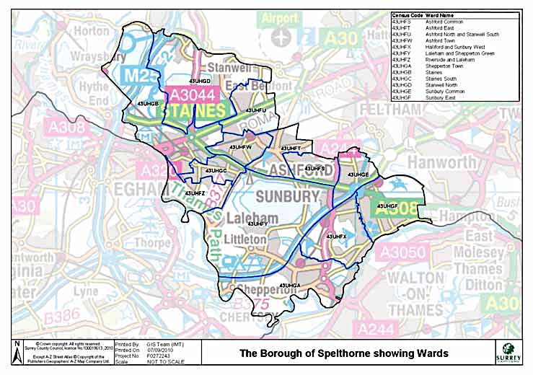
SHEPPERTON YC
SUNBURY YC
ASHFORD YC
LEACROFT YC
STANWELL YC

C. Impact of Funding changes and proposed new Resource allocation.

 | 14/15 Budget | 15/16 Budget | Difference | Total Projected Spend | Variation | SP & Y&CW | F/T Difference* | Total NYW | SP/Y&CW/NYW hrs | WiC HRS | WiC Difference* | AYW HRS | AYW Difference*
Spelthorne | £309,326 | £264,637 | £44,689 | £264,162 | £475 | 4 | -1 | 0 | 148 | 60 | 0 | 99 | 0.6

D. Table of crimes and their locations in Spelthorne
 |  | ANTI-SOCIAL BEHAVIOUR | VIOLENCE AND SEXUAL OFFENCE | CRIMINAL DAMAGE AND ARSON | DRUGS | POSESSION OF A WEAPON | MOST SIGNIFICANT AREAS
STANWELL | MARCH | 64 | 22 | 11 | 4 | 1 | HADRIAN WAY | HOLLYWELL WAY | TESCO | VISCOUNT ROAD | DOUGLAS ROAD
 | FEB | 47 | 10 | 18 | 3 | 1 | HADRIAN WAY | HOLLYWELL WAY | TESCO | MULBERRY ROAD
 | JAN | 56 | 17 | 16 | 4 |  | DOUGLAS ROAD | ST MARYS CRESCENT | TESCO
STAINES TOWN | MARCH | 58 | 14 | 12 | 10 | 3 | BUS/COACH STATION | POLICE STATION | SHOPPING CENTRE | STATION | WAITROSE
 | FEB | 39 | 20 | 12 | 6 |  | BRIDGE STREET SUBWAY | POLICE STATION | SHOPPING AREA | STATION | WAITROSE | WRAYSBURY GARDENS | STATION APPROACH
 | JAN | 25 | 12 | 6 | 6 |  | BUS STATION | POLICE STATION | SHOPPING AREA | STATION | WAITROSE
STAINES URBAN | MARCH | 35 | 20 | 9 | 1 |  | DUNCAN GARDENS | THICKTHORNE LANE
 | FEB | 23 | 18 | 6 | 2 |  | DUNCAN GARDENS | KENT CLOSE
 | JAN | 27 | 16 | 6 | 2 |  | DUNCAN GARDENS | MATTHEW ARNOLD CLOSE
ASHFORD | MARCH | 57 | 34 | 20 | 4 | 1 | MORETAIN ROAD | CHURCH ROAD | CONVENT ROAD | LONDON ROAD
 | FEB | 53 | 26 | 14 | 8 | 1 | MORETAIN ROAD | CHESTERFIELD ROAD | ANGLESEY CLOSE | LONDON ROAD
 | JAN | 59 | 19 | 12 | 7 | 1
SHEPPERTON AND LALEHAM | MARCH | 8 | 8 | 3 |  |  | PENTLAND AVENUE
 | FEB | 9 | 5 | 2
 | JAN | 10 | 3 | 1
SHEPPERTON AND HALLIFORD | MARCH | 23 | 6 | 5 | 6 |  | CHURCH ROAD
 | FEB | 20 | 6 | 1 | 1 | 1
 | JAN | 12 | 12 | 7 | 2
SUNBURY | MARCH | 65 | 21 | 12 | 9 |  | PARK BY TESCO | SHOPPING AREA | THE PARADE | CROSSWAYS
 | FEB | 51 | 22 | 10 | 7 |  | PARK BY TESCO | SHOPPING AREA | THE PARADE | CROSSWAYS
 | JAN | 46 | 16 | 13 | 11

Surrey i JSNA Population 2013
Surrey i JSNA Index of multiple deprivation 2010
Surrey i JSNA Index of multiple deprivation 2007
Surrey Young Peoples Skills and Employability paper
Surrey i JSNA chapter: special education needs and disabilities 16-25 needs assessment 2013
Surrey I JSNA Chapter CAMHS health needs assessment 2009

