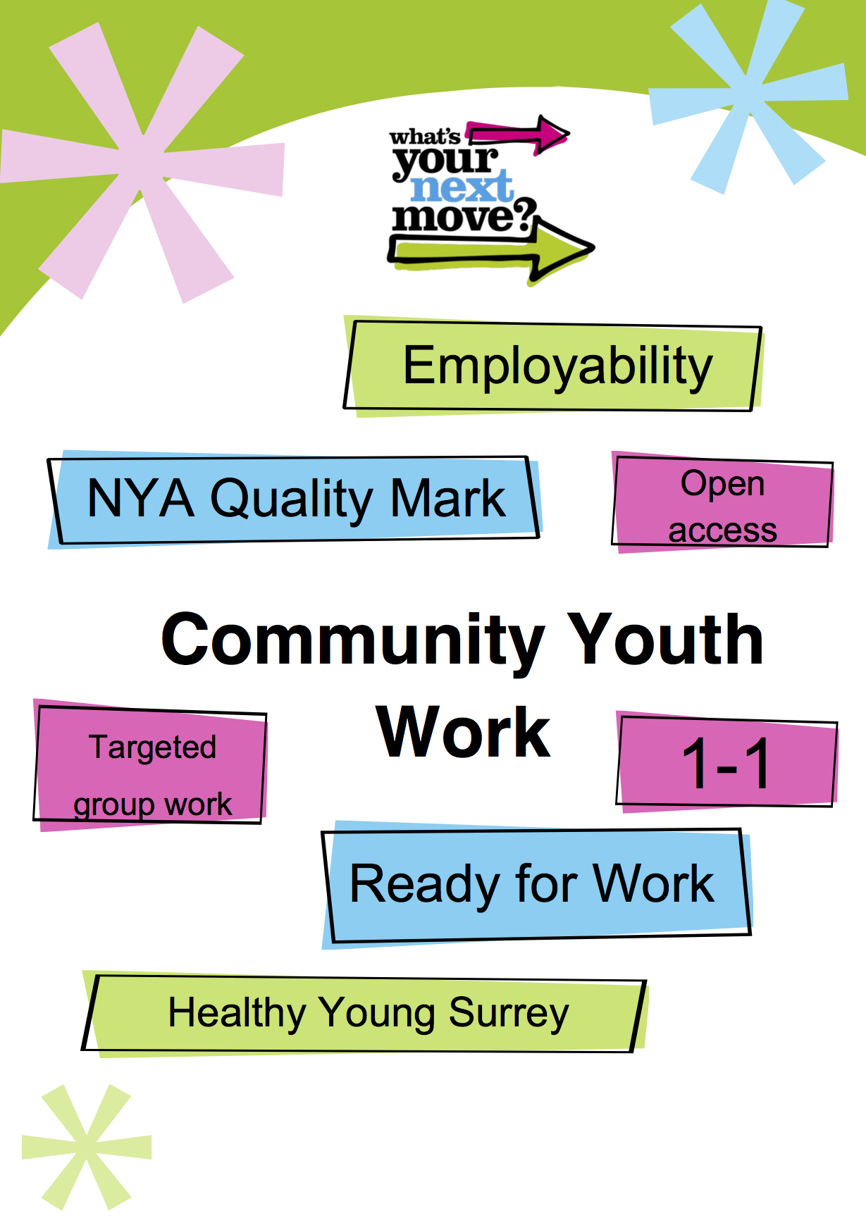
Tandridge
Youth Work Needs Assessment
Tandridge – Needs Assessment 2015
Area Overview
Tandridge district is located in the East of Surrey with a population of approximately 83,000 which includes an estimated 9,800¹ in the 10 – 19 year old age range. Almost 40% of Tandridge population is considered rural, this is the highest of any of Surrey’s districts. Geographically the district contains part of the North Downs and part of the Weald. The M25 runs through the district to the North providing commuter access to the county to the West and Kent to the East. The M23 runs southwards on the western edge of the district providing links to Gatwick airport and the South coast.
Community Youth Work- Aims and Objectives
In September 2014, Surrey County Council’s Cabinet approved Services for Young People’s youth work commissioning model for 2015-2020 to deliver the strategic goal of employability for all young people in Surrey. To achieve this goal, the Community Youth Work Service will target areas where there is the greatest risk of young people not making a successful transition into employability.
Historically Surrey Youth Services have operated with a “one size fits all” policy with regards to the division of resources in each district/borough. This meant that all Surrey County Council owned youth centres received the same amount of provision both in staffing and in running costs irrespective of the need in that area.
The service has now adopted a needs based model that directs resources according to need. This need has been obtained through the analysis of data relating to youth crime, NEET figures, Risk of NEET Indicators (RONI), health indicators, deprivation and transportation. Further information on need has been sought form local partners, stakeholders and young people.
This may mean that youth work is not always delivered from centres but may be a district/borough wide offer dependent on need. This will be achieved primarily through open access youth work with a further commitment to address early intervention, Healthy Young Surrey, Ready for Work and NEET prevention.
The new service will work through a ‘Hub and spoke’ approach. See diagram below:

The purpose of this model is that there will be a hub of need where the SCC offer will be greater than other areas and the focus of resources will be delivered in this/these areas. There will also be areas where partnership work with other youth providers will be possible and a joined up, holistic approach to the needs of young people will be delivered in partnership and therefore reduce the level of Community Youth Work Service resource. The third spoke is a community offer where support will be offered to the community to take ownership of the needs, again supported through SCC in the form of equipment, training or premises.
The Community Youth Work Service offers a more flexible approach to delivery and by moving away from the centre-based model gives greater freedom to work where the need is.
Current contextual Information
In 2014/15 the Centre-Based Youth Work (CBYW) model supported 2 Full-Time Youth Centres, these were Street YC and Harry’s YC. The CBYW contract provided a range of activities from open access provision to targeted work including work with travellers, LGBTQ, Duke of Edinburgh Award and Youth Achievement Awards.
The CBYW contract was supported by YMCA East Surrey, the managing agent for the CBYW contract in the district.
In 2014/15 Tandridge had an allocated budget of £123,730, for 2015/16 the applied Resource Allocation System (RAS) formulae meant an increase in the local budget of 4% against an overall reduction to the Community Youth Work Service total budget of 11% (£300,000). The service locally now includes allocated Senior Practitioner time, 1 FTE Neighbourhood Youth Worker and 1 Youth and Community Worker. Due to the service reorganisation and staff turnover we are currently recruiting the Neighbourhood Youth Worker at Street. The Youth and Community Worker based at Harry’s will also shortly be moving to a new location in Surrey, meaning we are also in the process of recruiting to this position. These staff are supported by 2.0 FTE part time hours which comprise a mix of Worker in Charge hours and Assistant Youth Worker hours. In 2015/16 the Community Youth Work Service will look to achieve 1680 hours delivery to young people.
The CYWS will develop its youth work model around Surrey’s Young People’s Outcomes Framework. Open Access provision will work with young people in developing its curriculum to ensure young people are resilient by improving their physical, emotional, mental and social wellbeing. Open Access and Targeted Interventions will work on reducing anti-social behaviour, reduce the impact of offending and improve young people’s safety in communities. Working in key areas, the CYWS team will work with young people that have been identified as NEET or at risk of becoming NEET (RONI) and others to assist young people overcoming barriers to employability. This will be achieved through the above delivery methods and through our early help offer linking with the Youth Support Service, Children’s Services and other services. The CYWS will also develop a range of employability programmes both in partnership with Youth Support Service and other providers utilising open access provision, workshops, short courses, training opportunities and potentially developing social enterprises. Through these mechanisms we will help young people make informed decisions and ensure they are active members of their communities and ensure employability for more young people.
Summary of Key Findings
- NEET & RONI data for 2014/15 shows a marked increase in comparison to available 2013/14 data. (Table 1.2)
- The needs analysis has identified Bletchingley and Nutfield, Godstone, Oxted South and Westway as the Wards where young people are at highest risk of not achieving employability.
- Caterham has the largest cluster of Wards where youth work interventions are needed

Needs Assessment
For the purpose of resource allocation I have conducted a needs assessment based on various data sets. I have concentrated on data which will give information that will assist in the delivery of outcomes aligned with the council’s current employability plan and Surrey Young People’s Outcomes Framework
The data sets used include Youth Justice YRI’s, NEET and risk of NEET indicators (RONI), LSOAs Areas of Deprivation, Households claiming out of work benefits, Children’s Service Referrals and 10 -19 Population. In identifying potential need, I have ranked wards, highlighting the top 10 in all of the above categories (Highest 1st). Wards have been classified as in High need of youth work interventions if scored in 5 or more sets; medium need if wards scored in 3 or more sets; low level need of youth work intervention if scored in less than 3 sets.
Table 1.1 (Risk factors for young people’s employability - analysis ward by ward)

Tandridge by Ward | BN | BHO | C | DF | F | G | H | L | LC | ONT | OS | P | QP | TT | V | WCF | WW | W | WH | WO
Youth Justice – YRI’s / SO’s |  | 1st |  |  |  | 2nd |  |  |  |  | 3rd = |  |  |  |  |  |  | 3rd = | 5th
NEET & RONI | 3rd = |  |  |  |  | 2nd |  |  |  |  | 1st | 6th |  |  | 5th |  |  | 3rd =
Children’s Service Referrals | 3rd | 2nd |  |  |  |  |  |  |  |  | 1st | 5th |  |  | 6th |  |  | 4th
Households claiming ‘out of work benefits’ | 4th |  |  |  |  | 1st |  |  |  |  | 2nd = |  |  |  | 2nd = |  |  | 5th
LSOAs Areas of Deprivation | 3rd & 5th |  |  |  |  | 2nd & 7th |  |  |  |  |  |  |  |  |  | 1st |  | 4th & 6th
Population  10 - 19 | 4th | 5th |  |  |  | 3rd | 7th |  |  | 2nd | 1st | 8th | 10th |  |  | 6th |  | 9th
 | High | Med | Low | Low | Low | High | Low | Low | Low | Low | High | Med | Low | Low | Med | Low | Low | High | Low | Low
Other factors not included in the data sets above include SEN information and key health statistics for the borough. The key factors here are that a higher proportion of young people who are NEET in Tandridge who have Specific Educational Needs or a disability according to 2013/14 data. ¹ Countywide health data for 11 to 17 year olds who regularly smoke rank Tandridge 5th overall.
Key to Wards (Table 1.1)
BN = Bletchingley and Nutfield
BHO = Burstow, Horne and Outwood
C = Chaldon
DF = Dormansland and Felcourt
F = Felbridge
G = Godstone
H = Harestone
L = Limpsfield
LC = Lingfield and Crowhurst
ONT = Oxted North and Tandridge
OS = Oxted South
P = Portley
QP = Queens Park
TT = Tatsfield and Titsey
V = Valley
WCF = Warlingham East and Chelsham and Farleigh
WW = Warlingham West
W = Westway
WH = Whyteleafe
WO = Woldingham

Employability
In looking at the data relating to employability I examined the following categories:
- The number of young people who are currently NEET²
- The number of young people who display Risk of NEET indicators(RONI)²
- Number of Children living in Out-of-work Benefit Claimant Households⁵

Godstone, Oxted South and Westway currently have the highest NEET count at 10 per ward. The highest recorded RONI figures are Oxted South (38), Godstone (32), Bletchingley and Nutfield (30) and Westway (24) Oxted South With regard to households with children claiming out of work benefits Godstone ranked 1st (100), Oxted South and Valley ranked joint 2nd with (85) each and Bletchingley and Nutfield 4th (80) The NEET and RONI data has given the clearest indication where young people may be at risk of not achieving employability outcomes. When looking at the data there was a clear cluster of wards/LSOAs that showed that when figures combined (Westway, Valley, Portley) showed the greatest area of need in Tandridge.

Crime
In looking at the data relating to crime I examined the following categories;

- Youth Justice – Youth Restorative Interventions & Substantive Outcomes count²

The figures used in table 1.1 (page 4) relate to 2014/15 data, however in looking at trends I have also looked at 2013 data in determining if there has been an increase or decrease in young people involved in the youth justice system. What is clear is that the numbers of young people involved in recorded crime is low in Tandridge as a whole. Data shows 54 young people with YRI’s / SO’s in 2013 compared with 53 in 2014/15 for Tandridge. The Wards with the highest number of YRI’s in 2014/15 is Burstow, Horne and Outwood (5) and Godstone (5), next was Westway with (4) YRI’s. The SO count was also the highest in Burstow, Horne and Outwood with (5)

Deprivation

In looking at the data relating to deprivation I examined the following categories:
- LSOAs areas of deprivation³
- Number of Children living in Out-of-work Benefit Claimant Households⁵
- Young people who were Children in Need (Sep-13 to Aug-14)²
- Young people who were Looked After Children (Sep-13 to Aug-14)²
- Young people who were on Child Protection Plans (Sep-13 to Aug-14)²
- Young people who were on referred to Children’s Services (Sep-13 to Aug-14)²

Tandridge overall does not score highly for areas of deprivation in comparison to other Surrey areas. However the top ten areas of deprivation within Tandridge do correlate in the main with my findings with regard to NEET and RONI data. Warlingham East and Chelsham and Farleigh 001B is ranked 1st in Tandridge and 47th for Surrey, Bletchingley and Nutfield have 3 LSOA’s in the top 10 for Tandridge 008A (3rd), 008D (5th) and 008C (9th) Godstone has 2 LSOA’s in the top 10 009A (2nd) and 009D (7th) The other key Ward of note is Westway with 2 LSOA’s in the top 10 003E (4th) and 003D (6th)

In understanding where young people may be facing additional barriers to employability I reviewed the referrals to Children’s Services. Some of which correlated with areas of deprivation and in particular households with children claiming ‘out of work’ benefits. Oxted South had (33) referrals, Burstow, Horne and Outwood (30) referrals, Bletchingley and Nutfield (24) referrals and Westway with (21) again combining Caterham Wards as an area Caterham had (54) referrals to Children’s Services. Although these referrals are not broken down into age, it does give an indication of where possible early help interventions could be crucial in supporting young people to employability.
Feedback from Young People

General feedback states that youth workers have supported young people through difficult times. Young people felt that consistent relationships, trust and support are really important.

Feedback from partners, stakeholders and local community: ⁴
- Would want to see Street YC delivering Youth Work on Friday afternoons / evenings
- Important for youth workers to involve young people in community events
- Would like to see the I-bus used in communities across Tandridge
- Potential to support voluntary sector youth clubs in villages
- Working in partnership would share expertise across communities and extend potential offer to young people.

Proposed response to need
Caterham will be identified as the Youth Work Hub for Tandridge. The Neighbourhood Youth Worker will develop the youth work programme for Street YC and support one to one early help interventions in the Valley Ward. The Senior Practitioner will support youth work interventions on Caterham on the Hill utilising the I-bus for a minimum of one session per week. Partnership working with the Local Prevention provider will also be sought where appropriate to deliver employability outcomes for young people utilising resources to best effect. The Senior Practitioner will also support early help interventions in this area.
Oxted South will become the focus of youth work interventions delivered from Harry’s YC. Harry’s will become an SCC spoke in the new Community Youth Work Service model. The Youth and Community Worker will also support detached youth work using the I-bus where appropriate in Godstone and Bletchingley and Nutfield. Work in the villages will be identified as a partnership spoke and will seek to support joint local developments to enhance our youth offer.

 | 01.04.2014 – 31.03.2015  Centre-Based Youth Work |  | 01.04.2015 – 31.03.2016  Community Youth Work Service
Youth Centre | Method of Delivery | Hours of Delivery  (per wk.) | Project / Area | Method of Delivery | Hours of Delivery  (per wk.) | Need
Street YC | Open Access | 3 | Street YC / Valley | Open Access | 3 | Open Access with curriculum focussing on health and resilience
 | Duke of Edinburgh Award | 3 |  | D of E Award Targeted Interventions | 2 | Targeted work supporting young people who readily cannot access D of E. Focuses on building resilience and gaining employability skills. Linking with Merstham D of E group.
 | Open Access | 3 |  | Open Access | 3 | Open Access with curriculum focussing on resilience and employability.
 | Projects | 3 |  | Targeted Interventions | 2 | Need to engage young people who are NEET / RONI / causing anti-social behaviour in Valley. Small group work
 |  |  |  | Open Access | 3 | Open Access focussing on SEND offer to young people
 |  |  |  | Early Help Interventions | 3 | One to One support targeted at young people in Valley Ward
Harry’s | Open Access | 3 | Harry’s YC / Oxted | Open Access | 3 | Open Access with curriculum focussing on health and resilience
 | Open Access | 3 |  | Targeted | 3 | Need to engage young people who are NEET / RONI / in Hurst Green. Small group work
 | Targeted group | 3 |  | Twister Group | 3 | Work with vulnerable group
 | Twister Group | 3 |  | Early Help Interventions | 3 | One to One support targeted at young people focussing on Hurst Green
 |  |  | Godstone | Targeted Interventions | 3 | Need to engage young people who are NEET / RONI / Small group work  using the I-bus
 |  |  | Caterham on the Hill | Targeted Interventions & Early Help Interventions | 6 | Need to engage young people who are NEET / RONI / Small group work using the I-bus
 |  |  | Bletchingley & Nutfield | Targeted Interventions | 3 | Need to engage young people who are NEET / RONI / Small group work
 |  |  | Smallfield | Targeted Interventions | 3 | Need to engage young people who are NEET / RONI / Small group work  Linking with HYPC
 |  |  | District Wide | The majority of resource is administered to the above programme however to ensure a responsive service to need, the team will be able to deliver an additional 100 hours of targeted interventions. The team will also support the development of young people’s integration in communities through supporting community events led by the Senior Practitioner.

References
¹ Tandridge Young people’s needs assessment July 2014
² Tandridge – Ward level need summary SCC
³ Indices of Multiple Deprivation 2010
⁴ Conversations with YSS, Street Steering Group Members, YMCA East Surrey
⁵ Number of Children living in Out-of-work Benefit Claimant Households by Ward and Age at May 2013 DWP

