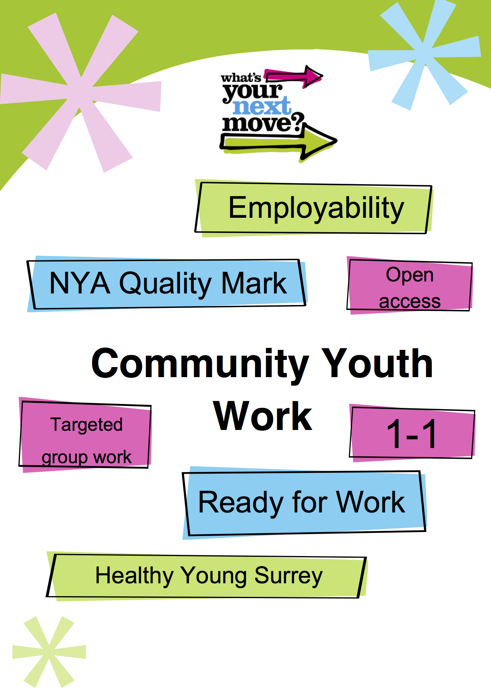
Reigate & Banstead
Youth Work Needs Assessment
Reigate and Banstead – Local Needs Assessment
Area Overview
Reigate and Banstead is located in the East of Surrey with a population of approximately 138,000¹ which includes an estimated 15,800² in the 10 – 19 year old age range. The borough comprises Banstead, Tadworth, Reigate, Redhill and Horley and a range of smaller villages. The M25 runs through the borough to the North providing good commuter access to the rest of the county however it also divides the borough meaning that the population North of the M25 associate more with Epsom and Ewell and the London Borough of Sutton than Reigate, Redhill and Horley to the South. The M23 is to the East linking with Gatwick Airport to the South which is adjacent to Horley. Reigate and Banstead is a relatively affluent area; however there are pockets of deprivation in the Wards of Preston, Merstham, Redhill West and Horley West. Merstham is the most deprived area in the borough and ranks 2nd in Surrey³
Community Youth Work- Aims and Objectives
In September 2014, Surrey County Council’s Cabinet approved Services for Young People’s youth work commissioning model for 2015-2020 to deliver the strategic goal of employability for all young people in Surrey. To achieve this goal, the Community Youth Work Service will target areas where there is the greatest risk of young people not making a successful transition into employability.
Historically the Centre-Based Youth Work Commission has operated with a “one size fits all” policy with regards to the division of resources in each district/borough. This meant that all Surrey County Council owned youth centres received the same amount of provision both in staffing and in running costs irrespective of the need in that area.
The service has now adopted a needs based model that directs resources according to need. This need has been obtained through the analysis of data relating to youth crime, NEET figures, Risk of NEET Indicators (RONI), health indicators, deprivation and transportation. Further information on need has been sought form local partners, stakeholders and young people.
This may mean that youth work is not always delivered from centres but may be a district/borough wide offer dependent on need. This will be achieved primarily through open access youth work with a further commitment to address early intervention, Healthy Young Surrey, Ready for Work and NEET prevention.

The new service will work through a ‘Hub and spoke’ approach. See diagram below:

The purpose of this model is that there will be a hub of need where the SCC offer will be greater than other areas and the focus of resources will be delivered in this/these areas. There will also be areas where partnership work with other youth providers will be possible and a joined up, holistic approach to the needs of young people will be delivered in partnership and therefore reduce the level of Community Youth Work Service resource. The third spoke is a community offer where support will be offered to the community to take ownership of the needs, again supported through SCC in the form of equipment, training or premises.
The Community Youth Work Service offers a more flexible approach to delivery and by moving away from the centre-based model gives greater freedom to work where the need is.
Current contextual Information
In 2014/15 the Centre Based Youth Work (CBYW) model supported 4 Full-Time Youth Centres. These were Banstead YC, Phoenix YC, Merstham YC and Horley YC, the model also supported a satellite provision - Sovereign YC. The CBYW contract provided a range of activities from open access provision to targeted work including the development of young leader programmes, Duke of Edinburgh Award and Youth Achievement Awards. All centres have achieved their level one NYA Quality Mark
The CBYW contract was supported by Raven Housing Trust (RHT), the managing agent for the CBYW contract in the borough. RHT continues to support sports based provision at Phoenix YC and is keen to develop future partnership work with CYWS in the Preston, Merstham and Redhill West Wards. Other key partnerships include YMCA East Surrey who hold the current LPF contract for the borough and are currently delivering Open Access provision in Redhill on behalf of the Community Youth Work Service; and Reigate & Banstead Borough Council who are involved in many combined projects across the borough. These are developing partnerships which will look to increase capacity to deliver more successful outcomes to young people through targeted/outreach and joint ventures.
Reigate and Banstead in 2014/15 had an allocated budget of £268,025. For 2015/16 the applied Resource Allocation System formulae meant a reduction in the local budget of 4.6%, to £255,629 against an overall reduction of 11% (£300,000) to the Community Youth Work Service across the county. The service locally now includes 3 FTE Youth and Community Workers and 1 FTE Senior Practitioner. The full time team are supported by 3.8 FTE part time hours which comprise a mix of Worker in Charge hours and Assistant Youth Worker hours. In 2015/16 the Community Youth Work Service will look to achieve 3000 hours delivery to young people.
The Community Youth Work Service will develop its youth work model around Surrey’s Young People’s Outcomes Framework. Open Access provision will work with young people in developing its curriculum to ensure young people are resilient by improving their physical, emotional, mental and social wellbeing. Open Access and Targeted Interventions will work on reducing anti-social behaviour, reduce the impact of offending and improve young people’s safety in communities. Working in key areas, the CYWS team will work with young people that have been identified as NEET or at risk of becoming NEET (RONI) and others to assist young people overcoming barriers to employability. This will be achieved through the above delivery methods and through our early help offer linking with the Youth Support Service, Children’s Services and other partners. The CYWS will also develop a range of employability programmes both in partnership with the Youth Support Service and other providers utilising open access provision, workshops, short courses, training opportunities and potentially developing social enterprises. Through these mechanisms we will help young people make informed decisions and ensure they are active members of their communities and ensure employability for more young people.
Summary of Key Findings
- Merstham and Horley West currently have the highest NEET and RONI numbers as well as being ranked 1st and 2nd for areas of deprivation in the borough.³
- Reigate and Banstead have 5 of the top 20 Wards for deprivation in the county.³
- The Wards Redhill West and Earlswood & Whitebushes are identified as high need areas for youth work interventions which were not covered by CBYW
- Preston and Horley West have the highest numbers of children 5-15 with mental health disorders.⁴
Needs Assessment
For the purpose of resource allocation I have conducted a needs assessment based on various ONS data sets. I have concentrated on those ONS data sets which will give information that will assist in the delivery of outcomes aligned with the council’s current employability plan and Surrey Young People’s Outcomes Framework
The data sets used include Youth Justice YRI’s, NEET and risk of NEET indicators (RONI), LSOAs Areas of Deprivation, Households claiming out of work benefits, Children’s Service Referrals Population and Ethnicity. For the purpose of identifying potential need, I have ranked wards, highlighting the top 10 in all of the above categories. Wards have been classified as in High need of youth work interventions if scored in 6 sets or higher and ranked 1st to 5th in 50% or more; wards with scores in 3 to 5 sets are classified as medium need of youth work intervention and Wards with less than 3 have been deemed as a low need for youth work intervention. (Table 1.1) *Low, medium, or high need refers in this context to risk factors for young people not achieving successful transition into employability. An exception to the above way I have extrapolated data within the sets is Preston Ward. This Ward is significantly smaller in population than other Wards, therefore this system would not fully recognise the local needs in this specific area.
Table 1.1
Reigate & Banstead by Ward | BV | N | T | P | CHW | TW | KBH | M | RH | RC | RW | RE | MSJ | SPW | EW | SS | HW | HC | HE
Youth Justice –  YRI’s / SO’s |  | = 8th | = 6th |  |  |  |  | 3rd |  |  | 5th | = 8th |  | = 6th | 4th |  | 1st | 2nd | = 8th
NEET & RONI |  |  | 9th | 7th | 10th |  |  | 3rd |  |  | 4th |  | 8th | 2nd | 5th |  | 1st | 6th
LSOAs Area of Deprivation |  |  | 9th | 4th & 6th |  |  |  | 1st & 8th |  |  | 3rd & 5th |  |  | 10th |  |  | 2nd | 7th
Households ‘out of work’ benefits |  |  | 9th | 8th | 10th |  |  | = 1st |  |  | 3rd | 7th |  | = 1st | = 5th |  | 4th | = 5th
Children’s Service Referrals |  |  | = 10th | 8th | 9th | = 10th |  | 1st |  |  | 5th | 7th |  | 2nd | 3rd |  | 4th | 6th
BME & Non White Population | 4th |  | 10th | 5th |  |  | 6th | 7th |  |  | 2nd | 1st |  |  | 3rd | 8th |  |  | 9th
Population 10 - 19 | 9th | 7th |  |  | 1st |  |  | 3rd | 10th |  | 8th |  | 5th | 6th | 2nd |  | 4th
 | Low | Low | Med | High | Med | Low | Low | High | Low | Low | High | Med | Low | High | High | Low | High | Med | Low
- BV = Banstead Village
- N = Nork
- T = Tattenhams
- P = Preston
- CHW = Chipstead, Hooley and Woodmansterne
- TW = Tadworth and Walton
- KBH = Kingswood with Burgh Heath
- M = Merstham
- RH = Reigate Hill
- RC = Reigate Central
- RW = Redhill West
- RE = Redhill East
- MSJ = Meadvale and St. Johns
- SPW = South Park and Woodhatch
- EW = Earlswood and Whitebushes
- SS = Salford and Sidlow
- HW = Horley West
- HC = Horley Central
- HE = Horley East

- Key to Wards
- Other factors not included in the data sets above include SEN information and key health statistics for the borough

- Employability
- In looking at the data relating to employability I examined the following categories:
- The number of young people who are currently NEET⁵
- The number of young people who display Risk of NEET indicators(RONI)⁵
- Number of Children living in Out-of-work Benefit Claimant Households⁶

Using the latest available data from SCC Horley West had the highest NEET count for 2014/15 at 25. In addition to this Horley West also had the joint highest RONI count at 55 for 2015 and had 135 households with children claiming out-of-work benefits; South Park and Woodhatch also had the same RONI count at 55 and 18 NEET. South Park and Woodhatch had a higher number of households with children claiming out-of-work benefits at 145, the same as Merstham which came 3rd with a RONI count of 50 and 20 recorded as NEET. Other wards which should be noted for similar trends with high NEET / RONI and households claiming out-of-work benefits include Redhill West (4th) and Earlswood and Whitebushes (5th)

As a borough NEET for 2014-15 were 190; RONI for 2015 are 515; Children in households claiming out-of-work benefits were 1,585

Crime

In looking at the data relating to crime I examined the following categories;

- Youth Justice – YRI & SO count⁵

Using 2014-15 data from SCC again Horley West had the highest combined YRI and SO count at 16, this was closely followed by Horley Central with 15 although Horley West had the higher YRI’s at 12 and Horley Central had higher SO count at 9. Merstham 3rd with 6 YRI’s and 6 SO. Other wards that should be noted include Earlswood and Whitebushes at (4th) Redhill West (5th)

Deprivation

In looking at the data relating to deprivation I examined the following categories:
- LSOAs areas of deprivation
- Number of Children living in Out-of-work Benefit Claimant Households⁶
- Young people who were Children in Need (Sep-13 to Aug-14)⁵
- Young people who were Looked After Children (Sep-13 to Aug-14)⁵
- Young people who were on Child Protection Plans (Sep-13 to Aug-14)⁵
- Young people who were on referred to Children’s Services (Sep-13 to Aug-14)⁵

Using the Indices of Multiple Deprivation 2010 Merstham 008A ranked highest in the borough. Its Surrey ranking is 2nd out of 709 LSOAs; Horley West 016E is ranked 2nd in the borough and 10th for Surrey, Redhill West 010E is 3rd in the borough and 15th for Surrey. The highest 5 areas of deprivation in Reigate and Banstead are also in the top 20 for Surrey county as a whole.³

The data for Children’s Services referrals have been collated together to give an overall figure for each ward. These include Children in Need; Child Protection Plans; Looked after Children and Open Referrals. Using this data Merstham was (1st) with 53, South Park and Woodhatch (2nd) with 48, Earlswood and Whitebushes (3rd) with 38, Horley West (4th) with 35 and Redhill West (5th) with 33⁵

Health

Families in Poverty Needs Assessment 2011 identifies Preston Ward (11.5%) of children aged 5 – 15 with mental health disorders and Horley West (10.2%) in addition to this smoking prevalence is higher than the national benchmark in wards including Preston, Merstham, Tattenhams, South Park and Woodhatch, Horley West, Horley Central, Horley East, Redhill West, Redhill East and Earlswood and Whitebushes⁴

Feedback from young people:⁷
- Young people value having safe places to go and consistent staff running them.
- So if we are naughty we will get to keep our youth club?
- Good kids will miss out – we still have needs!
- Young people having strong role models and youth workers they can trust to talk to and who understand them is very important.
- Young people don’t want youth clubs to become an extension of school!

Feedback from partners, stakeholders and local community:⁸
- YMCA East Surrey keen to develop partnership working and to link with community youth work service to develop a more joined up approach to support young people achieve employability outcomes.
- Raven Housing Trust are keen to support work / develop partnership in areas of deprivation including Redhill West, Merstham and Preston.
- People have expressed concern at the movement of the established Youth and Community Worker at Banstead to a different location.
Proposed response to need

 | 01.04.2014 – 31.03.2015  Centre Based Youth Work |  | 01.04.2015 – 31.03.2016  Community Youth Work Service
Area | Method of Delivery | Hours of Delivery  (per wk.) | Method of Delivery | Hours of Delivery  (per wk.) | Need
Redhill |  |  | Open Access | 3 | Open Access with curriculum focussing on health and resilience
 |  |  | Open Access | 3 | Open Access with curriculum focussing on health, resilience and employability
 |  |  | Targeted Interventions | 2 | Need to engage young people who are NEET / RONI in Redhill West. Small Group Work and Outreach
 |  |  | Early Help Interventions | 3 | One to One support & signposting young people to appropriate CYWS interventions
 |  |  | Local Impact = Increase in delivery of 11 hours per week
Merstham | D of E Award | 3 | D of E Award Targeted  Intervention | 3 | Targeted Work supporting young people who readily cannot access D of E. Focuses on building resilience and gaining employability skills.
 | Open Access Juniors | 3 | Open Access | 3 | Open Access with curriculum focussing on health and resilience
 | Open Access  Seniors | 3 | Open Access | 3 | Open Access with curriculum focussing on health, resilience and employability
 | Short Courses & Youth Committee | 3 | Targeted Interventions | 2 | Need to engage young people who are NEET / RONI in Merstham. Small Group Work
 | Outreach Project | 2 | Outreach Programme | 2 | Need to engage young people who are NEET / RONI in Merstham. Outreach
 |  |  | Early Help Interventions | 3 | One to One support & signposting young people to appropriate CYWS interventions
 |  |  | Local Impact = Increase in delivery of 2 hours per week
Tadworth | Open Access Years 7+ | 2 | Open Access | 3 | Open Access with curriculum focussing on health and resilience
 | Junior Club Years 6 + 7 | 2 | Open Access | 3 | Open Access with curriculum focussing on health, resilience and employability
 | Senior Club Years 10+ | 2 | Project Night  Seniors | 2 | Targeted programmes focusing on health, relationships, self esteem
 | Steering Group | 2 | Young Leader Training | 2 | Developing employability skills
 | Leader Training | 2 | Targeted Interventions | 2 | Providing support for young people with mental health, low self-esteem, confidence
 | Project Night | 2 | Early Help Interventions | 3 | One to One support & signposting young people to appropriate CYWS interventions
 |  |  | Local Impact = Increase in delivery of 3 hours per week
Banstead | Open Access Years 8+ | 3 | Open Access | 3 | Open Access with curriculum focussing on health and resilience
 | Open Access Years 6 + 7 | 3
 | Juniors  Years 2 – 5 | 3
 | Closed Group Years 7+ | 3
 |  |  | Local Impact = Decrease in delivery of 9 hours per week
Reigate | Open Access Juniors | 3 | Open Access | 3 | Open Access with curriculum focussing on health and resilience
 | Open Access Seniors | 3 | Open Access | 3 | Open Access with curriculum focussing on health, resilience and employability
 |  |  | Outreach Programme | 2 | Engage young people who are NEET or RONI, targeted interventions in South Park & Woodhatch
 |  |  | Local Impact = Increase in delivery of 2 hours per week
Horley | Open Access Juniors / Health | 4 | Open Access | 3 | Open Access with curriculum focussing on health and resilience
 | Open Access Inters | 3 | Targeted Interventions | 2 | Group Work to increase young people’s resilience & tackle anti-social behaviour
 | Open Access Seniors | 6 | Open Access | 3 | Open Access with curriculum focussing on health, resilience and employability
 |  |  | Outreach Programme | 4 | Engage young people who are NEET or RONI, targeted interventions in Earlswood & Whitebushes / Horley West
 |  |  | Early Help Interventions | 3 | One to One support & signposting young people to appropriate CYWS interventions
 |  |  | Local Impact = Increase in delivery of 2 hours per week
Borough Wide |  |  | The majority of resource is administered to the above programme however to ensure a responsive service to need, the team will be able to deliver an additional 250 hours of targeted interventions through its Early Help Offer and employability programmes delivered by Youth & Community Workers focusing in high need areas.

- Early Help offer will include one to one support to enable and prepare young people to engage in the wider community youth work offer.
- Employability interventions will include group work sessions around employability skills in open access sessions; Skills developed through young leader programmes and the exploration of establishing new ‘work’ programmes around previously established projects such as the youth café and radio station in Horley.
References
¹ Quality of Life in Reigate & Banstead Borough Profile February 2014
² Reigate and Banstead Needs Assessment July 2014
³ LSOAs Areas of deprivation 2010
⁴ Families in Poverty Needs Assessment February 2011
⁵ Reigate and Banstead – Ward level needs summary
⁶ Number of Children living in Out-of-work Benefit Claimant Households by Ward and Age at May 2013 DWP
⁷ Conversations with young people on visits to Banstead YC, Phoenix YC, Sovereign YC, Horley YC
⁸ Conversations with partners including YSS, YMCA East Surrey, Raven Housing Trust

