Residential short breaks in Surrey
Applewood
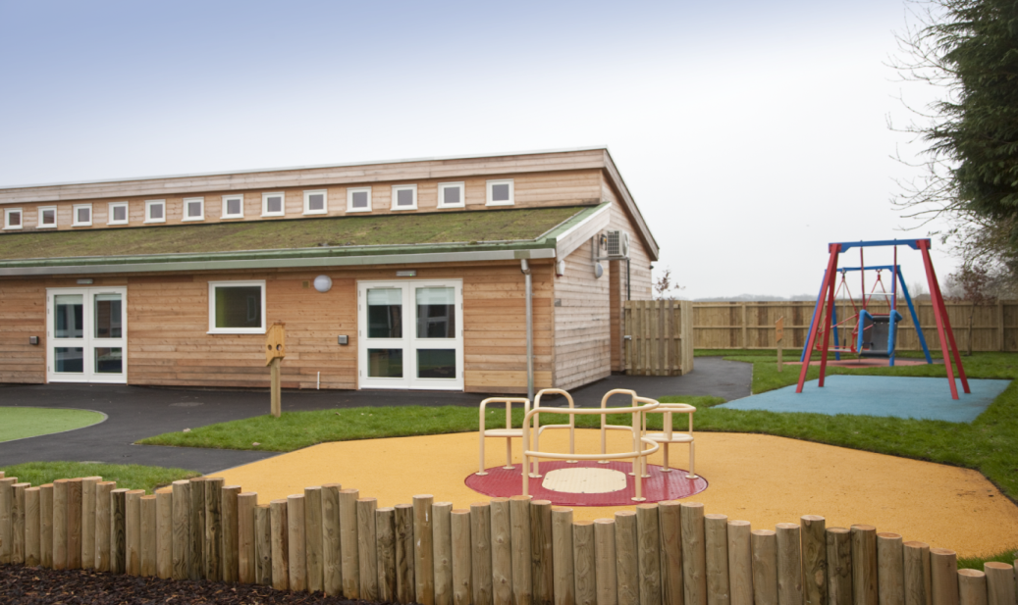
Applewood is a purpose built specialist children’s home situated in a quiet residential area in Tadworth. The service is registered to take up to six children (male and female) between the ages of five to 18 years. The range of needs that can be met include:
- autistic spectrum disorders and associated challenging behaviours
- epilepsy
- diabetes
- heart conditions
- cerebral palsy
- acquired brain injury
- learning disabilities.
Applewood offers a range of tea visits, day care, weekday, weekend and holiday overnights. Referrals are made by the children with disabilities team following completion of a child and family assessment. Each child will have an ‘all about me’ personal profile detailing their personal care needs, preferences and likes and dislikes. A range of activities and outings are offered including:
- cinema
- bowling
- swimming
- walks
- trips to the park
- farm
- seaside
- sightseeing drives
- restaurants/cafes.
- shopping.

Beeches
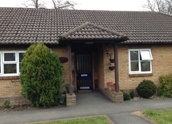
Beeches Bungalow in Reigate gives children and young people under 18 years old with varying degrees of learning and physical disabilities the chance to stay away from home, learn skills, make friends and give their family and/or relatives a break from providing ongoing care.
The respite centre has five individual bedrooms which are decorated to help the children feel as 'at home' as possible whilst 24 hour care is available from the centre's nursing team.
Care plans are developed with the involvement of the young person who uses the service and their parent/carer.

Children and young people's preferences, likes and dislikes are recorded and care and support provided in accordance with their care plan. Children and young people using the service have needs in relation to epilepsy, learning disabilities, autistic spectrum disorder and gastrostomy (PEG) feeding.
Referrals are made through the children with disabilities team following a child and family assessment or Surrey and borders community learning disability team.

Cherry Trees
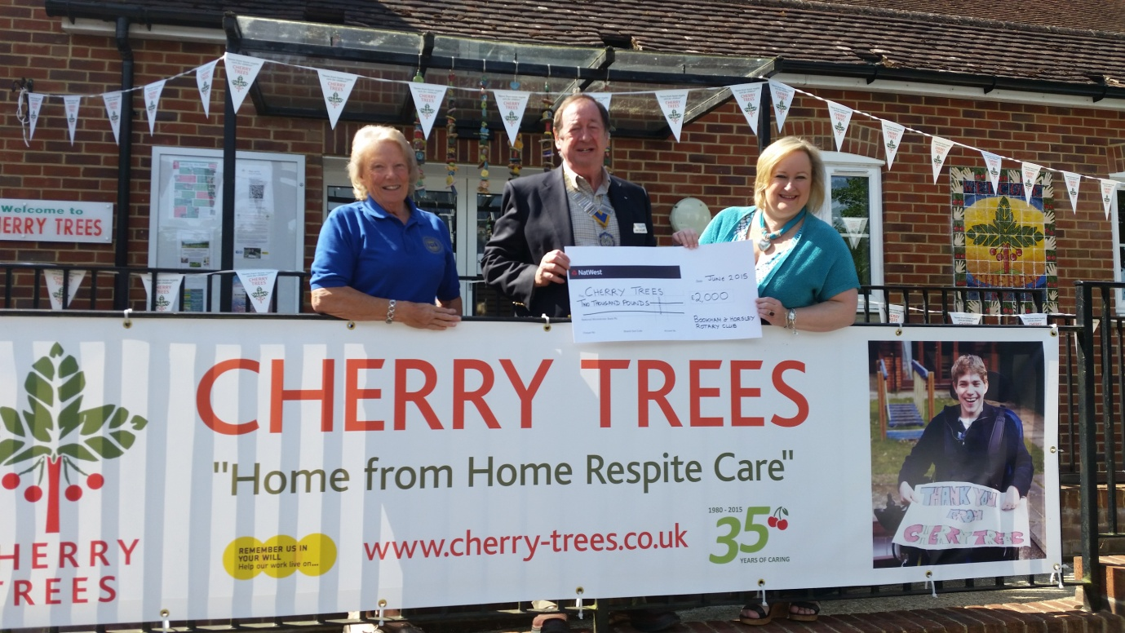
Cherry Trees, based in East Clandon near Guildford, provides a caring environment for families in and around the Surrey area. The care provided is very flexible and children can be aged from 0-19. There are places for up to 18 children during the day and 14 overnight.
Stays at Cherry Trees can be for as little as a few hours enabling parents to go shopping or attend appointments, or up to 17 days to allow families to take a holiday. Regular planned day, overnight or weekend care can be arranged, as well as emergency care in times of crisis.
Cherry Trees has no set criteria for deciding which children can attend other than they have moderate to severe disabilities and that the service will be able to meet their needs. Referrals may be made through the children with disabilities team following a child and family assessment or parents may contact the service directly.

The Children’s Trust, Tadworth
The Children’s Trust residential short breaks offer flexible and nurse led care for children and young people between the ages of 0-18.
The service is for children and young people:
- with complex disabilities and health needs
- who are vulnerable to acute changes in health which necessitate 24 hour care
- whose complex needs require them to be managed by a registered nurse
- who are aged between 0-18 years old.
Unfortunately due to the vulnerability of children at The Children’s Trust they are unable to accommodate children with aggressive or severe challenging behaviour. However, they may be able to suggest alternative placements. A child accessing the service will experience a structured day of activities, which are tailored to meet their care needs including a varied programme of evening and weekend recreation activities run by the play and leisure services team.
Technology dependent children
The Children’s Trust is one of few organisations able to offer residential short breaks for children and young people who have a tracheotomy and/or are technology dependent (eg long term ventilation).
Opportunities are available for children and young people to enjoy time away from home or hospital whilst continuing to be cared for by trained professionals. It also enables parents and families to take a break.
Flexible packages are available for children and young people from a wide geographical area. Referrals may be made through the children with disabilities team following a child and family assessment or commissioned by the Clinical Commissioning Group (CCG) for children and young people who meet the criteria for continuing health care.

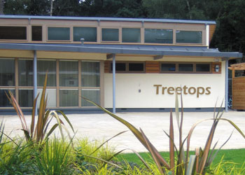
White Lodge Treetops

Treetops is a purpose built short break centre located in Chertsey, Surrey (a few minutes from junction 11 of the M25). Treetops is a service for disabled children and young people, male and female, aged 0-18. With six individual bedrooms (four bedrooms have hoists, all six rooms have specialised beds to meet the individual needs of the children) and large communal areas, Treetops offers a ‘home from home’ experience for the children and young people who visit.
Treetops provides short leisure breaks for children and young people who have a range of physical, learning and sensory disabilities and are aged from a few months old up to 18 years. The service is able to meet the very specific needs of children and young people including those who have health care requirements (eg gastrostomy feeding) and those who have autistic spectrum disorders).
Treetops offer a varied activity programme, which is aimed at giving choice and new opportunities to the children and young people who stay. Treetops also offers day care making the total numbers of children and young people up to nine during weekends, tea visits and school holidays.
The majority of families who use Treetops are referred and funded by Children’s Services in Surrey or their local social services children with disabilities team. Prior to referring the family, a social worker would have undertaken a child and family assessment. Following this day care hours and or nights would be allocated to be used per week or month. Treetops also offers private overnights/day care (non-peak times), subject to availability and need.

