School Organisation Consultation
Proposal to Establish a Special Educational Needs Unit at Epsom Downs Primary School

December 2022
School Organisation Informal Consultation

Local Authority Details:

Local Authority: | Surrey County Council
Address: | Quadrant Court  35 Guildford Road  Woking  GU22 7QQ

School Details:

School Name: | Epsom Downs Primary School
Age Range: | 3 to 11
Type of School: | Community School
URN: | 125127
Address: | St Leonard’s Road, Epsom Downs, Surrey
Postcode: | KT18 5RJ

Introduction

This paper outlines a proposal to establish a unit for children with Special Educational Needs (SEND) at Epsom Downs Primary School. There will be 25 places for autistic pupils and those with communication and interaction needs from Reception to Year 6. All pupils will have an Education, Health and Care Plan (EHCP).

Proposal

Epsom Downs Primary School is a two-form entry (2FE) primary school in the borough of Reigate and Banstead in Surrey. The school was rated ‘Good’ by Ofsted in December 2018. In agreement with the school’s Headteacher and Governing Body, Surrey County Council is proposing to establish a SEND unit at Epsom Downs Primary School with 25 places for autistic pupils and those with communication and interactions needs. Pupils will have an EHCP specifying the specialist provision within the school as an appropriate placement to meet their individual needs. Table 1 shows the proposed timeline for the changes to take place September 2023. Dates and steps in the timeline may change based on the outcome of this consultation.

Table 1. Proposed Timeline

Phase | Date
Consultation | 15 Dec 2022 to 10 Feb 2023
Review of Consultation Responses | February 2023
Outcome of Consultation Published* | February 2023
Statutory Notices | 20 Feb 2023 to 19 Mar 2023
Lead Cabinet Member Decision | April 2023
Implementation | September 2023

* Outcome will be published at www.surreysays.co.uk

It is proposed that:

- A new SEND Unit will be established to provide a total number of 25 places for autistic pupils and those with communication and interaction needs aged 4 to 11 years (3 per year group in Year R to Year 2, 4 per year group in Year 3 to Year 6).

- There will be no change to the mainstream published admission number (PAN) of 60.

- The 25 SEND Unit pupils will be above the mainstream published admission number (PAN).

- All pupils placed at the SEND Unit by Surrey County Council would have an EHCP specifying the school as an appropriate placement to meet their individual needs. Further details on the admissions process for SEND specialist provision in Surrey can be found on the Surrey Local Offer website The document ‘SEND admissions processes for referrals for specialist placement for school age children’ describes how this process works and is available on the Surrey County Council website.

Background

Epsom Downs Primary School is a 2-form entry (2FE) primary school in the borough of Reigate and Banstead in Surrey with a published admission number (PAN) of 60 and an overall mainstream capacity of 420. The school was rated ‘Good’ by Ofsted in December 2018. Table 2 shows the number of places in each year group across the school.

Table 2: Number of places at Epsom Downs Primary School by National Curriculum Year (NCY) Group

N | Year R | Year 1 | Year 2 | Year 3 | Year 4 | Year 5 | Year 6 | Total
46 | 60 | 60 | 60 | 60 | 60 | 60 | 60 | 466

What do we want to achieve?

Surrey’s SEND Capital Programme:

Between 2019-2022, Cabinet approved £139.6m capital investment to deliver 2,300 additional specialist school places in Surrey through 77 capital projects. This is in order to expand the county’s specialist education estate up to 6,000 state-maintained specialist school places by 2030/31, which is aligned with the adopted county-wide commitment to root children in their local communities and ensure no one is left behind. As of September 2022, around 800 new specialist school places have already been delivered across Surrey through 35 Capital projects.

Epsom Downs is a well-established community school with a good reputation. Pupils and families benefit from a well-established ethos, clear vision, values, and a skilled, innovative, energetic, and committed staff team with a strong record of providing high-quality education to pupils. This is a fantastic opportunity to extend that offer to local autistic pupils and their families. Children in the mainstream part of the school with additional needs also benefit from the additional specialist expertise that this will bring

The aim of the proposal is to establish a SEND Unit at Epsom Downs Primary School, to provide 25 places for autistic pupils and those with communication and interaction needs.

What will be provided through the SEND Unit?

Pupils attending Epsom Downs Primary School would be in addition to the mainstream Published Admission Number (PAN) of the school, as there is an expectation that a minimum of 50% of the school day would be spent in the Unit. This would enable meaningful inclusion into the mainstream classes which is wholly individualised to the needs of the pupil. Some pupils may spend more time in the Unit than others and it would be the responsibility of the school to manage the specialist offer and inclusion levels in partnership with the parents and the local authority.

Curriculum and Educational Offer

Unit staff will work closely with the mainstream class teachers so that each child will have access to a broad and balanced curriculum that is personalised to meet their needs. Teachers will differentiate their learning to enable them to make progress. This may mean that there will be different levels of work set within a lesson, often at an individual level. The school day will be the same as the mainstream school.

The quality of teaching and learning in the centre will be overseen by a Lead Teacher and as part of the whole school monitoring programme. Training and learning for all staff will support the development of meaning inclusion throughout the school. Targets from the Annual Reviews feed into termly target setting and then into daily planning.

Staff

All of the Unit staff will have specialist training and development. The Lead Teacher, in addition to her teaching qualification, will have additional specialist qualifications relevant to working with autistic children and those with communication and interaction needs. Both teachers and support staff will undertake a programme of training which keeps them up to date with all the specialist skills necessary for working with children with special educational needs/additional needs.

More information about the school’s vision and curriculum can be found on the school website: Epsom Downs Primary School.

Reasons for the establishment of a new SEND unit at Epsom Downs Primary School

Surrey County Council has identified a long-term sufficiency gap for additional specialist places across Surrey. Demand for specialist provision in the south-east of Surrey for autistic pupils and those with communication and interaction needs is high. As a result, other specialist provision in the local area is operating at or above capacity. The provision of an additional 25 places will help support local families who would otherwise have to travel further afield for their child to receive an appropriate full-time education. The proposed unit at Epsom Downs Primary School will increase availability of specialist places that are matched appropriately to need-type, phases of education and geographic location, as well as reduce home to school journey times and associated costs.

SEND units with a designation of ASD¹ in mainstream schools support autistic pupils and those with communication and interaction needs whose additional needs are such that they are able to spend approximately 50% of the taught curriculum in mainstream classes with support. This type of provision supports pupils who benefit from the specialist support of the SEND unit while accessing inclusion in mainstream classes. By developing local specialist provision, children can learn and flourish in their own community and be part of a familiar setting which supports their unique way of learning.

¹ Autistic Spectrum Disorder (ASD) is the term used by the Department for Education (DfE) as the school designation that meets the needs of autistic pupils and those with communication and interaction needs.

Demand for SEND Unit and special school places in Surrey

Demand data for both special schools and SEND units is included in the graphs below. There are fewer SEND unit places than special school places and pupils tend to attend SEND units closer to home. Where SEND unit places are not available, autistic pupils and those with communication & interaction needs may be placed out of the county in non-maintained independent schools. Therefore, the data shown below is forecasting the number of pupils who need a specialist place either in a SEND unit or special school.

In the academic year 2020-2021, 1190 of Surrey resident pupils aged 4-11 years old who are autistic or have communication & interaction needs attended SEND units or specialist schools. 13% of this cohort were placed out of county due to a lack of placement availability in Surrey. Latest sufficiency modelling projects growth of 15% from 1190 in 2020-21 to 1368 in 2025-2026.

Due to the location of the school being close to the border of the north-east quadrant of Surrey, it is reasonable to expect that pupils may attend the SEND Unit from both the south-east and north-east quadrants. Therefore, the data below has been provided for both.

Graph 1 shows that south-east projections indicate 18 % growth in the total number of autistic pupils and those with communication & interaction needs, with EHCPs who need a specialist school or SEND unit place from 2020-21 (309) to the peak in 2025-26 (364).

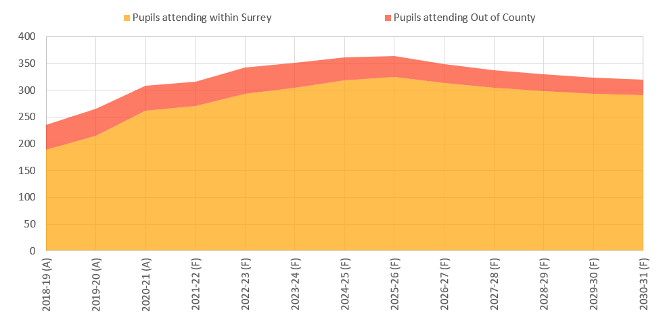

Graph 2 shows that north-east projections indicate 17% growth in the total number of autistic pupils and those with communication & interaction needs, with EHCPs who need a specialist school or SEND unit place from 2020-21 (309) to the peak in 2023-24 (363), with 12% growth remaining in 2025/26 (345).
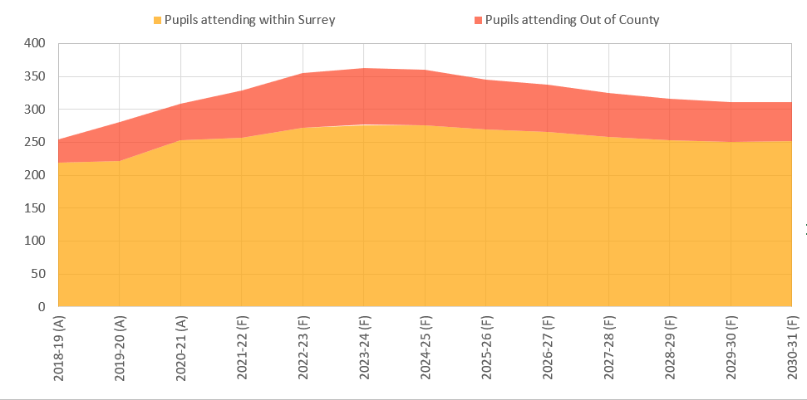

ASD SEND Unit provision in Surrey

More details of our specialist provision can be found in the booklet “Finding the right primary school in Surrey” on the Surrey Local Offer website.
Table 3 below provides a summary of existing SEND Units designated to meet the needs of autistic pupils and those with moderate learning difficulties as their primary presenting needs.

Table 3: Autistic Spectrum Disorder (ASD) Designated SEND Units in Mainstream Schools in South-East and North-East Surrey (primary phase)

School | District | Age Range | Planned Places | Occupancy | Planned Expansion
Ashford Park Primary School | Spelthorne | Primary 4-11 years | 25 | 92% | Planned redesignation to ASD
Bell Farm Primary School | Elmbridge | Primary 3-11 years | 21 | 86% | N/A
Chandler's Field Primary School | Elmbridge | Primary 4-11 years | 20 | 100% | Growing to capacity of 25 places by 2024/25
Cuddington Community Primary | Epsom & Ewell | Primary 4-11 years | 14 | 100% | N/A
Epsom Primary & Nursery School | Epsom & Ewell | Primary 4-11 years | 12 | 100% | Expanding by 21 places
Meadhurst Primary School | Spelthorne | Primary 3-11 years | 20 | 95% | Expanding by 18 places
St Matthew's C/E Primary School | Reigate & Banstead | Junior 7-11 years | 16 | 100% | Planned expansion by 13 places

Key Outcomes and Benefits

Expanding outstanding, sufficient and sustainable special school provision for Surrey resident primary age pupils in Reigate and Banstead and the surrounding area will provide the following benefits as stated in the Developing local Special Educational Needs and Disability (SEND) Provision report to Cabinet on 25 January 2022:

- Benefits realisation ensures Surrey’s maintained specialist education provision is fit for purpose and creates additional employment/supported internship opportunities for residents around areas of expansion.

- Children, young people, and families can access the same level of high-quality support wherever they live in Surrey. We have a good, shared understanding of our children and young people who have SEND in Surrey and our support offer matches their identified needs.

- Expanding Surrey’s specialist provision aligns with the Preparation for Adulthood programme and strategy for Post-16 to create local further education and employment pathways such as apprenticeships and supported internships. This enables young people who have SEND to make a successful transition to adulthood and secure employment.

- Capacity created locally will also make certain that SEND home to school transport distance and costs are reduced so that pupils attend their closest most appropriate school with shorter journey times. Opportunities for developing independent travel skills can be maximised as a result of children and young people being educated closer to home. This will also address local congestion around school sites as well as traffic flow around the county, which will be of benefit to Surrey’s Green Agenda

- The distribution and occupancy of current Special Schools and SEND Units in mainstream schools clearly illustrates that there is insufficient provision of Autism and Communication & Social Interaction Needs, Moderate Learning Difficulties, Severe Learning Difficulties and Social Emotional Mental Health Needs Special places.

- The approved remodification and expansion programme will ensure that additional places are matched appropriately to need type, phases of education and geographic locations.
An Equality Impact Assessment is being completed throughout the consultation process and will be published as part of the Lead Cabinet Member decision meeting.

Implementation Plan

Finance and Resourcing

Revenue income: Epsom Downs Primary School will receive £6,000 per pupil per year for each agreed planned place commissioned (25 places). The school will also receive a “top up” sum for each pupil on roll at the SEND Unit, appropriate to the needs of individual children.

Staffing

The set up and running of the provision of the SEND unit within the school would be led and managed by a strong existing team with additional staff employed as the pupil numbers increase.

Capital planning and buildings

The capital project is part of Phase 4 of the SEND Capital Programme agreed by Surrey County Council Cabinet on 25 January 2022. A feasibility study will inform the changes and refurbishment requirement in the school to accommodate the expanded SEND unit. Capital works will be funded by Surrey County Council.

Growth Model

It is proposed that there will be 10 places available in September 2023 (3 in Reception, 3 in Year 1 and 4 in Year 3). There will be an intake of 3 places for autistic pupils and those with communication and interaction needs in Reception each year, with an additional intake of 1 place in Year 3. The table below show how the SEND unit will grow from September 2023 to full capacity in September 2026. The growth model may change depending on timescales and the outcome of the property feasibility study. The main intake point will be key stage transfer groups in Year R and Year 3, although, where there are spaces and demand, new children may be accepted into the school in non-key stage transfer groups.

Table 4: Growth model for the SEND Unit at Epsom Downs Primary School (autistic pupils and those with communication and interaction needs)

Year | NCY 0 | NCY 1 | NCY 2 | NCY 3 | NCY 4 | NCY 5 | NCY 6 | Total
2023/24 | 3 | 3 |  | 4 |  |  |  | 10
2024/25 | 3 | 3 | 3 | 4 | 4 |  |  | 17
2025/26 | 3 | 3 | 3 | 4 | 4 | 4 |  | 21
2026/27 | 3 | 3 | 3 | 4 | 4 | 4 | 4 | 25

Consultations, approvals and overall timescales

- It is proposed that the changes commence from 1 September 2023. The proposed changes require a period of consultation, the publication of Statutory Notices and the agreement of Surrey County Council’s Cabinet Member for Education and Learning if the proposal is to proceed.

- The first stage of consultation will be informal and will be open on 12 December 2022. During this period, Surrey County Council will share the proposal with the wider professional network, schools including headteachers and chairs of governors, with unions, parent representatives, partner agencies and with the staff and parents of the school subject to the proposals. The consultation will also be shared with local councillors and residents, SEND Advice Surrey and Family Voice Surrey.

- Following the informal consultation period, it is proposed to publish a Statutory Notice for a four-week period. The publication of Notices is when the local authority formally states that it intends to implement the proposed changes. This will be the final opportunity for consultees to make their views known before a final decision is taken. Following the consultation periods, officers will summarise the feedback and will report to the Cabinet Member for Education and Lifelong Learning.

Have your say

Surrey County Council and Epsom Downs Primary School would like to know what people in the area think about the proposal. The consultation will open on Monday 15 December 2022 and close on 10 February 2023. You can respond by:

a) Accessing the consultation online on the ‘Surrey Says’ website: www.surreysays.co.uk and searching for the school’s consultation (school name or post code), or by scrolling through the list of open consultations.

b) Completing the consultation response form that is available alongside this document. You can email the form or print it, complete it and send it back to Peter Speers, Commissioning Manager, at the address below:

SEND Epsom Downs Primary School
Education Place Planning
Quadrant Court
35 Guildford Road
Woking
GU22 7QQ

Email: schoolorg@surreycc.gov.uk with the subject: FAO Epsom Downs Specialist Unit Expansion

All responses must be received by Friday 10 February 2023

What happens next?

We will hold a virtual public engagement meeting for parents and any other interested parties to discuss the proposals and to hear views. As a public meeting, anyone who wishes to may attend.

Thursday 12 January at 6pm
Microsoft Teams – virtual meeting

Please email schoolorg@surreycc.gov.uk to register your interest and you will be sent a link to the online meeting. The meeting will consist of a short presentation followed by questions and answers.

Please join to share your views and ask questions. You do not have to have a child at the school to join the meeting. After the engagement meeting, we will publish all questions asked and answers provided on the website.

At the end of the consultation period, we will review all the responses received and share these with the school and publish them on the Surrey Says website.

Subject to the outcome of the consultation, we intend to publish a Statutory Notice at the school, in a local newspaper and on the Surrey Says website stating our intention to expand the SEND Unit at Epsom Downs Primary School. There will be a four-week statutory consultation period for further representations to be received by the council.

All representations will be reviewed before a final decision is taken by the Cabinet Member for Education and Lifelong Learning

