  - Consultation on New Special Free School
  - Proposed New Autism
and Communication & Interaction need (ASC) Special Free School
for the West of Surrey

Introduction
- In November 2018 the Council’s successful bid to the Department of Education (DfE)’s Special Free Schools Programme resulted in approval for two new local special schools for children and young people with Special Educational Needs and or Disabilities (SEND) in Surrey. SCC also made the decision to fund and deliver a third special free school to meet long-term projected demand for specialist school places.

- The DfE new special free schools are Fox Grove School, which opened in September 2021 and Betchwood Vale Academy which is scheduled to open in September 2023. This consultation is the start of the process to enable the third new special free school to open in September 2024.

- Under sections 13 and 14 of the Education Act 1996 and Part 27 Section 3 of the Children and Families Act 2014, Surrey County Council and other Local Authorities have a statutory duty to ensure that:
- There are sufficient schools for primary and secondary education in their areas.
- They keep under review the educational provision for children and young people who have special educational needs and or a disability (SEND)
The Local Authority and its partners have a statutory duty to keep special educational provision under review, including planning, commissioning, and monitoring. This a vital role that local authorities retain in an increasingly school-led education system and one that requires long-term strategic planning.
- Special School sufficiency planning is informed by accurate SEND systems-data, mid-year population estimates, the trajectory of housing growth for each district in Surrey and historical as well as current tracking of learner movement trends. Detailed local knowledge enhanced through consultation with parents and carers and good relationships with local schools also supports the strategic approach to evidence-informed place planning.
- The Surrey Special Educational Needs and Disabilities (SEND) Partnership Strategy 2019 - 2022 includes an action to create additional specialist school places in Surrey for children with SEND, both in special schools and in SEN Units in mainstream schools. This will reduce travel time and distance between home and school, enable pupils with SEND to be more a part of their local community and help to increase their progress, attainment and outcomes.
- Surrey’s 2030 Community Vision, supports the aspiration that everyone achieves their full potential, contributes to their community and no one is left behind. Our ambition is that children and young people who have SEND and EHCPs are educated in their nearest, most appropriate setting and closer to home.
- On 24 September 2019, Surrey’s Cabinet approved a 10 year Strategy for Specialist Placements, including a four year plan to provide an additional 823 specialist school places in Surrey. This included the proposed new Special School, which would deliver up to 200 of those new places. Subsequent capital investment approved by Cabinet in 2020 and 2021 totals a combined SEND capital investment of £79.6m which will create over 1,600 additional specialist school places in Surrey towards the total projected demand.
- The need to create an all-through phase Special School provision in the West of the county was identified and signed off in the Special Educational Needs and Disability (SEND) Capital Programme by Cabinet in September 2019. An approved capital budget of £25 million was assigned to the new Special Free School project.
- A site was originally identified in the Woking area but that proved unviable within the existing capital budget due to unforeseen site issues.

The proposal
- SCC is proposing to establish new Special Free School provision in the West of the County to accommodate boys and girls aged 4 to 19 years with Autism and Communication & Interaction needs (ASC). Admissions will be in line with the Special Educational Needs and Disabilities Code of Practice, 2015. It is envisaged that the new school would provide between 176 to 200 places at full capacity.

- The site will be confirmed before the final school specification is published and sponsors sought through the statutory competitive process. Further public consultation will be required in line with statutory Planning Consultations and Judicial Review periods for Land & Property developments, as well as Department for Education Free School Presumption (Section 10 Consultation) processes.
- The proposal is for the school to open to pupils in September 2024.

Background
- The proposed new school would join the current family of 25 publicly funded special schools in the county (12 Community Schools, 12 Academies and 1 Free School).

- The North West and South West quadrants are currently served by three other ASC special schools and seven SEN Units in mainstream schools for pupils with Autism and Communication & Interaction needs:

Special Schools:
Setting | Designation | Age Range | Numbers on Roll | Occupancy Sep 21
Freemantles School | ASC | 4 - 19 Years | 204 | 99%
Pond Meadow Academy | ASC | 2 - 19 Years | 152 | 100%
St Dominic's School | ASC | 7 - 19 Years | 145 | 97%

Mainstream SEND Units:
Setting | Designation | Age Range | Numbers on Roll | Occupancy Sep 21
Badshot Lea Village Infant School | ASC | 4-7 years | 15 | 94%
Bagshot Infant School | ASC | 4-7 years | 5 | 50%
Broadwater | SLCN | 11-16 years | 25 | 83%
Burpham Primary School | SLCN | 4-7 years | 11 | 92%
Cranleigh C of E (VC) Primary | SLCN | 4-7 years | 4 | 40%
Eastwick Infant Academy | ASC | 4-7 years | 23 | 100%
Eastwick Junior Academy | ASC | 7-11 years | 23 | 100%
Jubilee High School | SLCN | 11-16 years | 11 | 92%
Northmead Junior School | SLCN | 7-11 years | 16 | 100%
Pyrcroft Grange Primary | ASC | 3-11 years | 20 | 100%
Rodborough School | ASC | 11-16 years | 20 | 100%
Salesian School | ASC | 11-16 years | 20 | 100%
Stepgates Community Primary | SLCN | 4-11 years | 18 | 90%
The Grove Primary School | SLCN | 4-11 years | 15 | 100%
Tomlinscote School | SLCN | 11-16 years | 9 | 90%
William Cobbett Junior School | ASC | 4-11 years | 33 | 100%
Worplesdon Primary School | ASC | 4-11 years | 16 | 76%

- Freemantles School is being expanded to reach a total capacity of 270 places by September 2028. The proposed new Special School is needed in addition to this because even when expanded, Freemantles will not have enough capacity to meet the expected demand for specialist school places. Furthermore, the SEN Units in mainstream schools are by their nature relatively small, expansions would be minor and cannot meet the level of projected deficit places. In addition, these centres are only able to take learners whose ASC characteristics are such that they are able to spend approximately 50% of their time in mainstream classes with their peers. Whereas the children and young people who would be attending the proposed special school will have more extreme anxiety, mental-health related comorbidities and complex learning needs. These needs require specialist school placements and the learners would simply would not cope in mainstream classes.

Process and Timescales
- Under section 6A of the Education and Inspections Act 2006 (the ‘free school presumption’) where a local authority identifies the need to establish a new school it must, in the first instance, seek proposals to establish an academy (free school). SCC are beginning this process by holding this initial consultation with the aim of collecting views to help decide how to proceed and to help formalise and finalise proposals.
- Under the Free School ‘presumption’ route, the local authority (Surrey County Council) is responsible for providing the site for the new school and for delivering the capital programme for building the new school. The proposed location is yet to be finalised: SCC is carrying out a final analysis of a small number of potential sites to gauge their appropriateness – this is likely to help determine how the provision is organised.

- Whilst the new special school is being proposed by SCC, it will need to be run and operated by a sponsor as a Free School or academy, independent of the local authority. SCC aim to seek proposals from prospective sponsors early in 2022 and have a confirmed sponsor in place by July 2022.
- In order to give the new special school the best chance of opening in September 2024, it will be necessarily for SCC to carry out a large part of the design work in advance of the sponsor being confirmed. All design work will be in line with the relevant regulations and guidance around special school buildings and it is expected that the sponsor will be able to have some input into design elements once appointed.
- The proposal is for the school to open to pupils in September 2024. There are many steps to take to get to that point including further periods of consultation once a sponsor has been selected; however, the key milestones of most interest are as follows:
- November 2021 – initial local authority consultation (this process)
- January 2022 – full school specification published
- March 2022 – proposals sought from prospective sponsors
- July 2022 – sponsor confirmed
- April 2023 – construction starts
- September 2024 – school opens

Rationale (evidence of need)

Increasing Demand for Specialist School Places
- Since 2015, the number of children with an EHCP who live in Surrey and require a specialist school place has increased by 73%. This can potentially be attributed, in part, to the increase in the birth rate, the changes brought about by the Children and Families Act and the SEND Regulations in 2014, the 0-25 SEND Code of Practice in 2015 and the improvements to earlier identification and diagnosis of need.
- The rationale for the proposed new special school is to assist in meeting a demographic pressure for Special School Places, specifically for the ASC cohort. The development of the proposed school is consequently part of a suite of proposals being developed by Surrey County Council in conjunction with the Department for Education (DfE)’s Free Schools programme to deliver a step change in the number of places for learners who have complex SEND in local Special Schools and SEN Units in mainstream schools.
- The full rationale and evidence of need is provided in the section below; however, SCC envisage that the proposed school will need to cater for 176 to 200 pupils to support the growing demand for specialist ASC places in this area.
- This provision supports the local area’s strategic vision to increase the number of special educational assets in county so that Surrey’s children and young people can be educated in their nearest most appropriate school.
- The demand for maintained specialist school places in Surrey for children and young people with SEND has grown significantly over the past four years from 2,859 planned places to 3,769 in 2021-2022: of those places, 97% are occupied. As the county’s specialist estate has not expanded at the same rate as the demand, this is turn has increased reliance on the independent sector to ensure all pupils are able to access suitable full-time education. The use of this provision is almost twice as high compared to an average of benchmarking counties including Hampshire, Essex, Kent, East Sussex and Hertfordshire.

Growing Numbers of Pupils with Autistic Spectrum Conditions
- Surrey currently has over 3,500 EHCPs for children and young people who have ASC identified as their primary need. Approximately 44% of these pupils attend specialist provision.
- Autism Spectrum Conditions (ASC), including Communication & Interaction Needs and Complex Social Communication Needs has continued to be the most prevalent need in Surrey since 2015. The rate of ASC growth continues to be almost double that of the growth rate for Moderate Learning Difficulties (MLD) and Social Emotional and Mental Health needs (SEMH), which are the next two highest areas of need in the county. On average, ASC growth has increased by 32% in Surrey over the last 4 years.
- There is increased demand for specialist placements for children with a primary need of ASC. In Surrey, numbers of school-age children with ASC named as a primary need on their EHCP increased by 43% between 2018/19 and 2021/22 (from 2,725 to 3,899). The forecasts suggest that numbers will continue to grow over the next five years.
- In terms of education provision, Surrey is divided into a number of education areas within the four quadrants: North East, North West, South East and South West of the county. Special schools and specialist centres in Surrey, as in other local authorities, do not just meet the needs of learners in the immediate surrounding areas within a district. Across the North West and South West of Surrey, there is a potential shortfall of specialist places for ASC in 2024/25. If places are not delivered and projected growth continues in line with current trends, there will not be sufficient places to meet demand.
- As part of SCC’s September 2019 strategy, the Western areas of Surrey have been the subject of interim proposals to expand provision by way of ‘bulge’ classes and the dedication of resourced Specialist Centres within mainstream primary and secondary schools. However, it is recognised that Special Schools such as this proposed SEND School are vital for the future because of the higher level of specialist education and care offered by these settings.
- Projections also show increases in demand in neighbouring quadrants. Specialist placements are considered based on more than just the distance from a pupil’s home. The new school is therefore likely to admit pupils outside of the immediate surrounding area and, as such, will serve a wider community based on need-type and phase of education, whilst still taking a pupil’s home residence into consideration.
- Graph 1 evidences the projected demand for specialist provision for children and young people with ASC across Surrey to 2031. This demonstrates a sustained increase in demand throughout the forecast period. The growth rate is highest in the North West (38%) but there is growth in the South West as well (13%).
Graph 1: Projected EHCP growth for pupils age 4-19 years in Surrey
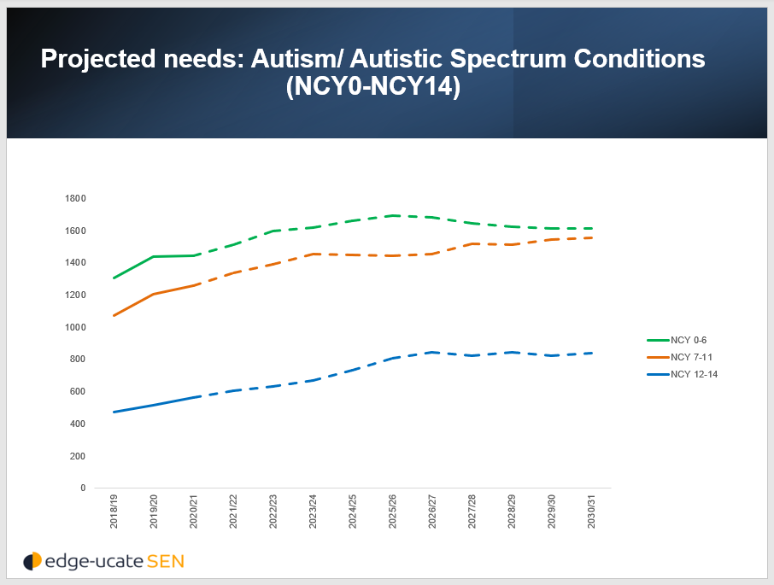

- Graph 2 shows the west of the county’s projected demand for specialist places for pupils with ASC. This is expected to grow with increases expected in each of the primary, secondary and post-16 sectors.
Graph 2: NW and SW quadrant projected demand for ASC specialist school place 2021-2031
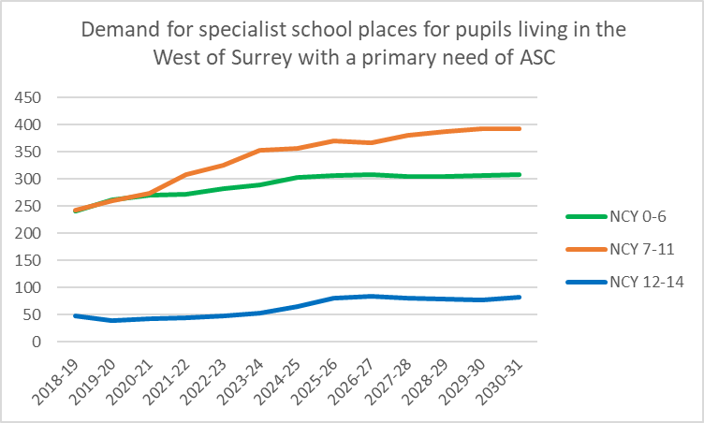
- In addition to growing demand, it is helpful to consider existing access to provision. Data from 2020/21 shows that of 955 special school pupils with ASC living in the West Quadrants of Surrey, 611 (43%) were not educated in their home district. Furthermore, 399 (42%) pupils attended schools in other Quadrants.

Pupil placement
- Special Schools for pupils with Autism and Communication & Interaction needs ASC are designed to support children and young people who have an EHCP and benefit from accessing either a same age-appropriate or highly specialist curriculum in order to develop independence and make good academic progress. Their needs require a low arousal environment, carefully planned transitions with minimal disruptions and a high level of targeted intervention and differentiation throughout the school day.
- School places are allocated in accordance with the Children and Families Act 2014, which requires the Local Authority to take into account the pupil’s special educational needs, parental request for schools, and the formal view of the schools requested before making a decision. Places will be allocated based on parental requests wherever possible, unless:
- the school is unsuitable for the child’s age, ability, aptitude or SEN
- the placement would be incompatible with the efficient education of the other children with whom your child would be educated, and
- the placement would be incompatible with the efficient use of resources.
- Further details on the admissions process for SEND specialist provision in Surrey can be found here: Applying for a school place for children pre-16 with SEND (surreycc.gov.uk)
- The proposed new special school would seek to realise the local area’s vision to:

- Enable all learners to lead happy independent and fulfilling adult lives.
- Enable all learners to be included in and valued by society.
- Enable all children and young people to make outstanding progress academically within a safe, caring and healthy school environment.
- Enable all learners to develop their communication skills to ensure that they can express their thoughts and feelings and can interact with others in their local community as well as wider society.
- Enable all learners to develop their independence skills to enable a successful transition into society.
- Enable all learners to develop their physical, emotional and mental wellbeing, so that they can be happy, healthy, empowered and included in society.
- Work in positive partnerships with parents, carers, fellow professionals and the wider community to ensure that the needs of learners are met, and achievements recognised and celebrated.
- Provide high quality and continuous training development and support for all staff working at the school and for the wider members of the community including parents, carers and families.
- Work with other schools and the wider community of professionals to share expertise and develop inclusive opportunities for learners in a range of contexts (employment, social and cultural).

Consultations, approvals and overall timescales
- There are a number of stages to go through before the proposed new school can open. This is the initial consultation that is run by the local authority. It will run from 16 November 2021 until 17 December 2021.

- SCC will consider the responses to this consultation before deciding whether or not to proceed. The next step would be to publish a full specification outlining in detail what we would expect the school to look like including the location, type and character. The responses to this consultation would inform that specification.
- In March 2022, SCC would seek proposals from potential sponsors asking them to demonstrate how they would meet the requirements set out in the specification. The Regional School Commissioner (RSC) for the South East Region, on behalf of the Secretary of State, will consider the local authority assessments and recommendations before deciding which proposer is in the best position to take forward the new school. The RSC will inform the local authority and the successful proposer of its decision, and the local authority will inform any unsuccessful proposers. We would expect this to be completed by July 2022.
- Section 10 of the Academies Act 2010 requires the chosen sponsor to consult again before the school can open. This consultation should inform stakeholders and the local community about the details of the project. We would expect this to take place in late 2022 or early 2023.
- A new build school would be subject to planning permission and the consultation associated with that.

Have your say
Surrey County Council would like to know what people think about this proposal. The consultation opens on 16 November 2021.
You can respond by:
- Using the online survey. You can access the consultation online on the ‘Surrey Says’ website by searching for “New Special Free School” or by scrolling through the list of open consultations.
- Completing the consultation response form that is available alongside this document and emailing it to schoolorg@surreycc.gov.uk with the subject “FAO New Special Free School Presumption”

- Printing and completing the consultation response form that is available alongside this document and sending it back to the address below:
New Special Free School Presumption
Education Place Planning - FAO Peter Speers
Quadrant Court
35 Guildford Road
Woking
Surrey GU22 7QQ
All responses must be received by midnight on Friday 17 December 2021.

What happens next?
At the end of the consultation period, SCC will collate and review all of the responses received and publish them on the Surrey Says website. The responses will be analysed and an assessment made as to whether to proceed with the proposal.

Consultation response form

Proposal to open a new ASC Special Free School in West Surrey
Please give us your views. Please tick the box that best shows what you think about the proposed expansion and also give us any comments you have. You can write on the other side of this sheet if you want more space to write comments.

1. Do you agree with the proposal to open a new Special Free School with places for up to 200 pupils with ASC in West Surrey from September 2024?
Agree |  |  |  |  | Don’t know |  |  |  |  | Disagree
2. Do you agree that there is a need for additional Special School provision in the West of Surrey to serve children and young people with ASC needs?
Agree |  |  |  |  | Don’t know |  |  |  |  | Disagree
3. What do you think is the most important thing to consider when creating a new ASC Special Free School (e.g. location, facilities, community involvement)?
4. What district of Surrey do you live in? (Please circle)
Elmbridge |  |  |  | Reigate and Banstead |  |  |  |  | Tandridge
Epsom and Ewell |  |  |  | Runnymede |  |  |  |  | Waverley
Guildford |  |  |  | Spelthorne |  |  |  |  | Woking
Mole Valley |  |  |  | Surrey Heath
5. What is your interest in this proposal (e.g., parent, school governor, local resident)?
6. Are you responding on behalf of an Organisation? If so, please give details.
7. Please provide any other comments.

Have you provided comments on a separate sheet? (Please circle) Yes /No
Please return to:

New Special Free School Presumption
Education Place Planning - FAO Peter Speers
Quadrant Court
35 Guildford Road
Woking
Surrey GU22 7QQ

Email: schoolorg@surreycc.gov.uk

Cabinet papers dated 24 September 2019, item 152/19, “School Place Planning: Strategy for Specialist Placements” and associated annex containing list of projects.

