School Organisation Consultation

#### Proposal to enlarge St. Bede’s School

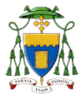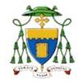



St. Bede’s School

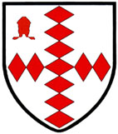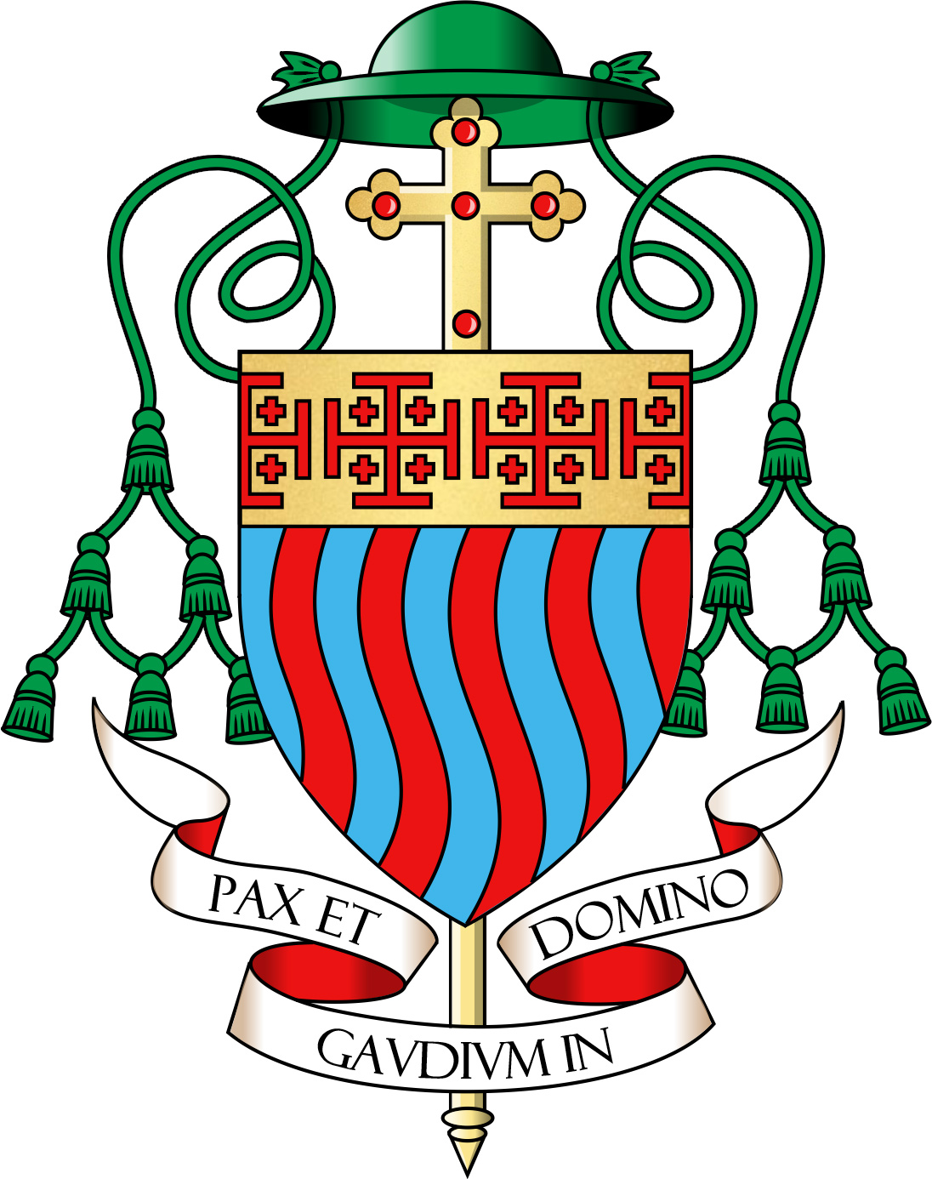[](https://en.wikipedia.org/wiki/File:St_beded.jpg)

The Proposal

Surrey County Council, in cooperation with the Governing Body of St. Bede’s School, the Diocese of Southwark and the Diocese of Arundel & Brighton, is proposing to:

* Enlarge St. Bede’s School from nine forms of entry (9FE) at Year 7 to eleven forms of entry (11FE) at Year 7, to allow for a roll of 1,650, comprising eleven classes of 30 pupils in each year group.
* Build additional permanent classrooms and ancillary space to facilitate this.

The enlargement would be effective from 1 September 2019.

The current position

* + St. Bede’s School has permanent accommodation for 1,350 pupils.
  + The school has a Published Admission Number (PAN) of 270.

**Why are we proposing to enlarge St. Bede’s School?**

Reigate & Banstead is experiencing a significant increase in the demand for school places, reflecting both a significant rise in birth rate and increased house building and migration within the area. Births in the Borough in 2014 were 27.7% higher than births in 2002. A significant number of primary school places have been provided reflective of this demand and this increased pupil cohort is now starting to make the transition into the secondary sector. As such, there is now the need to accommodate increased secondary demand, via a corresponding expansion of secondary schools. If approved, this proposal would provide 300 additional secondary places within Reigate and Redhill that would, in part, help to bridge the projected gap between the supply of and demand for school places.

St. Bede’s School is a Voluntary Aided Ecumenical Christian school. The school is conducted as an interdenominational Christian school and delivers an education offer with a Christian ethos. The Local Authority values diversity in school provision and works with the Diocese of Southwark and the Diocese of Arundel & Brighton to ensure that there are sufficient places for parents who would choose a Christian education for their child.

The school is on an attractive site close to pupil demand. The school has a strong reputation and is oversubscribed for school places. For September 2018, the school received 455 1st preferences, and 899 preferences overall. Expanding this school will promote parental preference, by allowing the Governing Body to admit applicants who name the school as their preferred option.

A programme of building works at the school will improve the general fabric of the school buildings and enhance the learning experience for pupils, parents and staff.

We also feel that there are specific education benefits of the school increasing in size, including:

* + Increased staff numbers, with a greater diversity of experience, leading to educational development and progress;
  + Greater opportunities for staff development/recruitment;
  + Greater flexibility with a larger budget to deploy staff and curriculum resources effectively; and
  + Greater opportunities for curriculum development and school clubs.

The need for additional secondary places in Reigate & Redill

Within Reigate & Redhill, there is presently provision for 1,023 places per year in Year 7, composed of the following:

* Reigate School (offering 250 Year 7 places per annum);
* Royal Alexandra and Albert School (offering 113 Year 7 places per annum);
* St. Bede’s School (offering 270 Year 7 places per annum);
* The Warwick School (offering 210 Year 7 places per annum); and
* Merstham Park School (offering 180 Year 7 places per annum).

Demand for secondary school places in Reigate & Redhill is projected to rise over the coming years, in line with the general increase across the whole of the Reigate & Banstead Borough. Projections of future demand for school places are presented in the below table:

|  |  |  |  |
| --- | --- | --- | --- |
| **Year** | **Y7 PAN** | **Y7 Projection** | **Surplus** |
| 2019/20 | 1,023 | 1,010 | 13 |
| 2020/21 | 1,023 | 1,012 | 11 |
| 2021/22 | 1,023 | 1,058 | - 35 |
| 2022/23 | 1,023 | 1,101 | - 78 |
| 2023/24 | 1,023 | 1,125 | - 102 |
| 2024/25 | 1,023 | 1,105 | - 82 |
| 2025/26 | 1,023 | 1,128 | - 105 |
| 2026/27 | 1,023 | 1,113 | - 90 |
| 2027/28 | 1,023 | 1,105 | - 82 |

As can be seen from the above, there is a sustained need for additional secondary places in the area. A core component of the strategy devised to meet this need is the proposed expansion of St. Bede’s by two Forms of Entry, which (if approved) would reduce all of the above projected deficits by 60 places.

There is also good evidence to suggest that there are insufficient places for Catholic families in the area. At present, there are approximately 110 places available at St. Bede’s for Catholic applicants. The Catholic primary schools in the Redhill Deanery currently have a combined published admission number of 150.

School Building Requirements

The school has capacity to expand in its existing location. A building programme will be required to provide the permanent facilities to allow for this increase. Appropriate capital has been approved to achieve this. The planning application process provided an opportunity to raise issues relating to the proposed building and implications including traffic, school facilities, energy and the impact on the local community and access. Responses to the education consultation should focus on the educational implications of the proposed change.

Have Your Say

We would like to know what the community think about our proposal. There is a Consultation Response Form on page 7 of this leaflet. We are specifically looking for your views on the educational aspects of this proposal.

The consultation will be open until midday on **Monday 9 July 2018**.

What happens next?

We are going to hold a public meeting at the School where you can express your views, obtain more information and have your questions answered. The details of the meeting are as follows:

|  |  |  |
| --- | --- | --- |
| **St. Bede’s School**  **On**  **Thursday 21 June 2018 at 16:30** |  |  |
| **Please come and share your views** |  |  |

At the end of the Consultation, the Governing body will consider the responses and decide whether to proceed with the proposal. The outcome of the decision will be published on the school website:

<http://www.st-bedes.surrey.sch.uk/>

Where can I get more information?

You can find out more by contacting:

Oliver Gill (St. Bede’s School Consultation)

Room 326

County Hall

Penrhyn Road

Kingston-upon-Thames

Surrey

KT1 2DN

email: [schoolorg@surreycc.gov.uk](mailto:schoolorg@surreycc.gov.uk)

Can I write to you with my views?

Surrey County Council and St. Bede’s School would like to know what the community thinks about this proposal. The consultation will open on **Monday 11 June 2018**.

You can respond by:

a) Accessing the consultation online on the ‘Surrey Says’ website: [www.surreysays.co.uk](http://www.surreysays.co.uk) and searching for the school’s consultation (school name or post code), or by scrolling through the list of open consultations.

b) Completing the consultation response form that is available at the end of this document. You can email the form or print it, complete it and send it back to the address below.

Oliver Gill (St. Bede’s School Consultation)

Room 326

County Hall

Penrhyn Road

Kingston-upon-Thames

Surrey

KT1 2DN

FAO Oliver Gill (Oakwood School Consultation) to:

[schoolorg@surreycc.gov.uk](mailto:schoolorg@surreycc.gov.uk)

All responses must be received by noon on **Monday 9 July 2018**.

Consultation Response Form

**Proposal to expand St. Bede’s School from 1,350 to 1,650 places, from September 2019**

Please give us your views. Please tick the box that best shows what you think of the following questions and also give us any comments you have. You can write on the other side of this sheet if you want more space to write comments.

|  |  |  |  |  |  |  |  |  |  |  |  |  |  |  |
| --- | --- | --- | --- | --- | --- | --- | --- | --- | --- | --- | --- | --- | --- | --- |
| 1. Do you agree with the proposal to expand St. Bede’s School from September 2019? | | | | | | | | | | | | | | |
| Agree | | |  |  | Don’t know | | | | |  |  | Disagree | | |
|  |  |  |  |  |  |  |  |  |  |  |  |  |  |  |
|  | | | | | | | | | | | | | | |
| Comments: | | | | | | | | | | | | | | |

Please tick the boxes that apply to you.

|  |  |  |
| --- | --- | --- |
|  | | |
| A parent/carer of a child at the school | | | |  |
|  | | | |  |
| A parent/carer of a child in an Early Years setting | | | |  |
|  | | | |  |
| A parent/carer of a child who may in future attend the school | | | |  |
|  | | | |  |
| A parent/carer of a child at another school | | | |  |
|  | | | |  |
| Someone who works at the school | | | |  |
|  | | | |  |
| A Governor of the school | | | |  |
|  | | | |  |
| Some other link to the school | | | |  |
|  |  |

Someone else with an interest – please give details

It would also be helpful if you could give your postcode

Please return to:

Oliver Gill (St. Bede’s School Consultation)

Room 326

County Hall

Penrhyn Road

Kingston-upon-Thames

Surrey

KT1 2DN

email: [schoolorg@surreycc.gov.uk](mailto:schoolorg@surreycc.gov.uk)

|  |  |  |  |  |
| --- | --- | --- | --- | --- |
|  | |  | | |
|  | Please tick if you have written comments on the other side | |  |

St. Bede’s School - Consultation Response Form

Additional Comments

|  |
| --- |
|  |
|  |
|  |
|  |
|  |
|  |
|  |
|  |
|  |
|  |
|  |
|  |
|  |
|  |
|  |
|  |
|  |
|  |
|  |
|  |
|  |
|  |
|  |
|  |
|  |
|  |
|  |