Consultation Analysis
(Informal consultation and Statutory Notices)

Proposal to expand and change the designation of the SEN Unit at Ashford Park Primary from a designation of MLD to a designation of ASD

Consultation Analysis (Informal and Statutory Notice period) Proposal to expand and change the designation of the SEN Unit at Ashford Park Primary from a designation of MLD to a designation of ASD

Introduction

This report is an analysis of responses gathered on the proposal to expand the SEN unit (known as the Acorn Centre) at Ashford Park Primary School from 21 to 25 places and change the designation from MLD to a designation of ASD[].

Surrey County Council published an informal consultation from 27 September 2022 to 6 November 2022. After reviewing initial responses Statutory notices were published from 14 November 2022 to 12 December 2022.
Part 1 of this paper is an analysis of the responses received during the informal consultation notice period and Part 2 is an analysis of the responses during the Statutory Notices. The summary and key points give a summary of the findings from both consultations. This paper will be submitted to the Lead Cabinet Member for Education and Learning as part of the Lead Cabinet Member report, for consideration in the decision to determine the statutory notices on 31 January 2023.

Consultation Summary

The aim of the consultation was to seek views on the proposal from all interested parties, particularly from pupils and their families who attend Ashford Park Primary School, pupils and their families who may attend the school in the future, and the views of the local community.
The informal consultation was open from 27 September to 6 November 2022. The associated documentation was published on the Surrey County Council ‘Surrey Says’ website and circulated to local stakeholders. Interested parties were invited to return responses to the consultation via an online form or alternatively email or post responses.
An online public meeting was held 13 October 2022 at 6pm.

The Statutory Notices were published from 14 November 2022 to 12 December 2022. The associated documentation was published on the Surrey County Council ‘Surrey Says’ website and circulated to local stakeholders. The notices were also published in the Surrey Advertiser on 18 November 2022. Interested parties were invited to return responses to the consultation via an online form or alternatively email or post responses.

An Equality Impact Assessment was completed throughout the informal consultation and statutory notice period. Responses to the consultations contribute to the Equality Impact Assessment which can be viewed with the papers for the Cabinet Member for Education and Learning Meeting on 31 January 2023.

Key points from the consultation responses:

- There were 9 responses to the informal consultation and 11 responses during the statutory notice period.
- 100% of respondents to informal consultation agreed with the proposal. 82% of respondents to the statutory notices agreed with the proposal.
- The majority of respondents who commented mentioned positive impacts for children and young people and the school.

Part 1 – Information consultation

Quantitative Analysis

There were 9 responses to the consultation. 100% of respondents agreed with the proposal to expand the SEN unit and change the designation from MLD to ASD.
The chart below shows the distribution of responses to the consultation. The highest percentage of respondents selected “staff member from another school” (55%).

Graph 1: What is your Relationship with the School

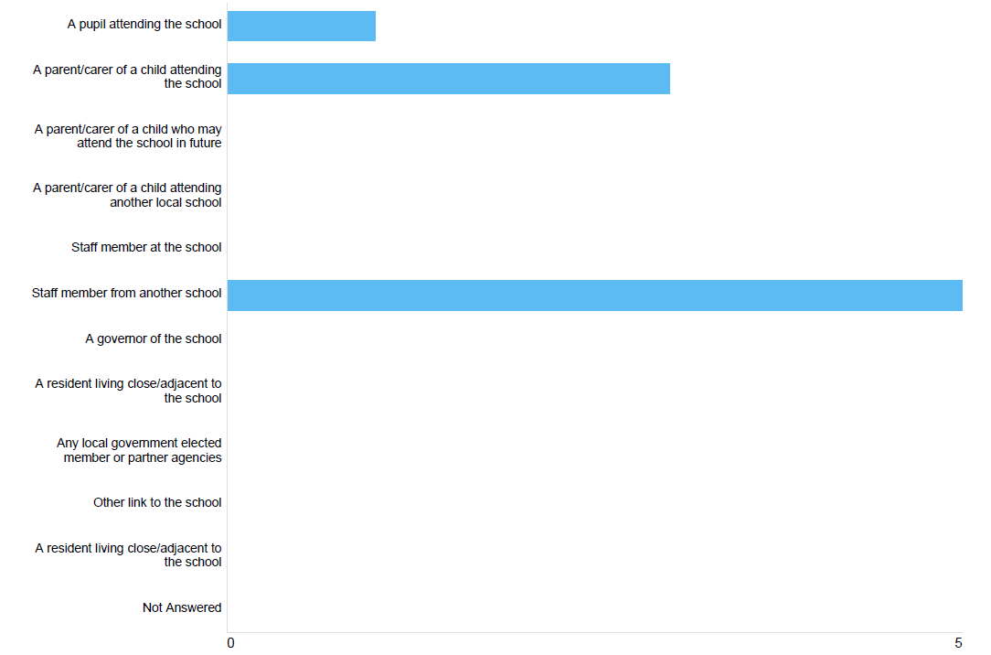

Qualitative Analysis

Respondents had the opportunity to add comments at the end of the survey. Out of 9 respondents 4 (44%) left comments; 2 parents/carers of children at the school and 2 members of staff from another school.

Respondents mentioned the need for more specialist provision and specifically places for children with ASD. Respondents commented on the positive impacts for autistic pupils and those with communication and interaction needs, as well as positive impacts for the school.

“We are seeing more and more demand for such a setting locally to us each academic year. We need the support locally and whole heartedly back the proposal.”

“We recognise that there is a pressure on finding places for pupils with ASD in Surrey.
We would want to endorse the collective and individual work schools in our area are doing to support the specific needs of children in our local community. We recognise both the need for this work and the expertise of the school to offer quality provision that meets this need.”

“I think that this would benefit my children as well as benefit other children.”

Public Meetings

An online public meeting was held on 13 October using MS Teams. There was a short presentation followed by a question and answer session for attendees.

2 people attended on 13 October 2022, both were parents of pupils at Ashford Park Primary school. Themes arising from the public meeting reflected the themes from the responses to the consultation.

A Question and Answer document is published at www.surreysays.co.uk on the Statutory Notices Consultation page and addresses the questions asked throughout the consultation period and during this meeting.

Part 2 – Statutory Notices

Quantitative Analysis

There were 11 responses to the consultation. 9 respondents (82%) agreed with the proposal to expand the SEN unit and change the designation from MLD to ASD and 2 respondents (8%) disagreed with the proposal.
Graph 2 shows the distribution of responses to the consultation.
The highest percentage of respondents selected “a parent/carer of a child attending the school” (9) and 2 respondents selected “staff member from another school.”

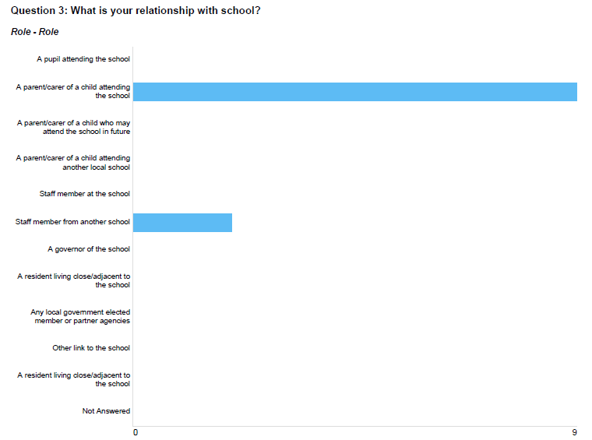
Graph 2: What is your Relationship with the School

Qualitative Analysis

Respondents had the opportunity to add comments at the end of the survey. Out of 11 respondents, 5 left comments.

Positive Impacts

4 out of 5 respondents mentioned the positive impacts of expanding the SEN Unit, commenting on the need for more school places and specialist provision for autistic pupils and those with communication and interaction needs.

“This is a key SEND provision which will meet the needs of local children and their families which is much needed in Spelthorne and the NE of Surrey.”

“Its will be of great help to support parents and kids with Autism. Especially given a specialist provision is not available in the 20 mile radius.”

“I totally agree with the unit expanding. There is not enough places available at the moment. The school has outstanding teachers in the unit and so many more children will benefit from having some time in mainstream and in a unit……. The school definitely has enough space and will not affect anything else my expanding their unit.”

Negative Impacts

2 respondents commented on the proposed expansion having a potential negative impact on other children attending the school.

“I fear that children without ASD will have less educational attention to support them when children with ASD will clearly require increased support.”

“So many Autistic children need specialist education and there are few useful resources in Surrey……I think the changes will be positive overall. However, I do worry that the children with other learning difficulties outside of autism may suffer the consequence of the changes.
I am also thinking that the class size may be too big to manage effectively.”

Autistic Spectrum Disorder (ASD) is the term used by the Department for Education (DfE) as the school designation that meets the needs of autistic pupils and those with communication and interaction needs. Moderate Learning Difficulties (MLD) is the DfE school designation, known locally in Surrey as Learning and Additional Needs (LAN).

