Surrey Integrated Substance Misuse Treatment Service: Detoxification Consultation

Frequently Asked Questions, Visual Pathways, Glossary of Terms and Consultation Feedback

For consultation running from Monday 19 March 2018 until Sunday 20 May 2018.

June 2018

Frequently Asked Questions
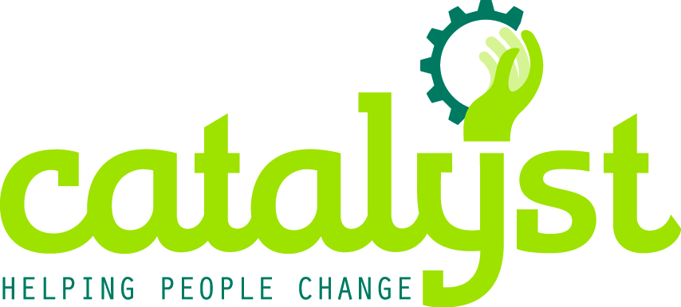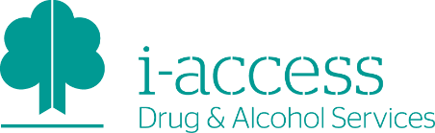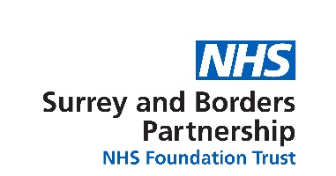
- Can I talk to someone to get more information?
If you would like to talk to us and have any questions or queries about the Integrated Substance Misuse Treatment service please contact:

public.health@surreycc.gov.uk

FAO Martyn Munro
Public Health
Surrey County Council
Room G55, County Hall
Penrhyn Road
Kingston-upon-Thames
KT1 2DN

We will aim to respond to all queries within three working days if by email or 10 working days of receipt if by post.

- Where has this consultation been advertised?
SurreySays- https://www.surreysays.co.uk/deputy-ceo/changes-to-detoxifcation-services
Websites:
http://www.catalystsupport.org.uk/
https://www.healthysurrey.org.uk/news
http://www.sabp.nhs.uk/news
Social media:
Facebook
Surrey and Borders Partnership NHS Foundation Trust @sabpnhs
Twitter
@sabpNHS
@HealthySurrey ‏
@CATALYSTethos
Print copies can be found:
- In Windmill House
- In i-access venues across Surrey
- In Catalyst venues across Surrey

- How long is the Consultation?
The Public Consultation period will run from 19 March 2018 until midnight on Sunday 20 May 2018.
- How will we monitor the impact of the changes?
Public Health are currently revising an Equality Impact Assessment on the changes to the substance misuse treatment services, feedback gathered via this consultation will feed into the Equality Impact Assessment.
Public Health will continue to monitor the performance of substance misuse treatment services via the Public Health Outcome Framework, Diagnostic Outcomes Monitoring Executive Summary (DOMES), National Drug Treatment Monitoring System (NDTMS) and performance data collected at contract reviews.

4a. Consultation Feedback Summary
You Said | We Did
What will replace the 28-day post detoxification structured support “Recovery Programme” offered at Windmill House? | We will be looking at how we can enhance the community support during and after detoxification, co-ordinating existing resources and including access to the group and other support to be offered by the ambulatory detoxification.
Concern around support provision for those who are detoxifying out of hours for example during the evening, night time and at weekends | We are preparing a range of support options available during detoxification
Concern regarding increased presentation at other health settings of people who struggle in the community directly after a detoxification | We have planned detoxification options that provide appropriate clinical care and support for people to safely undertake a detoxification.
How will impact of the changes be monitored? | There will be an Equality and Impact Report, monitoring of A&E and GP feedback, an evaluation of the new detoxification options between July 2018 and March 2019 and a detoxification needs assessment for those not engaged with substance misuse treatment services. Public and stakeholder events.
Transport support for:  - access to ambulatory detoxification  - travel to the out of county facility - Including travel support for family and carers to support them during detoxification | We are planning transport support to ambulatory and inpatient detoxification for those people with the greatest need
Suitability for inpatient detoxification | As currently, this is based on assessed clinical need, not financial concerns
More detail of what is offered at Bridge House – including travel information | https://www.kmpt.nhs.uk/services/bridge-house-at-fant-oast-inpatient-detox-unit/7187
Readable and relevant information for carers and young carers | Work with carer and young carer groups, and other stakeholders to provide suitable information
More involvement for service development with people who have used detoxification services and those with lived experience going forward | Continue communication with service users, those with lived experience, family and carers, and key partners via www.healthsurrey.org.uk, SABP and Catalyst websites and at further public meetings similar to those we held as part of the consultation
Concern about meeting the need of people with multiple disadvantages including people with co-occurring conditions i.e. mental health problems and substance misuse | The assessment for detoxification is centred on how the needs of the individual can be most effectively be met.
Are the ambulatory clinic venues in the most suitable places? | There will be 2 venues across the county based on the current demonstrated areas of need, but these will be reviewed and options considered.

- What is currently offered at Windmill House?
Current provision for Tier 4 (inpatient detoxification) is delivered by Surrey and Borders Partnership NHS Foundation Trust (SABP) via the 13 bed facility Windmill House, located at the St Peter’s Hospital site in Chertsey. Surrey’s substance misuse treatment system includes access to 11 of these beds. The service provides 24 hour inpatient stabilisation, detoxification treatment and a four week recovery-focused therapeutic programme.
Windmill House currently provides inpatient support for approximately 150 clients each year, detoxification takes between eight -10 days and clients are subsequently assessed to access a recovery programme, taking their possible total stay length of up to an additional four weeks. This model has been developed locally over a 20+ year period and is unique to Surrey’s Substance Misuse treatment system.
- What happens during a Home Detoxification from alcohol dependence and who is it most suitable for?
The person receives home visits for at least the first three days from a qualified nurse who starts the alcohol detoxification using medication prescribed by the person’s GP or one of the i-access prescribers. The nurse supervises the person’s detoxification, monitors their progress, supports the person and their carer and carries out regular physical health checks.
Appointments tend to last about an hour. Home detoxification takes between five and 10 days based on clinical need.
Home Detoxification is most suitable for:
- People who are unable to travel to and from the ambulatory detoxification site each day so are unable to engage in this treatment option.
- People with a responsible carer who can be present throughout the detoxification.
- Those who do not have any complex issues, such as significant physical health problems that may have an impact on the safety of home detoxification, or significant mental health problems including risk of self-harm or suicide.

- What happens during a Community Detoxification from drug dependence and who is it most suitable for?
People who are dependent on opiates and benzodiazepines require initial stabilisation on replacement medication. Community detoxification is only advocated when the person is able to abstain from any on top illicit drug use. The dose of prescription medication is gradually reduced to zero at a pace discussed and agreed with the person during their one-to-one key-working sessions. The final stage of this process is often the part people find most challenging. We therefore propose to use the ambulatory detoxification programme to provide additional day time support for the final two weeks of the drug detoxification programme.

- What will happen during an Ambulatory Detoxification for and who is it most suitable for?
Ambulatory Detoxification from alcohol dependence will take between five and 10 days, starting on a Monday. The person attends a clinic every weekday morning to receive their detoxification medication, which is administered by a qualified nurse. They are given their night time dose as take away medication.
Drug detoxification programmes take place in the community through frequent appointments with a qualified work and vary according to the person’s individual needs. Those who need additional support to complete detox will be invited to attend the ambulatory detoxification programme for the final two weeks of their reduction regime.
This service will be available at two proposed clinic locations in Surrey: Farnham Road Hospital in Guildford and Wingfield Resource Centre in Redhill.
People do not need a carer at home throughout this but they will need to have engaged with the abstinence preparation group programme or appropriate one- to-one sessions, which include planning support systems and strategies for managing cravings and triggers for drinking.
This option will be offered to:
- People who are not appropriate for a home detoxification as they don’t have a responsible carer
- People who will benefit from a more intensive option which provides additional support, such as people with significant additional physical or mental health needs.

- What happens during an Inpatient Detoxification from drug and alcohol dependence and who is it most suitable for?
Inpatient and residential detoxification is conducted with 24-hour medical and nursing support that can be responsive to the individual needs of the person. Both medication for the detoxification programme and talking therapies are provided as well as support and treatment for other significant physical or mental health problems the person may be suffering from.
Inpatient detoxification is most suitable for those who:
- Are not suitable for community-based detoxification
- require medical and/or nursing care because of significant additional physical or mental health needs
- People who are dependent on more than one substance so their detoxification needs cannot be safely managed in their home are experiencing significant social problems, such as unstable accommodation, that will limit the benefit of home or ambulatory detoxification.
Residential detoxification should normally be considered for people who have significant coexisting physical or mental health need, and for people who for other reasons are unable to engage with community or ambulatory detoxification.
- What is the i-access Abstinence Preparation Group?
All people who are alcohol dependent and wish to stop drinking completely are encouraged to engage in the i-access abstinence preparation group. This is an evidence based group programme which supports people to stabilise and reduce their drinking while teaching and rehearsing skills to manage craving and triggers for drinking. It prepares people for a life free of alcohol by planning support systems necessary to maintain abstinence after the detoxification period. People who are unable to engage in a group programme are offered the abstinence preparation group on a one-to-one basis. Following the summer 2018 transition period, there will be three options for drug and alcohol detoxification for people in Surrey. All people with a history of alcohol dependence will need to have engaged in the abstinence preparation group programme first before being considered for detoxification.
- Where are services like this delivered already?
SABP delivers detoxification services in areas outside Surrey - iHear in Hounslow and Pavilions in Brighton. Both services are rated ‘Good’ by the Care Quality Commission (CQC) and people with drug and alcohol dependency and carers in contact with these services report good experiences and outcomes. SABP’s delivery of Ambulatory detoxification has received a rating of ‘Good’ by CQC as part of the wider community services we offer in these contracts.
- Are SABP and Catalyst already working together?
Catalyst and SABP have a strong history of partnership working across Mental Health and Substance Misuse, including the delivery of three Safe Havens in Aldershot, Woking and Guildford, offering out of hours mental health crisis support. They have both been part of the delivery of adult substance misuse treatment services in Surrey for a number of years.
- Where can I see the needs assessments which have been carried out?
Recovery Needs Assessment led by Public Health; explored the experiences of those in recovery, the treatment and recovery workforce, peer led recovery initiatives and stakeholders from Surrey’s treatment system. A range of engagement methods were used including a co-design workshop, a substance misuse partnership workshop and face-to-face interviews.
The Joint Strategic Needs Assessment (JSNA) is an assessment of the current and future health and social care needs of the local community. The JSNA informs the Joint Health and Wellbeing Strategy (JHWS) which is a strategy for meeting the needs identified in the JSNA. These are needs that could be met by the local authority, Clinical Commissioning Groups or NHS England. Surrey’s JSNA includes a Substance Misuse Chapter and Improving Health Behaviours Chapter.
- Who is involved in the designing the Integrated Substance Misuse Treatment Service?
Public Health, SABP and Catalyst are engaged in leading a process to review Surrey’s Substance Misuse treatment system, both community and inpatient services. This has brought together experts, clinicians and managers with their partners to explore how reduced resource can be used to meet the needs of Surrey residents and to enable resources to be flexible to meet changes in demand for services. Partners include Clinical Commissioning Groups, Adult Social Care, and a Service User and Carers reference group.
This collaborative process has allowed for:
- More flexibility to provide an Integrated Substance Misuse service for Surrey residents which includes a range options for detoxification
- Maintaining a high quality substance misuse treatment system within reduced financial resources
- Ongoing service improvement, responding to feedback from service users and their carers/families and any changes in performance and outcomes

- What is the National Public Health Grant and why is Surrey considered to be ‘below target’?

Public Health in local authorities is funded directly by a grant received from the Department of Health. The target grant allocation for Local Authorities is calculated nationally according to a formula that aims to represent variations in need between Local Authorities. However, due to historical patterns of funding allocation, Local Authorities do not currently receive their target grant allocation. Surrey’s 2017/18 grant allocation was more than 30% below the level of funding we would have if we received our target allocation and this has been frozen with no timeline for moving closer to target. The allocation in 2017/18 equated to £31/per head compared to £59/head for England as a whole. Surrey County Council continue to raise this with Government and participate fully in any consultation regarding the Public Health grant. We continue to add our support to our professional bodies (the Faculty of Public Health and the Association of Directors of Public Health) and their stance on Government decisions regarding the grant (see the list of sources at the end of this paper for links to further information on these bodies).

By 2019/20, the budget available to spend on core public health programmes will be 30% less than it was at the start of 2015/16.

As a result of these pressures, it has been necessary to review and significantly rationalise the budgets for all Public Health commissioned programmes.

- What will be available for people immediately Windmill House closes in June?
The confirmed timeline for closure is based on clinical judgement to ensure the safety of people and the service, and in order to manage the closure process well. The closure will not interrupt the access to appropriate support for people. Detoxification is part of a structured treatment journey that may take place over many months.
People’s needs will continue to be carefully assessed and managed by experienced staff in i-access teams. The majority of people requiring detoxification will continue to be managed in the community through home detoxification and community withdrawal. Ambulatory detoxification will also be available as an option from July. People who do need inpatient provision will be accommodated through spot purchasing of beds in for treatment.

Visual Pathway – These diagrams show the journey people take through detoxification for drugs and alcohol.
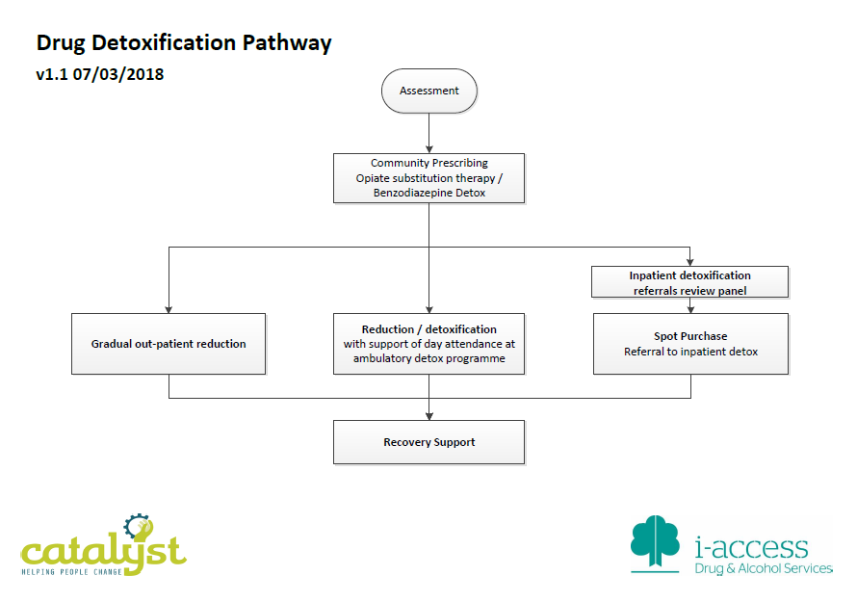

Glossary of Terms
Alcoholics anonymous
AA is concerned solely with the personal recovery and continued sobriety of individual alcoholics who turn to the Fellowship for help. Alcoholics Anonymous does not engage in the fields of alcoholism research, medical or psychiatric treatment, education, or advocacy in any form, although members may participate in such activities as individuals. https://www.alcoholics-anonymous.org.uk/About-AA/What-is-AA?

Catalyst
Catalyst is a Surrey based non-profit organisation working with people who are dealing with issues stemming from drug and alcohol misuse and mental health, reducing the harm to themselves, their families and communities. www.catalystsupport.org.uk

Clinical Commissioning Groups (CCGs)
CCGs were created following the Health and Social Care Act in 2012, and replaced Primary Care Trusts on 1 April 2013. They are clinically-led statutory NHS bodies responsible for the planning and commissioning of health care services for their local area. There are six which cover Surrey County Council.

Care Quality Commission (CQC)
CQC is the independent regulator of health and adult social care in England. Purpose is to make sure health and social care services provide people with safe, effective, compassionate, high-quality care and we encourage care services to improve. http://www.cqc.org.uk/
Collaborative Design
There are many ways to define a collaborative design process, the common thread is that all parties involved in delivering, commissioning and experience services are able contributing to how services are designed and delivered. For the purposes of the Integrated Substance Misuse Services this process reflects the evolving landscape of health and social care to support integration through closer working between providers, commissioners and citizen engagement.

Diagnostic Outcomes Monitoring Executive Summary (DOMES)
The DOMES report presents local statistics on recovery, treatment and contact with the criminal justice system

Integrated Substance Misuse Service:
The following tiers of treatment are included in the Integrated Substance Misuse Treatment Service:
Tier 2: Low threshold substance misuse specialist interventions i.e. harm reduction and injecting equipment exchange and recovery support
Tier 3: Care planned interventions including substitute prescribing, psychosocial structured interventions and recovery support
Tier 4: Access to inpatient detoxification and post detox support
Needs Assessments
Health needs assessment (HNA) is an essential tool to inform commissioning and service planning, and can be defined as a systematic method of identifying the unmet health and healthcare needs of a population, and making changes to meet those unmet needs.

National Drug Treatment Monitoring System (NDTMS)
All services that provide structured treatment for drug and/or alcohol users are asked to submit data to NDTMS. This information is analysed by the National Drug Evidence Centre to produce the figures published via this web portal. https://www.ndtms.net/default.aspx

Narcotics Anonymous
N.A. is a non-profit fellowship or society of men and women for whom drugs had become a major problem. We are recovering addicts who meet regularly to help each other stay clean http://ukna.org/content/what-na

Public Health Outcomes Framework (PHOF)
The Public Health Outcomes Framework examines indicators that help us understand trends in public health. https://www.gov.uk/government/collections/public-health-outcomes-framework

SABP
Surrey and Borders Partnership NHS Foundation Trust is the leading provider of health and social care services for people of all ages with mental ill-health and learning disabilities in Surrey & North East Hampshire and drug & alcohol services in Surrey, Hounslow and Brighton. www.sabp.nhs.uk

SCC
Surrey County Council is the county council administering major local services in the non-metropolitan county of Surrey in England. Surrey County Councils vision is to “Ensure Surrey residents remain healthy, safe and confident about their future.” www.surreycc.gov.uk

SMART Recovery
SMART Recovery (SMART) is a science-based programme to help people manage their recovery from any type of addictive behaviour. This includes addictive behaviour with substances such as alcohol, nicotine or drugs, or compulsive behaviours such as gambling, sex, eating, shopping, self-harming and so on. SMART stands for ‘Self Management and Recovery Training’. https://www.smartrecovery.org.uk/about/

Talking Therapies
Talking therapy is for anyone experiencing negative thoughts and feelings or who is feeling distressed by emotional or mental health problems, or difficult events in their lives which they can't sort out on their own. Sometimes it's easier to talk to a stranger than to relatives or friends. During talking therapy, a trained counsellor or therapist listens to you and helps you find your own answers to problems, without judging you.
https://www.nhs.uk/conditions/stress-anxiety-depression/benefits-of-talking-therapy/
http://www.sabp.nhs.uk/services/mental-health/adult/community/mind-matters-surrey

The report is available at http://www.cqc.org.uk/sites/default/files/new_reports/AAAG6816.pdf
The original target allocations for 13/14 and 14/15 were based on based on ACRA's final recommendations for Public Health grants based on population need. The 'Exposition Book Public Health Allocations 2013-14: Technical Guide' provides more information on the calculations in the exposition book. Theses target allocations were not published beyond 14/15 and in 15/16 funding for Health Visiting services were transferred to Local Authorities from NHSE. The "target" allocation for Surrey for 2017/18 referred to above is therefore based on the 14/15 target, plus the Health Visiting transfer.
prior to the in-year reduction and including 0-5 budget transfer at full year effect
These include: health visiting services, school nursing services, substance misuse treatment services, smoking, healthy weight health checks and public mental health.
Department for Communities and Local Government and Department of Health. Public health grants to local authorities: 2017 to 2018. December 2016. https://www.gov.uk/government/publications/public-health-grants-to-local-authorities-2017-to-2018
Statements on the public health funding cuts from public health professional bodies and respected research organisations can be read via the links below: Association of Directors of Public Health http://www.adph.org.uk/wp-content/uploads/2015/11/ADPH-Press-Release-Spending-Review-Announcement.pdf The Faculty of Public Health http://www.fph.org.uk/potential_nhs_disaster_if_public_health_funding_is_cut http://www.fph.org.uk/comprehensive_spending_review:_‘rock_solid’_evidence_for_saving_nhs_money_ignored The Kings Fund http://www.kingsfund.org.uk/blog/2015/08/cuts-public-health-spending-falsest-false-economies
Health Knowledge https://www.healthknowledge.org.uk/public-health-textbook/research-methods/1c-health-care-evaluation-health-care-assessment/uses-epidemiology-health-service-needs updated 8 June 2018

