Surrey Integrated Substance Misuse Treatment Service

Consultation Paper– Surrey Integrated Substance Misuse Treatment Service: Detoxification Provision

Consultation will run from Monday 19 March 2018 until Sunday 20 May 2018.

March 2018

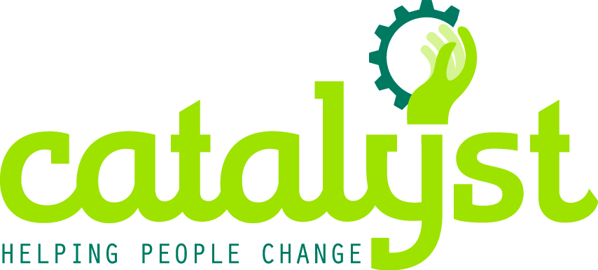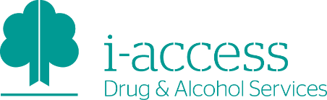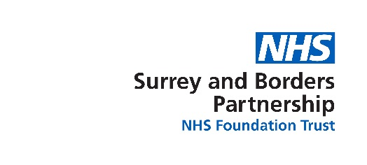

Overview
Surrey County Council (Public Health) and Surrey and Borders Partnership NHS Foundation Trust (SABP) are consulting people about changes to drug and alcohol detoxification services for adults, including community and inpatient provision.
From 1st July 2018, we will begin to implement changes to how drug and alcohol detoxification will be provided in Surrey. We will be moving inpatient services out of the current facility (Windmill House) and providing a greater range of treatment options in the community. Access to inpatient services if required will be offered out of county.
We want to make sure Surrey residents have access to high quality, evidence based care and support which considers both individual care and assessment needs and people’s personal wishes and aspirations.
The aim of this consultation is to ensure anyone who could be affected by the changes we are proposing has the opportunity to review them and input to their development.
This document will explain the background to the transformation of drug and alcohol detoxification in Surrey and why are we transforming detoxification services in Surrey now.
There are many ways you can provide feedback, these are listed in Section 7. Surrey County Council (Public Health) and SABP value your views and suggestions, which will be used to further develop Surrey’s substance misuse treatment services.

All words highlighted in blue are defined and / or more information is provided in the supporting document “Substance Misuse Treatment Service (Detoxification) FAQs and Glossary of Terms”.

Background to changes
During 2016/17, Surrey County Council (Public Health) carried out a variety of stakeholder and service user events to understand the needs of people affected by drugs and alcohol in Surrey. This information and needs assessment has been used to inform plans for the delivery of services from April 2018.

The Surrey County Council (Public Health) budget is under considerable strain from a combination of below-target funding and national cuts to the national public health grant. Ultimately, this means that by 2019/20, the overall budget available to spend on core public health programmes will be 30% less than it was at the start of 2015/16.

It has been identified that inpatient detoxification currently requires a quarter of the overall budget for substance misuse treatment services in Surrey. A detailed options analysis concluded that the cost of maintaining inpatient detoxification at Windmill House would impact on our ability to provide safe and effective community services to our treatment population.

Surrey has high performing and high quality substance misuse treatment services; Surrey County Council’s primary aim is to ensure that after April 2018 these are maintained.

To achieve this a community substance misuse treatment service will bring together separate elements of Surrey’s substance misuse treatment services into one integrated system. The Integrated Substance Misuse Treatment Service, will go live from April 2018 and will be provided by SABP, in partnership with Catalyst (a specialist Surrey based not for profit provider) until 2020.

- Who might be affected?
In the region of 3,000 people benefit from substance misuse treatment services in Surrey: of these, approximately 150 access inpatient detoxification at Windmill House each year. It is these individuals who will be directly affected. In addition their families, friends and carers who form part of an individual’s support might also be affected.

Detoxification from alcohol and drugs is an important part of most people’s treatment journey and is part of a package of support which is tailored according to a person’s individual needs. Drug and alcohol treatment programmes in Surrey prepare people carefully for their detoxification and provide talking therapies, either individually or in groups, to prevent relapse. i-access has a well-established abstinence preparation group programme for people who are drinking in a dependent pattern. Where individuals are not suited to the abstinence preparation group one-to-one sessions are offered.
People who are dependent on drugs are prepared for detoxification through individual sessions with their keyworker.
All people accessing treatment are encouraged to attend groups such as SMART Recovery and Fellowship groups such as Alcoholics Anonymous or Narcotics Anonymous.
- Why are we transforming detoxification services in Surrey now?
The timing of the transformation of detoxification services is based on a number of factors:
- The Public Health budget for substance misuse services is being reduced by 24% from April 2018
- Windmill House, which provides inpatient treatment, is a fixed structure which requires a significant proportion of the substance misuse budget
- Windmill House is currently situated on land at St Peter’s Hospital in Chertsey which is due to be sold in 2018. The significant reduction in funding available for substance misuse treatment services in Surrey means it is not possible to relocate Windmill House
- There is an opportunity to provide more detoxification options in the community therefore allowing for greater patient choice
Therefore, Public Health and SABP in partnership with clinicians and expertise from across Clinical Commissioning Groups and Adult Social Care have reviewed the options for delivery of this service to ensure it is proportionate, appropriate and flexible to the needs of Surrey residents.
The aim of the review was to find an option that offers choices appropriate to need, that is safe, within the budget available and ensures the whole treatment system can meet local needs now and in the future.

- What is the current service provided in Surrey for detoxification?
In the current service, individuals have three options to access detoxification. Individuals receive support from a qualified professional to ensure the appropriate option is chosen. Following detoxification all individuals are offered follow-up care and support.
3.1 Inpatient Detoxification from drug or alcohol dependence within in Windmill House.
Windmill House is a specialist unit which provides 24-hour residential treatment and support to people who require inpatient detoxification or stabilisation. People can also take part in a four week recovery-focused therapeutic programme.
3.2 Home Detoxification from alcohol dependence
Lasting between five and 10 days a person receives daily home visits which last for approximately one hour, from a qualified nurse who supervises, monitors progress, supports and carries out regular health checks.

3.3 Community Detoxification from drug dependence
This is done according to a person’s needs. The person will be supervised, monitored and supported during frequent appointments with a qualified worker at one of our service locations.

- What are the proposed services in Surrey for detoxification?
SABP plan to transition services throughout the summer of 2018. This will see Windmill House aim to close on 30th June 2018 when the following services will become available:
4.1 Ambulatory Detoxification from drug or alcohol dependence
This option will be staffed Monday to Friday. The person attends a clinic every week day morning. People detoxifying from alcohol will receive their detoxification medication, which is administered by a qualified nurse. They are given their night time dose as take away medication.
People detoxifying from drugs will be dispensed their medication from their identified community pharmacy.
Programme participants attend a support group run by a trained group facilitator. If necessary, a nurse gives additional medication according to the person’s individual need. The programme finishes at lunchtime and starts again the following weekday morning. Most alcohol detoxification programmes will last between five and 10 days and people are given medication for the weekend.
Drug detoxification programmes vary according to the person’s individual needs, but those who need additional support will be invited to attend the ambulatory detoxification programme for the final two weeks of their reduction regime.
This service will be available at two proposed clinic locations in Surrey: Farnham Road Hospital in Guildford and Wingfield Resource Centre in Redhill.

  - Home Detoxification from alcohol dependence
As detailed in section 3.2 Home detoxification will continue. Lasting between five and 10 days a person receives daily home visits lasting around an hour, from a qualified nurse who supervises, monitors progress, supports and carries out regular health checks.
  - Community Detoxification from drug dependence
As detailed in section 3.3 Community detoxification will continue. This is done according to a person’s needs. The person will be supervised, monitored and supported during frequent appointments with a qualified worker at one of our service locations.
  - Access to residential/inpatient detoxification
Inpatient detoxification from drug or alcohol dependence will be offered to people who have complex needs and for whom a home or ambulatory detoxification is not appropriate and/or safe.
The location will be reviewed with the individual and will be outside of Surrey. The individual will be supported to access treatment and provided with a care package which supports a smooth transition back to Surrey.
SABP will source an appropriate NHS provider. We will ensure the organisation that provides this service is of the highest quality and meets the standards expected by the Care Quality Commission, with minimum standards of ‘good’.

- How to have your say and send us your feedback
It is important for us to understand your views on these changes and how we can best support you. To ensure that you have the chance to understand and comment on the changes there will be a number of ways you can contribute:

Survey | https://www.surreysays.co.uk/deputy-ceo/changes-to-detoxifcation-services
Question and Answer Sessions | Martyn Munro (Senior Public Health Lead and Commissioner), Katy Matthews (Surrey and Borders, i-access Service Manager) and Sue Murphy (Catalyst CEO)  This is a chance to meet face to face and discuss provision post June 2018 and how it might affect you, or someone you know. | May 10th 10:00-12:00  Wingfield Resource Centre, St Annes Drive, Redhill  RH1 1AU  May 11th 10:00-12:00  The Prop, 30 Goldsworth Road, Woking  GU21 6JT  May 17th 14:00-16:00  St Barnabas Church, Temple Road, Epsom  KT19 8HA  May 18th 14:00-16:00  Guildford Action, Beverley Hall Community Centre, 71 Haydon Place, Guildford, GU1 4ND
Direct Contact | Public Health and SABP welcome your comments on these proposals.  Please send your comments by midnight on Sunday 20 May 2018 to:  If you would like this information in another format or another language please contact: | Email: public.health@surreycc.gov.uk  Call: 020 8541 7976  Textphone (via Text Relay): 18001 0300 200 1005  SMS: 07527 182 861 (for the deaf or hard of hearing)  Write: FAO Martyn Munro  Public Health , Surrey County Council  Room G55, County Hall  Penrhyn Road,  Kingston-upon-Thames  KT1 2DN

- What happens next?
Throughout the consultation we will aim to respond to all queries within three working days if by email, or 10 working days of receipt, if by post.

All feedback will be reviewed and considered as we continue to co-design substance misuse treatment services in Surrey.

If you respond to the survey and leave your email address we will send out a summary sheet which identifies how we plan to take your feedback on board, this will also be shared on Surrey Consultation Hub. All direct comments received during the consultation period will be considered and responded to.

