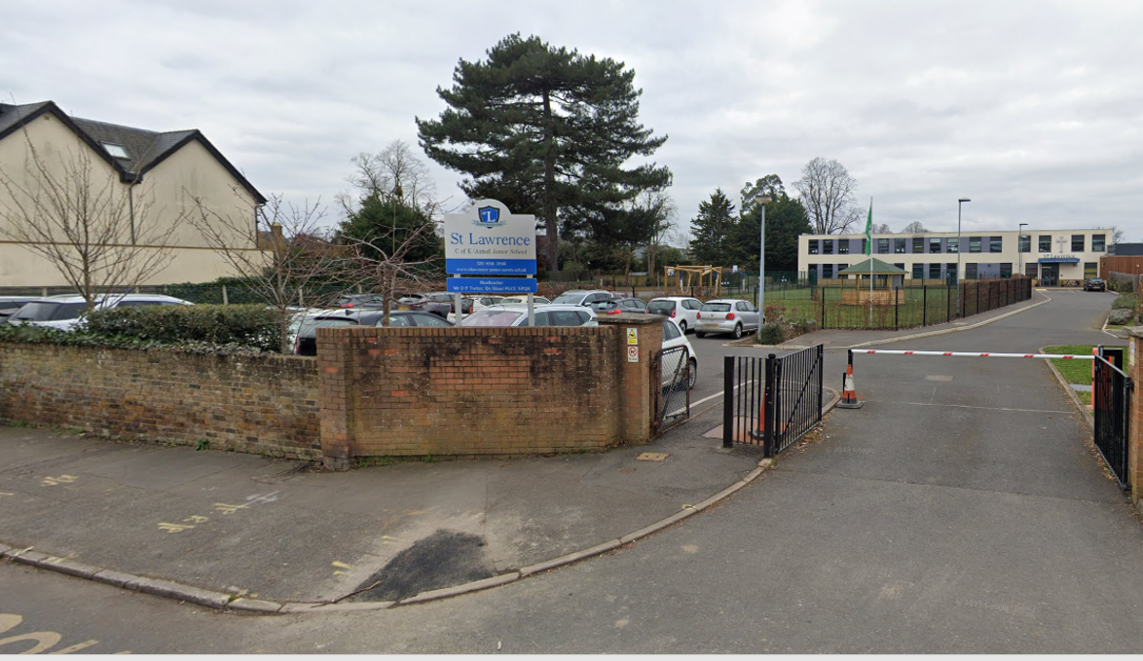
St Lawrence Junior School

Proposed Zebra Crossing

Statutory Consultation Feedback Report
March 2024

Background

In June of 2023 Surrey County Council carried out a consultation via the “Surrey Says” platform inviting the community to complete a questionnaire over 5 different road safety proposals for St Lawrence Junior School.
We Asked
You to choose between 5 road safety proposals to manage motor traffic near the school and make it easier and safer to cross Church Road nearer the junction with Vine Road.
We received 977 responses to the consultation.
You Said
- 77% agreed with a 20mph Limit
- 74% agreed with a Zebra Crossing
- 27% agreed with a School Street
- 20% agreed with Do Nothing
- 17% agreed with a trial Point Closure
We Did
In July 2023 we advised that following on from this consultation with residents and discussions with local County Councillor Steve Bax and Dominic Raab MP, Surrey County Council’s Highway Service will be proceeding with the 20mph Limit and the Zebra Crossing on Church Road within the current financial year 2023/24.
A full copy of the consultation report can be found https://www.surreysays.co.uk/environment-and-infrastructure/st-lawrence-junior-school-road-safety-proposals/results/stlawrenceconsultationreport.docx
The 20mph speed limit on various roads in the vicinity of the school was implemented in September 2023.

Statutory Consultation for Zebra Crossing
Legislation requires that a Statutory Notice is advertised before a zebra crossing on a raised table is constructed. This allows the public to object or to make representations to any aspect of the proposal. These objections and representations are considered before a final decision is reached on whether to set aside the objections and proceed with the scheme.
The Notice Period ran from the 26th January 2024 to 23rd February 2024. This report presents the results of the Statutory Consultation.

Analysis

- A total of 516 responses were recorded via “Surrey Says” emails and letters.
- From the total number of responses 499 registered their postcode and address
- 17 Respondents did not register their address.

Based on the registered addresses, the respondents have been classified based on post code as shown in Table 1

Location | Respondents
Within the immediate area: Church Rd; Parsons Mead; Wolsey Rd; Palace Rd; Arnison Rd; Manor Rd; Kent Rd; Vine Rd; Hurst Lane; Hansler Grove; Challoners Close; St Johns Rd; Pemberton Rd; Park Rd; Dennis Rd; School Rd; Grove Rd; Pavilion Place | 192  125 Objections  65 Support  2 Other
In East Molesey, but outside the immediate area | 152
West Molesey | 110
Within Surrey | 44
Outside Surrey | 1
No Address | 17
Total of all respondents | 516
Table 2: Responses by post code

Results

The council received 516 responses during the statutory consultation period, 326 (63%) in support, 182 (35%) objections and 8 (2%) who had other views on the proposal
Of the 516 responses received:
Scheme | Response | Count | %
Proposed Zebra Crossing on Church Road | Support | 326 | 63%
 | Objection | 182 | 35%
 | Other views | 8 | 2%
 | Total | 516 | 100%

Objections
Objections have been summarised below together with an officer response.

Objection 1 - The zebra crossing is not necessary as the recent pedestrian improvements on Church Road/Wolsey Road are sufficient. The Council has admitted that these measures have been a success. Wait to formally assess the merits of these measures before proceeding.
Measures to address the safety of the crossroads junction and pedestrian accessibility for both St Lawrence’s School entrances/exits has always been the objective of this school safety scheme.

The road safety improvements on Church Road/Wolsey Road were the first phase of this school safety scheme, and were implemented to address the following:

- Provide safer crossing opportunities for children and families to cross both Wolsey Road and Church Road in the vicinity of the school entrance.
- Reduce the speeds of the through traffic outside the Church Road school entrance.

These measures have successfully addressed the objectives of the first phase.

In the 2023 consultation, we asked for your views over 5 options on the second phase to manage motor traffic near the school and to make it easier and safer to cross Church Road nearer the junction with Vine Road. The proposed location for the zebra and the benefits and disadvantages of this option were clearly presented in the consultation. 74% supported the Zebra Crossing.

Objection 2 - The chosen location is unsafe, as it is too close to the crossroads junction with Vine Road, Kent Road, and Church Road. If there must be a zebra crossing locate it on the recently installed road table on Wolsey Road/Church Road.
Pedestrian safety is very important to the council and is a priority when designing any scheme. The zebra is suitable for this location, and will provide a clearly defined crossing point, give vulnerable pedestrians the right of way over traffic enabling them to cross safely, calm traffic and reduce risks to road safety at the junction.

It is important that zebra crossings are placed at locations that anticipate the desire lines that pedestrians want to take. Observations have shown that there is an established pedestrian desire line between Church Road and Vine Road for children and families accessing the Vine Road school entrance and Church Road school entrance.

Moving the zebra crossing onto the existing road table on Wolsey Road/Church Road is not feasible as it would fail to address the established desire line on Church Road/Vine Road. The proposed location is therefore considered to be the appropriate position.

The zebra crossing has been designed in accordance with Chapter 6 of the Traffic Signs Manual and the Traffic Signs Regulations and General Directions 2019 and therefore conforms to the relevant safety regulations. The Department of Transport advises a minimum distance of 5 metres from a road junction, and the proposed crossing is approximately 7 metres from the Vine Road junction.
As is standard for highway schemes, the design was subject to an independent Road Safety Audit (RSA). An RSA is a mandatory process that is undertaken when the design has been completed. The RSA did not raise concerns over the positioning of the zebra crossing.

Once the zebra crossing has been constructed there will be a further Road Safety Audit, and any issues highlighted will be considered and responded to accordingly.

The crossing will be clearly visible to vehicles approaching the junction on Vine Road. Drivers will naturally stop at the junction before turning left/right onto Church Road and will therefore have sufficient time to assess whether anybody is using the crossing. No conflict is anticipated with vehicles leaving this junction provided drivers comply with the Highway Code.

The associated works to change the alignment of the north bound kerb line of Church Road/Vine Road junction will re-position the Give Way Road markings, improving the sight lines for traffic travelling eastbound on Vine Road and traffic travelling southbound on Church Road. Pedestrians waiting at the crossing will be easily seen from the Vine Road give-way lines.

Objection 3 - It is not unsafe to cross Church Road. The parents are at fault for illegal and irresponsible parking.

In the 2023 public consultation, one of the options was ‘Do Nothing’. 74% of those who responded agreed with a zebra crossing and 20% agreed with ‘Do Nothing’.

Parking Enforcement Officers are regularly active in the area and will continue to be so. The council will continue to work with the school, both to educate the parents of their pupils over parking irresponsibly/illegally, and also to assist them with their School Travel Plan objectives. One of the aims of a School Travel Plan is to increase walking and cycling to school and reduce the reliance on cars for journeys to and from the school.

Objection 4 - The zebra crossing will increase congestion and air pollution.

The council recognises, drivers will need to stop at the zebra crossing to allow people to cross and although this should not result in traffic queuing on Vine Road and Kent Road, it may make southbound congestion marginally worse during the morning/afternoon peak. However, this does not outweigh the benefits of the proposed zebra crossing.
Elmbridge Borough Council monitor air pollution and Church Road is not in an Air Quality Management Area. Further information can be found on their web site here:
Local air quality measurements | Elmbridge Borough Council
The effects of transport choice on air pollution are complex. The provision of a zebra crossing should make walking more attractive and result in more children and families walking, cycling and wheeling thus helping reduce pollution and congestion, benefiting the whole community.
Objection 5 - The Zebra crossing will increase Light and Noise Pollution in a Conservation Area. Breech of the conservation area policy (Kent Town ) Area 1.

The scheme does not include the installation of any new street lights. Light reducing shields will be fitted on the beacons to limit the level of light pollution directed towards adjacent residential properties, whilst maintaining beacon visibility for drivers travelling along Church Road/Kent Road. These have been utilised successfully in other locations and will mitigate residential light pollution concerns.

A zebra crossing does not feature an audible signal and makes no significant change to the noise levels generated by vehicles.

As an authority Surrey County Council are specifically interested in Noise Important Areas as identified by the Department for the Environment, Food and Rural Affairs. There are no Noise Important Areas on Church Road or in its vicinity.

The Planning and Environmental Health Team from Elmbridge Borough Council has been consulted and responded with recommendations to ensure that the crossing has a ‘low impact’ on the setting within a designated conservation area.

Objection 6 - In Contravention of Conservation Area/Local Policy - A large zebra crossing on Church Road would constitute a breach of the Conservation Area policy within which Church Road is situated.

The Planning and Environmental Health Team at Elmbridge Borough Council have been consulted about this objection have confirmed the following:

“There would be no conservation area policies breached in the erection of a zebra crossing. Although in this case it would not be possible to suggest that there are heritage benefits, there are clearly public benefits in the form of safety. The roads in this part of the conservation area are typical residential streets, they are not rural single lanes and as such elements of road management are expected”.

Objection 7 - Loss of on street parking spaces on Church Road
Whilst the convenience of on street parking is undoubtedly important for residents, it is crucial to prioritise the safety and well-being of all our residents. Improving accessibility for pedestrians and prioritising pedestrian safety supports the councils’ initiatives aimed at creating healthier and more liveable communities.
On-street parking is available on Church Road and surrounding roads, that residents, visitors and delivery drivers could use.

The crossing will not have a negative impact on visitors to the adjacent properties as the demand for the missing parking spaces can be met further east on Church Road and/or side roads close to Church Road.

All properties on Church Road adjacent to the zebra crossing have off street parking facilities.

Every effort has been made to minimise the impact of loss of on street parking by officers, and the design ensured that a few on-street parking spaces have remained.

Objection 8 - Inappropriate use of public funds. The money should be used for improving the road and pavement conditions. Unjustifiability expensive, and no evidence that it is needed.

In response to a backlog of highway improvement schemes at schools across Surrey in 2022, the County Council allocated £3 million over 3 years to deliver schemes to support walking, push scooting and cycling, reduce road casualties, tackle speeding, and make the journey to school easier and safer. St Lawrence Primary School is one of 33 school road safety schemes chosen to be delivered during the three-year programme.

This new budget is specifically for infrastructure improvements outside schools, and it is not currently possible to use it to maintain the existing road network.

Countywide road resurfacing works are funded from a different, and much larger, budget than the funding available for highway improvement schemes near schools. These works are prioritised using a number of criteria including:
- Risk to the public – calculated using data such as number of insurance claims and number of small repairs carried out.
- Condition of road – this includes an engineer’s assessment.
- Road priority – greater priority is given to roads with greatest usage or need. Road class (A,B C and D), speed limits and daily traffic levels are factors which are considered.

The above criteria ensures that the available funding for maintenance is used on roads and pavements that are in greatest need of treatment in a fair and consistent manner across the county.

Objection 9 - Surrey County Council and the school should explore alternative measures – more commensurate with the residential area in which the school is located:

- School Crossing Patrol
Both the school and the council have attempted to recruit a School Crossing Patrol person for several years but have not been successful.
- Drop off Zone within the school grounds
Council policy supports Safer Routes to Schools and improving pedestrian routes as these are key elements in helping to reduce the reliance on cars. Achieving a modal shift from the private car will benefit the environment for the wider community by reducing traffic noise and air pollution. If the school chose to use their land for a drop off zone, the council would not support this, as this would only encourage parents to use their private cars.

Objection 10 - The reported accidents from the school and community are false and propaganda - they have urged residents to “vote” for either a road closure or a zebra crossing, based on the incidents of accidents involving pedestrians. There is no record of any such.
Data from Surrey Police for the last 5 years records three collisions resulting in personal injury on Church Road, Vine Road, and Manor Road. From these recorded collisions, 1 pedestrian (adult) was injured. Information on recorded personal injury collisions is publicly available through www.crashmap.co.uk
NOTE: A road traffic collision occurred at the 4-way junction shortly after the Statutory consultation period ended. As police investigations are still on-going, the council are unable to comment further at this stage.
The provision of the crossing is not just about promoting safety but also promoting sustainable travel such as walking, as a realistic alternative to the use of the private car. The provision of a formal crossing will encourage walking, cycling and push scooting as travel options and will improve access for pedestrians by providing a safe formalised facility.
Objection 11 - Lack of transparency, as to when the notion of a zebra crossing arose and by whom.
Measures to address the safety of the crossroads junction and pedestrian accessibility for both St Lawrence’s School entrances/exits has always been the objective of this school safety scheme. The measures installed on Church Road/Wolsey Road were the first phase of this safety scheme, and were implemented to provide the following benefits:
- Provide safer crossing opportunities for children and families to cross both Wolsey Road and Church Road in the vicinity of the school entrance.
- Reduce the speeds of the through traffic, along Church Road, specifically outside the Church Road school entrance.

A ‘trial’ point closure on Church Road, was the original idea for Phase 2 of the school safety scheme, - subject to an informal consultation. Unfortunately, during the construction of the raised table on Wolsey Road/Church Road, a contractor, incorrectly informed a local resident the trial point closure was going ahead (without consultation). Despite assurances from council officers that it was always our intention to carry out a full public consultation prior to deciding on the ‘trial’, the local community made it clear that there was no support for this an option.

In May 2023, a Stakeholder meeting was held at the school to discuss how to progress the options for ‘phase 2’ of the school safety scheme. It was during this meeting, that a zebra crossing was first discussed as an option to include in an informal consultation. The outcome of the informal consultation would dictate the options for phase 2. This was clearly stated within the consultation material.

Comments in Support...

As the results indicate there was overall support for the proposed zebra crossing, here is a selection of the comments left by respondents in support.
“Perfect, a zebra crossing is much needed after my daughter came close to being run over”.
“I fully support the proposal to install a zebra crossing, the 20mph limit has already made the roads in this area feel safer for walking and cycling. The zebra crossing will mean that more children will be allowed to walk to school.”
“This is an extremely dangerous junction in its existing form, especially for the schoolchildren.
As a former resident of Vine Road, I have seen many near misses at and near this junction due to poor visibility, the high speed of some vehicles and inappropriate parking during school drop
off and pick up. If it is not changed it is only a matter of time before there is a serious injury or worse. I support this application unreservedly”.

“As a parent with children at St Lawrence School who has very frequently witnessed many cars speeding along this road during drop off and pick up times, and a number of near misses with both children and adults, I am in full support of this proposal to improve road safety”.
“We greatly support the proposal for a zebra crossing, this will help slow down traffic and aid pedestrians to navigate these roads in a much safer way”.
“It’s about time some sort of crossing was available at this location so that school children can cross the road safely. I walked my daughter to school every day & was appalled at the standards of driving & parking in the area. I hope this encourages more parents to walk rather than drive their child to school”.

“It is a much-needed change to the route for safety purposes. It not only benefits the children of St Lawrence but many of their siblings who use the route to continue their journey to The Orchard Infant school and The Workshop preschool”.

“A crossing would improve the safety of our pupils”.

“Anything that can be done to enhance the safety of the roads, in particular close to schools is very important & should take priority”.

“Due to countless near misses in terms of children after and before school being hit, this is an amazing resolution”.

Decision
All responses to the Statutory Consultation, the objections and other representations, have been carefully considered. It is appreciated that there have been a number of differing views expressed as part of this statutory consultation process.
The decision has been taken, under delegated authority, by the Highway Engagement & Commissioning Manager in consultation with the Divisional Member, County Councillor Steve Bax to set the objections aside.

