Church Street and High Street, Leatherhead – Pedestrian zone
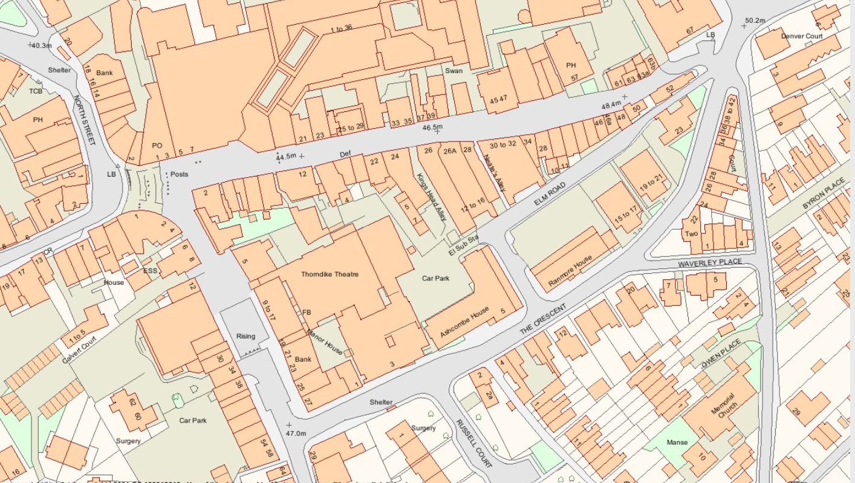
Legend
Pedestrian zone in High Street and Church Street =
Church Street
High Street

