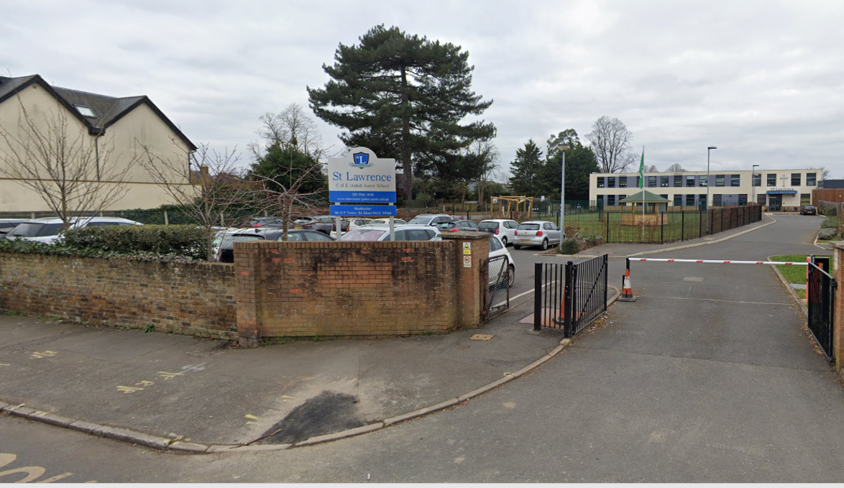
St Lawrence Junior School
Road Safety Consultation Feedback Report
July 2023

Between the 7^{th of} June 2023 and 2nd July 2023 Surrey County Council carried out a full public consultation via the “Surrey Says” platform inviting the community to complete a questionnaire over 5 different road safety proposals for St Lawrence Junior School.
- Letters were sent to 1080 residents and businesses in the immediate area (shown below) with details on how to take part. A contact number was available to allow people to request a paper form of the survey;
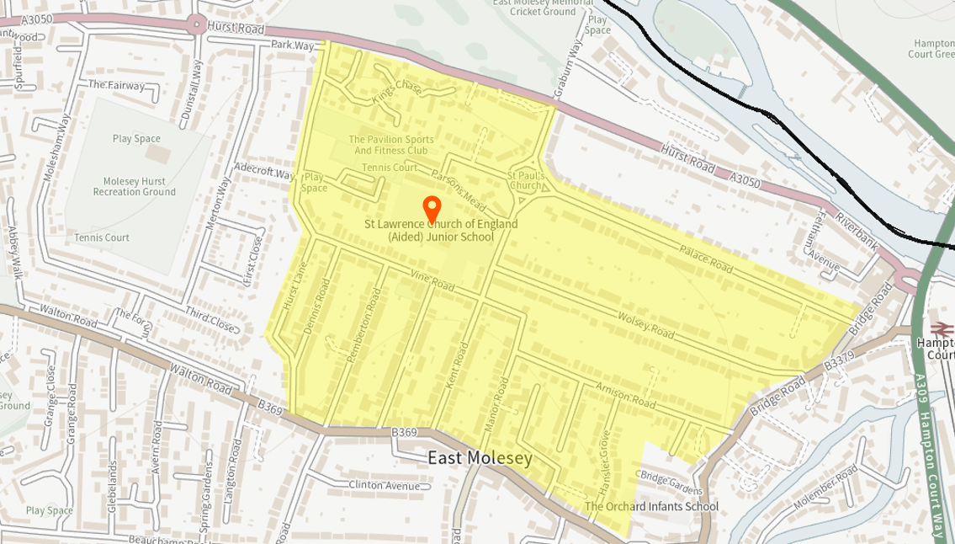
Immediate area of school to receive letters.

- Correx Boards were put up around the area with the details of the proposals and contact number;
- SCC published links on Twitter and Facebook encouraging people to take part in the consultation.

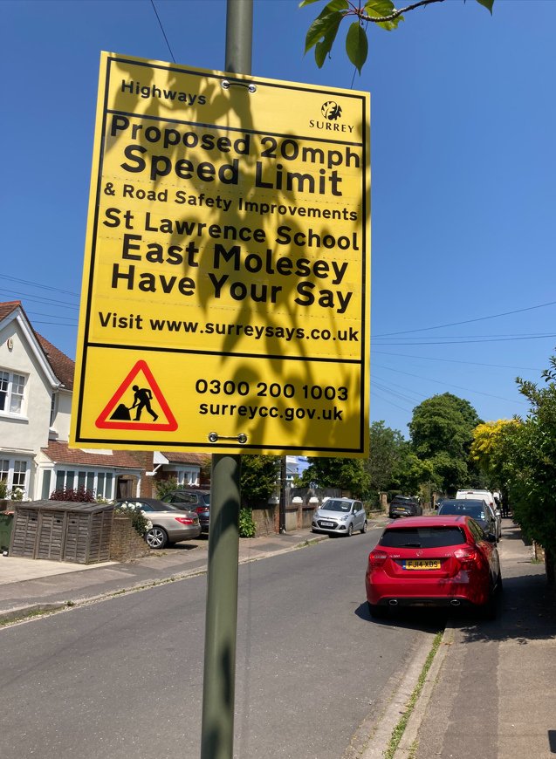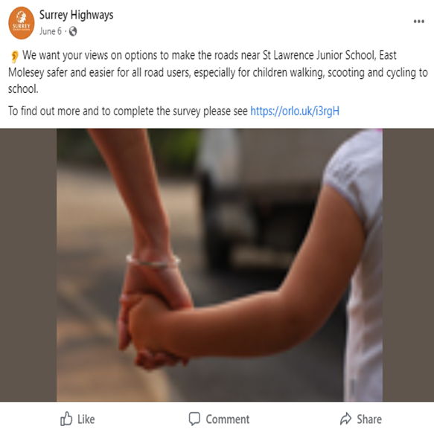
The questionnaire.
Respondents were asked to choose either Strongly Agree; Agree; Neither agree nor disagree; Disagree; Strongly Disagree for each of the 5 options proposed. Respondents could also choose to leave comments on each proposal.
- Option 1: 20mph speed limit on Church Road and surrounding roads (this can be implemented in addition to one of the following options)
- Option 2: Trial point closure; or
- Option 3: “School Street” pedestrian zone at school journey times on Church Road; or
- Option 4: A raised zebra crossing: or
- Option 5: Do nothing.
This report presents the results of the public consultation.

Analysis
The number of responses received via “Surrey Says” and via post is shown in Table 1 below.

Surrey Says responses | 975
Post responses | 2
Total responses | 977
Table 1: Number of responses received.
- From the total number of responses, 958 registered their postcode and address.
- 19 respondents did not register their address.

Based on the 958 registered addresses, the respondents have been classified based on the post code as shown in Table 2.

Location | Respondents
Within the immediate area as shown in yellow in map above | 515
In East Molesey, but outside the immediate area | 223
West Molesey | 209
Outside East/West Molesey | 11
Total of all respondents | 958
Table 2: Responses by postcode

Results
From the total 977 responses received, the following results show the numbers and percentages for each of the five options proposed.
Option 1 - 20mph Limit
- 77% Strongly Agreed and Agreed to the 20mph limit proposal.
- 16% Strongly Disagreed and Disagreed to the 20mph limit proposal.
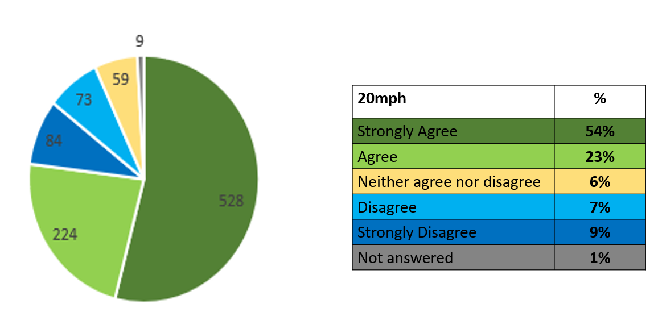
Diagram 1

Option 2 – Point Closure Trial
- 17% Strongly Agreed and Agreed to the Point Closure Trial
- 74% Strongly Disagreed and Disagreed to the Point Closure Trial
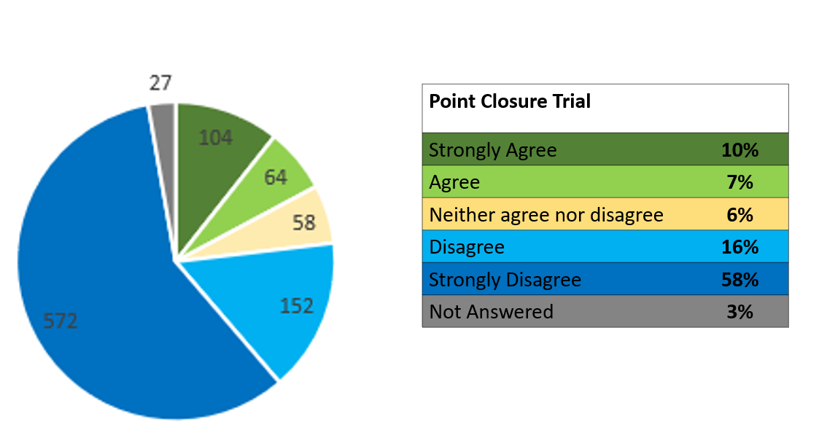
Diagram 2

Option 3 – School Street
- 27% Strongly Agreed or Agreed to the School Street proposal.
- 58% Strongly Disagreed or Disagreed to the School Street proposal.
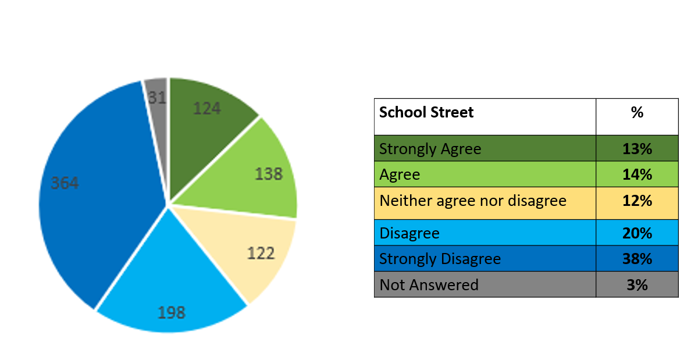
Diagram 3

Option 4 – Zebra Crossing
- 74% Strongly Agreed or Agreed to the Zebra Crossing proposal.
- 13% Strongly Disagreed or Disagreed to the Zebra Crossing proposal.

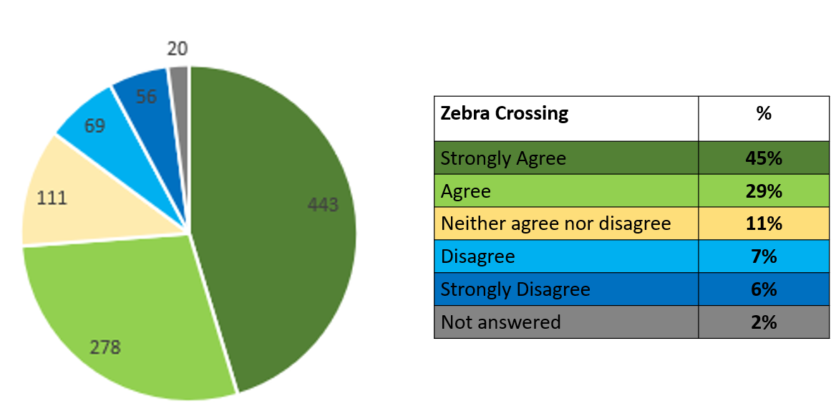
Diagram 4

Option 5 – Do Nothing
- 20% Strongly Agreed or Agreed to the Do Nothing proposal.
- 57% Strongly Disagreed or Disagreed to the Do Nothing proposal.

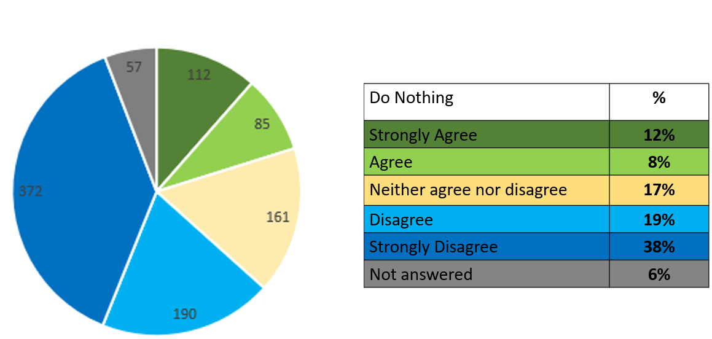
Diagram 5

Comments
Each respondent was invited to leave additional comments on each of the 5 options proposed.
Option 1 20mph Limit
As the above results indicate there was overall support for a 20mph limit on the roads around St Lawrence School, with many respondents stating they would like to see more roads in Molesey with a 20mph limit. Others felt it was unnecessary and would add further congestion to the area.
“I have long supported the idea of having a 20mph speed limit not only in this immediate vicinity but throughout Molesey, including on Walton Road, Matham Road, Spencer Road, Bell Road, Beauchamp Road, and Molesey Park Road. The speed of driving has become intolerable and incredibly dangerous. In my opinion, unless something is done now to reduce the speed of vehicles, it will not be long before a fatality of a child occurs. PLEASE IMPLEMENT A 20mph SPEED LIMIT THROUGHOUT MOLESEY”

“20mph limit should relate to all non-main residential roads in area. Cannot see a reason not to. Place measures must be in place to ensure this is kept to”.

“It is not necessary to add another congestion it is difficult to do the limit anyway”.

“I am unaware of any accidents on these roads so don’t feel this is necessary - Walton Road is always busy and these alternative routes can save considerable time”.

Option 2 Point Closure Trial

As the results indicate there was a strong oppose to this option, with many respondents worried about the impact on the surrounding road network and being unfair on the residents. Other comments showed that there was confusion over the meaning of a ‘Point Closure’.

“ This whole scheme seems to be driven by the school and the parents of its students. The problem presumably is the parents driving to school and parking inappropriately/dangerously. The suggested road closure, however, effects ALL the residents and road users, not just those from the school. A much simpler solution would be to stop these parents parking where it is dangerous or causing danger to the students.”
“This will merely push traffic to nearby roads and lead to congestion and displacement of risks to school children walking to school on those nearby roads. The consultation says that you don't know whether this will be the case. However, when the works were being undertaken to narrow the road outside St Lawrence, this very much was the case. There was a significant increase of traffic on Arnison Road, leading to a tailback as vehicles tried to get onto Bridge Road”.

“Annoying for residents trying to move around. Will push traffic and parking into other roads ugly bollards in conservation area”.

“This would cause considerable inconvenience 24/7 for large numbers of residents in the roads contained within Hurst Rd, Hurst Lane, Walton Road and Bridge Road. People would need to drive (eg. Elderly and infirm, transporting goods/shopping/deliveries etc, those en route to further away) and would have to drive further therefore causing greater pollution”.

“Nor sure what you mean”.

Option 3 School Street
Although the overall result showed a lack of support for this proposal, the comments left showed that there was more understanding with the concept and would address the problem without penalising the residents too much. While others felt the proposal was disproportionate and too expensive, and parents should be encouraged to walk to school.
“Addresses the problem times and deals with the concerns with a sensible and measured response”.

“This would be the safest option, especially for families transporting children between St Lawrence, The Orchard and the Children’s Workshop preschool”.

“This would seem a fair compromise so that children can get to and from school safely but then allows the flow of traffic back through outside of these hours but at 20mph”.

“People would have to be clock watching and risk a hefty fine if they are slightly early or late with their journey. Also, maybe more expensive to install and run for the council”.

“Too excessive”

“Fabulous idea. Make it safer to take children to school and make more parents leave their cars at home!!
When their journeys by car are unnecessary”.

“This is unnecessary. Parents should be responsible for making sure they and their children use roads safely.
A simple lollipop person would suffice”.

Option 4 Zebra Crossing

The results show an overwhelming support for this proposal, with most of the comments stating this would be the safest and less disruptive proposal to through traffic and residents. Other respondents felt, that the recently installed raised table on Wolsey Road/Church Road had already slowed traffic down and provided places for children and families to cross.

“The best option for children to safely cross”.

“Safe for everyone no need to monitor and have proved to increase safety for decades”.

“This helps with general traffic calming all the time and still allows local traffic to use the route”.

“I believe the raised area that has been created has already slowed traffic down sufficiently for pedestrians to be able to cross safely either side of the raised area”.

“This would be very detrimental to the residents of Church Road considering the measure that has been taken so far. They will lose all their on- street parking if a zebra is imposed and some residents are already compromised on use of their own drive as a result of the last set of road works. These residents and any visitors or tradesmen would be forced to park on Wolsey and Vine Road”.

Option 5 Do Nothing

The overall results show that the respondents agreed that additional road safety measures were required, however, some respondents felt that the school and parents should take more responsibility for the safety of the children.

“It is evident that there is a problem of safety, traffic congestion and adverse environmental impact on the neighbourhood which should be addressed”.

“Doing nothing will not an option, a solution needs to be implemented to reduce the chance of accidents and fatality. This is a very dangerous junction in its current state”.

“It is not an option to do nothing. There is too much traffic in the school area. The junction with Vine Road and Church Road is dangerous. Traffic travels too fast down Vine Road and Church Road. The surrounding school roads are heavily used at school times and also as cut throughs at other times by passing traffic. Local roads should be for school users and residents. I am in favour of proposals to ensure passing traffic is restricted to the main roads”.

“Parents need to be responsible in taking children to and from school and also teaching common sense.
School only affects the area and roads for about an hour a day and 38 weeks a year. Why should we all be affected all the time”.

“I think the 20-mph plan is sufficient with no need for any other measure. All the other proposals are completely disproportionate. The problems all relate to parents' disregard to the current double yellow lines at the junction. The children (and parents) need to be taught road safety - they do not take note of driveways and scoot / run across them without checking”.

Conclusion
The results show that from the 977 respondents 2 out of the 5 proposals have a clear majority.
- 77% for a 20mph Limit
- 74% for a Zebra Crossing

The 3 other proposals showed:
- 27% for a School Street
- 20% for Do Nothing
- 17% for a Point Closure Trial

