TRAFFIC FLOW DATA – SEPTEMBER 2022
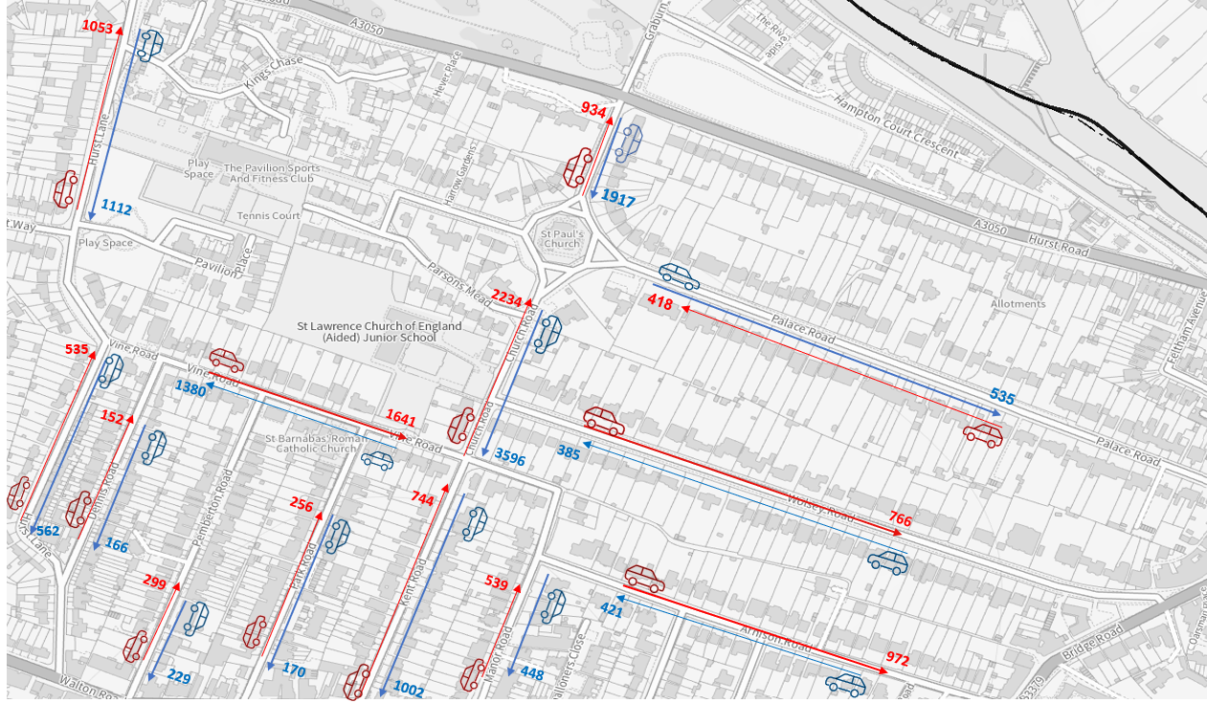
Numbers shown are 7-Day Average
Speed Data September 2022

