**20mph Speed Limit Planned Roads**

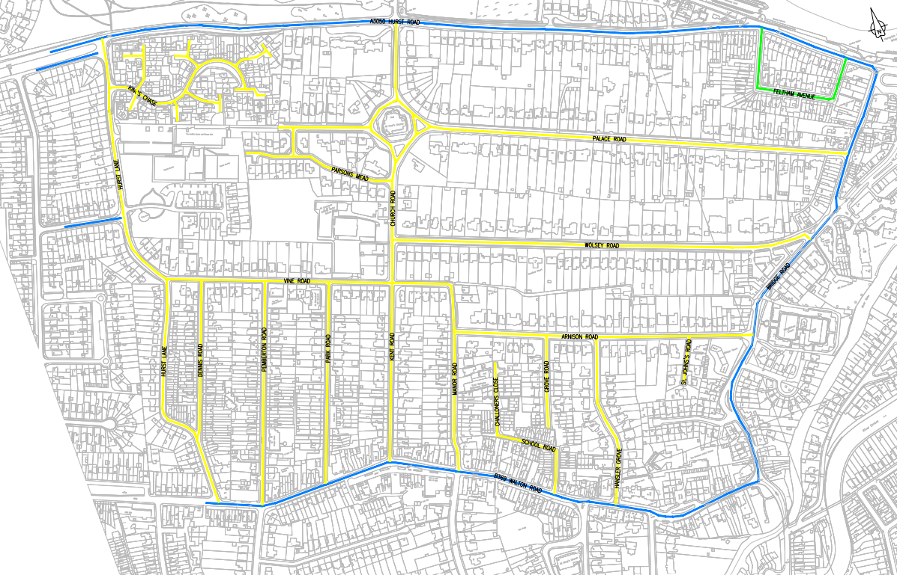

Existing 30mph to become 20mph

Existing 30mph Speed Limit to remain