Walton Oak Primary

School
Proposed Zebra Crossing & Road Safety Improvements

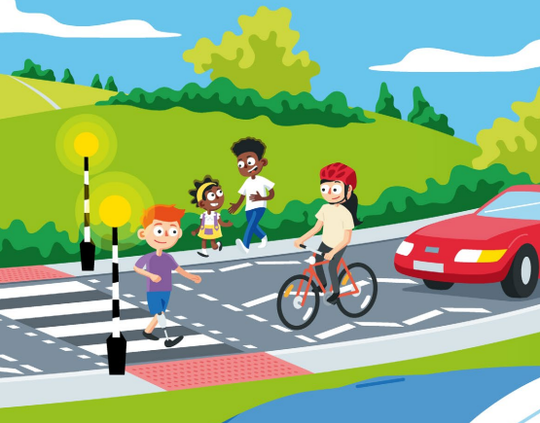
Ambleside Avenue Walton on Thames

Background
Following the schools School Crossing Patrol (SCP) leaving, a petition was presented to the Local Committee of Elmbridge in November 2021 requesting a pedestrian crossing on Ambleside Avenue for children and families to cross safely to Walton Oak Primary School
Surrey County Council Road Safety Officers visited the school in October 2021 to assess the opportunities to improve the highway to make it safer to access the school. An initial assessment recommended implementing a zebra crossing facility on the existing raised table near to the junction with Rodney Road.
The proposed road safety measures have the following objectives:
- Improve pedestrian priority and accessibility, including making it easier to cross Ambleside Avenue and access Walton Oak Primary School
- Encourage more children and families to walk, cycle or scoot to school.
- Remove the barriers to active travel to reduce congestion and air pollution at the school gates.

Proposed Works
Raised Zebra Crossing
The established desire line for children and families to cross Ambleside Avenue was set by the previous School Crossing Patrol (SCP). However, without the aid of a SCP this desire line is difficult to cross due to both the close vicinity of parked cars on the south side of Ambleside Avenue and cars emerging from Rodney Road.
We propose to extend the existing raised table 5 metres southeast to implement a raised zebra crossing. To allow for the crossing to be installed, it will be necessary to implement white crossing zig zag markings to prevent cars from parking and obstructing visibility between children, families and motorists. Unfortunately, this will mean a loss of 35 metres of on-street parking opposite to the school entrance. The loss in on-street parking must be balanced against the potential for improved safety in the area of the school.

Removal of existing Priority Give Way Measures
During the site assessment in October 2021, officers observed a collision between a large vehicle and a parked car near to the priority give way. The Priority Give Way measures are no longer fit for purpose, as they do not make it clear who has priority. This leads to conflict between opposing streams of traffic and as witnessed, the added risk of negotiating past parked vehicles near to the priority give way measures.
The raised table will be retained, as a traffic calming measure. By removing the pedestrian guard railing and priority give way measures, additional on-street parking spaces will be created.

Bus Stop Clearways
1. Northbound ‘St John’s Drive Bus Stop
Cars were observed parking across the existing Bus Stop on Ambleside Avenue (northwest of the junction with Rodney Road), resulting with the bus having to stop in the middle of the road. Passengers were witnessed having to alight in the middle of the road and make their way between parked cars to access the pavement. Installing a Bus Cage at this bus stop will make it illegal for cars to park within the bus stop road markings.
2.Southbound ‘The Furrows’ bus stop on Ambleside Avenue, (opposite nos.54/56).
To ensure this bus stop is clear from displaced parking and to protect passengers from having to alight in the middle of the road, a bus stop cage will be implemented to make it illegal for cars to park within the bus stop road markings.

Funding
Funding has been secured from Elmbridge Borough Council’s Community Infrastructure Levy (CIL) fund. This is a planning charge collected in Elmbridge to help fund and deliver infrastructure to support the development across the Borough. It is recognised that residents would like to see additional repairs to the roads in the immediate area, as well as across the County. CIL funding is specifically for infrastructure improvements, and it is not currently possible to use to maintain the existing road network. Surrey County Council continues to seek additional funding to invest in road maintenance.
We would like to hear your comments on these planned road safety improvements. To respond to the consultation and have your views taken into account, you must complete the online questionnaire at …………… (link).
If you would rather have a paper copy of the survey, then please request a copy by either calling 0300 200 1003 or email at highways@surreycc.gov.uk

Please respond by Friday 2nd June 2023 to have your say
What happens next?
All feedback will be fully considered once the consultation has closed. If a decision is made to proceed, construction will take place later this year.

